
V1.0.0

Network Video Recorder
User's Manual

Foreword
General
This manual introduces the functions and operations of the network video recorder (hereinafter referred to as "the Device"). Read carefully before using the device, and keep the manual safe for future reference.
Safety Instructions
The following signal words might appear in the manual.
Signal Words | Meaning
 | Indicates a high potential hazard which, if not avoided, will result in death or serious injury.
 | Indicates a medium or low potential hazard which, if not avoided, could result in slight or moderate injury.
 | Indicates a potential risk which, if not avoided, could result in property damage, data loss, reductions in performance, or unpredictable results.
 | Provides methods to help you solve a problem or save time.
 | Provides additional information as a supplement to the text.
Revision History
Version | Revision Content | Release Time
V1.0.0 | First release. | September 2023
Privacy Protection Notice
As the device user or data controller, you might collect the personal data of others such as their face, fingerprints, and license plate number. You need to be in compliance with your local privacy protection laws and regulations to protect the legitimate rights and interests of other people by implementing measures which include but are not limited: Providing clear and visible identification to inform people of the existence of the surveillance area and provide required contact information.
About the Manual
● The manual is for reference only. Slight differences might be found between the manual and the product.
● We are not liable for losses incurred due to operating the product in ways that are not in compliance with the manual.
● The manual will be updated according to the latest laws and regulations of related jurisdictions. For detailed information, see the paper user’s manual, use our CD-ROM, scan the QR code or visit our official website. The manual is for reference only. Slight differences might be found between the electronic version and the paper version.
● All designs and software are subject to change without prior written notice. Product updates might result in some differences appearing between the actual product and the manual. Please contact customer service for the latest program and supplementary documentation.
● There might be errors in the print or deviations in the description of the functions, operations and technical data. If there is any doubt or dispute, we reserve the right of final explanation.
● Upgrade the reader software or try other mainstream reader software if the manual (in PDF format) cannot be opened.
● All trademarks, registered trademarks and company names in the manual are properties of their respective owners.
● Please visit our website, contact the supplier or customer service if any problems occur while using the device.
● If there is any uncertainty or controversy, we reserve the right of final explanation.

Important Safeguards and Warnings
This section introduces content covering the proper handling of the Device, hazard prevention, and prevention of property damage. Read carefully before using the Device, and comply with the guidelines when using it.
Transportation Requirements
Transport the Device under allowed humidity and temperature conditions.
Storage Requirements
Store the Device under allowed humidity and temperature conditions.
Operation Requirements
● Do not place the Device in a place exposed to sunlight or near heat sources.
● Keep the Device away from dampness, dust, and soot.
● Install the Device on a stable surface to prevent it from falling.
● Do not drop or splash liquid onto the Device, and make sure that there is no object filled with liquid on the Device to prevent liquid from flowing into it.
● Put the Device in a well-ventilated place, and do not block its ventilation.
● Operate the Device within the rated range of power input and output.
● Do not disassemble the Device.
● Use the Device under allowed humidity and temperature conditions.
● Replace unwanted batteries with new batteries of the same type and model.
Installation Requirements
● Do not connect the power adapter to the device while the adapter is powered on.
● Strictly comply with the local electric safety code and standards. Make sure the ambient voltage is stable and meets the power supply requirements of the device.
● Do not expose the battery to environments with extremely low air pressure, or extremely high or low temperatures. Also, it is strictly prohibited to throw the battery into a fire or furnace, and to cut or put mechanical pressure on the battery. This is to avoid the risk of fire and explosion.
● Use the standard power adapter or cabinet power supply. We will assume no responsibility for any injuries or damages caused by the use of a nonstandard power adapter.
● Do not place the Device in a place exposed to sunlight or near heat sources.
● Keep the Device away from dampness, dust, and soot.
● Put the Device in a well-ventilated place, and do not block its ventilation.
● Install the Device on a stable surface to prevent it from falling.
● The power supply must conform to the requirements of ES1 in IEC 62368-1 standard and be no higher than PS2. Please note that the power supply requirements are subject to the device label.
● The device is a class I electrical appliance. Make sure that the power supply of the Device is connected to a power socket with protective earthing.
● Use power cords that conform to your local requirements, and are rated specifications.
● Before connecting the power supply, make sure the input voltage matches the power requirements of the Device.
● When installing the Device, make sure that the power plug and appliance coupler can be easily reached to cut off power.
● Install the Device near a power socket for emergency disconnect.
● It is prohibited for non-professionals and unauthorized personnel to open the Device casing.
Maintenance Requirements
The appliance coupler is a disconnection device. Keep it at a convenient angle when using it.

Table of Contents
Foreword I
Important Safeguards and Warnings III
1 Introduction 1
1.1 Overview 1
1.2 Features 1
2 Unpacking 3
3 Structure 4
3.1 Compact 1U 4
3.1.1 Front Panel 4
3.1.2 Rear Panel 4
3.2 Big 1U 6
3.2.1 Front Panel 6
3.2.2 Rear Panel 6
4 Installation 9
4.1 Installing HDD 9
4.1.1 Compact 1U 9
4.1.2 Big 1U 11
4.2 Connecting to Alarm Input and Output 14
4.2.1 Alarm Port Description 14
4.2.2 Alarm Input 15
4.2.3 Alarm Output 15
5 Local Operations 17
5.1 Starting the Device 17
5.2 Initialization 17
5.3 Setup Wizard 20
5.4 Login 25
5.5 Live View 26
5.5.1 Live View Control Bar 26
5.5.2 Navigation Bar 27
5.5.3 Shortcut Menu 28
5.5.4 PTZ 28
5.5.4.1 Operating PTZ Control Panel 28
5.5.4.2 Configuring PTZ Functions 29
5.5.4.2.1 Configuring Presets 29
5.5.4.2.2 Configuring Patrol Group 30
5.5.4.3 Using PTZ Functions 30
5.5.4.3.1 Using Presets 30
5.5.4.3.2 Using Patrol Groups 30
5.6 Main Menu 30
5.7 Playback 31
5.7.1 Instant Playback 31
5.7.2 Playback Page 31
5.7.3 Playback Controls 34
5.7.4 Quick Search 35
5.7.5 Clip 36
5.7.6 Tag Playback 36
5.8 File Search 37
5.8.1 Searching for Video 37
5.8.2 Searching for Picture 39
5.8.3 Smart Search 40
5.8.3.1 Face Search 40
5.8.3.1.1 Face Detection 40
5.8.3.1.2 Face Recognition 42
5.8.3.2 VCA Search 45
5.8.3.3 LPR Search 46
5.8.3.4 MD2.0 Search 48
5.8.4 Smart Report 49
5.8.4.1 People Counting 49
5.8.4.2 Heat Map 50
5.9 Smart Analysis 51
5.9.1 VCA Settings 51
5.9.1.1 VCA Option 51
5.9.1.2 Configuring Face Detection 52
5.9.1.3 Configuring Face Recognition 55
5.9.1.4 Configuring VCA 57
5.9.1.5 Configuring People Counting 61
5.9.1.6 Configuring Heat Map 65
5.9.1.7 Configuring LPR 66
5.9.2 Database 69
5.9.2.1 Configuring Face Database 69
5.9.2.1.1 Creating Local Face Database 69
5.9.2.1.2 Creating Remote Face Database 70
5.9.2.2 Adding Images to Face Database 70
5.9.2.2.1 Adding Face Images One by One 71
5.9.2.2.2 Adding Face Images in Batches 73
5.9.2.3 Configuring Blocklist and Allowlist 74
5.10 Camera 75
5.10.1 Configuring Remote Devices 75
5.10.1.1 Adding Remote Devices 75
5.10.1.1.1 Adding Remote Devices from Search 75
5.10.1.1.2 Adding Remote Devices Manually 77
5.10.1.1.3 Importing Remote Devices 78
5.10.1.2 Upgrading Remote Devices 79
5.10.2 Checking PoE Status 79
5.10.3 Configuring Image Attributes 80
5.10.4 Configuring Overlay Settings 82
5.10.5 Configuring Privacy Masking 83
5.10.6 Configuring Video Settings 84
5.10.7 Configuring E-Tracking 86
5.11 Storage 87
5.11.1 Configuring Recording Plan 88
5.11.2 Configuring Storage Strategy 89
5.11.3 Configuring Disk Group 91
5.11.4 Configuring Recording Mode 92
5.12 System 93
5.12.1 Configuring General System Settings 93
5.12.1.1 Configuring Basic Configuration 94
5.12.1.2 Configuring Date Settings 95
5.12.1.3 Configuring Holiday Settings 96
5.12.2 Configuring Account Settings 98
5.12.2.1 Adding Users 98
5.12.2.2 Adding User Groups 99
5.12.2.3 Adding ONVIF Users 100
5.12.2.4 Resetting Password 101
5.12.2.4.1 Configuring Password Reset 101
5.12.2.4.2 Resetting Password on Local Interface 102
5.12.3 Configuring Network Settings 105
5.12.3.1 Configuring Basic Settings 105
5.12.3.1.1 Configuring TCP/IP Settings 105
5.12.3.1.2 Configuring Port Settings 106
5.12.3.1.3 Configuring DDNS Settings 107
5.12.3.1.4 Configuring P2P Settings 109
5.12.3.1.5 Configuring Email Settings 110
5.12.3.2 Configuring Security Settings 111
5.12.3.2.1 Configuring Basic Services 111
5.12.3.2.2 Configuring Firewall 114
5.12.4 Configuring Events 115
5.12.4.1 Disarming All 115
5.12.4.2 Configuring Video Detection Alarms 116
5.12.4.2.1 Configuring Motion Detection Alarms 116
5.12.4.2.2 Configuring Video Tampering Alarms 119
5.12.4.2.3 Configuring Scene Changing Alarms 120
5.12.4.2.4 Configuring Camera Offline 121
5.12.4.3 Configuring Alarm Settings 122
5.12.4.3.1 Configuring Local Alarms 122
5.12.4.3.2 Configuring Alarms from External Cameras 123
5.12.4.3.3 Configuring Alarm Output 124
5.12.4.4 Configuring Error Alarms 125
5.12.4.4.1 Configuring Storage Error Alarms 125
5.12.4.4.2 Configuring Network Error Alarms 127
5.12.4.5 Searching for Alarm Information 128
5.12.4.6 Viewing Alarm Status 129
5.12.5 Configuring Display Settings 130
5.12.5.1 Configuring Display Output 130
5.12.5.2 Configuring Auto Switch 132
5.12.6 Configuring Serial Port 133
5.13 Maintenance 134
5.13.1 Viewing System Information 134
5.13.2 Searching for Logs 135
5.13.3 Viewing Network Information 136
5.13.3.1 Viewing Online User 136
5.13.3.2 Viewing Network Load 136
5.13.3.3 Testing Network 137
5.13.4 Exporting and Importing System Configurations 139
5.13.4.1 Exporting System Configurations 139
5.13.4.2 Importing System Configurations 140
5.13.5 Updating the System 140
5.13.5.1 File Update 140
5.13.5.2 Online Update 141
5.13.6 Restoring Defaults 141
5.13.6.1 Restoring Defaults on the Local Interface 141
5.13.6.2 Resetting Device through the Reset Button 141
5.13.7 Configuring Automatic Reboot 142
6 Web Operations 143
6.1 Logging in to the Web 143
6.2 Web Main Menu 144
Appendix 1 HDD Capacity Calculation 145
Appendix 2 Cybersecurity Recommendations 146

1 Introduction

1.1 Overview
The Device is a high-performance network video recorder. It supports local live view, multichannel display, local storage of recorded files, and remote management and control function.
The Device works with network cameras, network video servers and other devices to form a strong surveillance network through the central management software. In the network system, data are transmitted through the network cable between the monitoring center and the monitored zone. You do not need to connect audio or video cables from the monitoring center to the monitored zone and can enjoy the benefits of simple connection and low maintenance costs.
The Device can be widely used in areas such as public security, water conservancy, transportation, and education.

1.2 Features
The actual functions might vary depending on the software and hardware version and the model you are using.
Real-time Surveillance
● Connects to monitor through VGA or HDMI port for real-time surveillance.
● Supports HDMI and VGA output at the same time.
Recording and Playback
● Supports recording and playing back videos of each channel.
● Supports slow play, fast play, backward play and frame by frame play for playback.
Smart Detection
● Supports face detection, VCA and intelligent motion detection.
● Supports search and playback of the smart detection records.
Alarm Linkage
Supports multiple alarm linkage actions in response to an alarm event, such as email, beep.
Online Update
Supports updating the program online.
Backup
Supports backup of logs, system configurations, recorded videos and snapshots, and more.
Network Surveillance
Supports network-based remote monitoring, remote playback and remote PTZ control

2 Unpacking
After receiving the Device, refer to the following table to verify nothing is missing or broken. If any issue occurs, contact our customer support.
Table 2-1 Checking list
No. | Item | Requirements
1 | Package | ● No visible damage.  ● Not distorted or broken.  ● Nothing missing.
2 | Label | Not torn up.  Keep the label well. You might need to provide the serial number on the label when calling the after-sales service.
3 | Casing | ● No visible damage.  ● No loose connection of the cables and mainboard.  If cables are loose, contact our customer support.

3 Structure
This chapter introduces the front panel and rear panel of the Device.

3.1 Compact 1U

3.1.1 Front Panel
Figure 3-1 Front panel
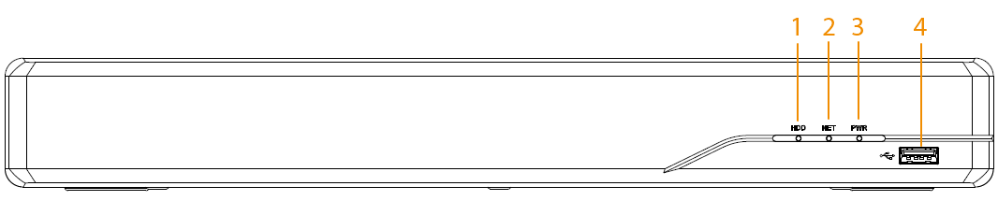
Table 3-1 Front panel description
No. | Name | Description
1 | HDD indicator light | The light is solid blue when the HDD is abnormal.
2 | Network indicator light | The light is solid blue when the network is abnormal.
3 | Power indicator light | The light is solid blue when the power is connected properly.
4 | USB port | Connects to peripheral devices such as USB storage device, keyboard, and mouse.

3.1.2 Rear Panel
Figure 3-2 Rear panel (4-PoE port)
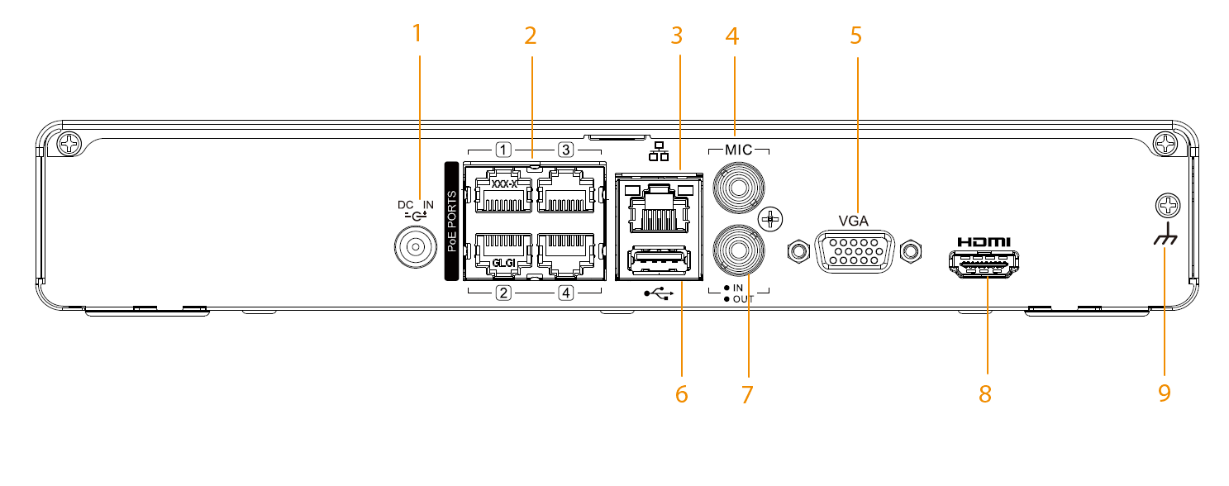
Figure 3-3 Rear panel (8-PoE port)
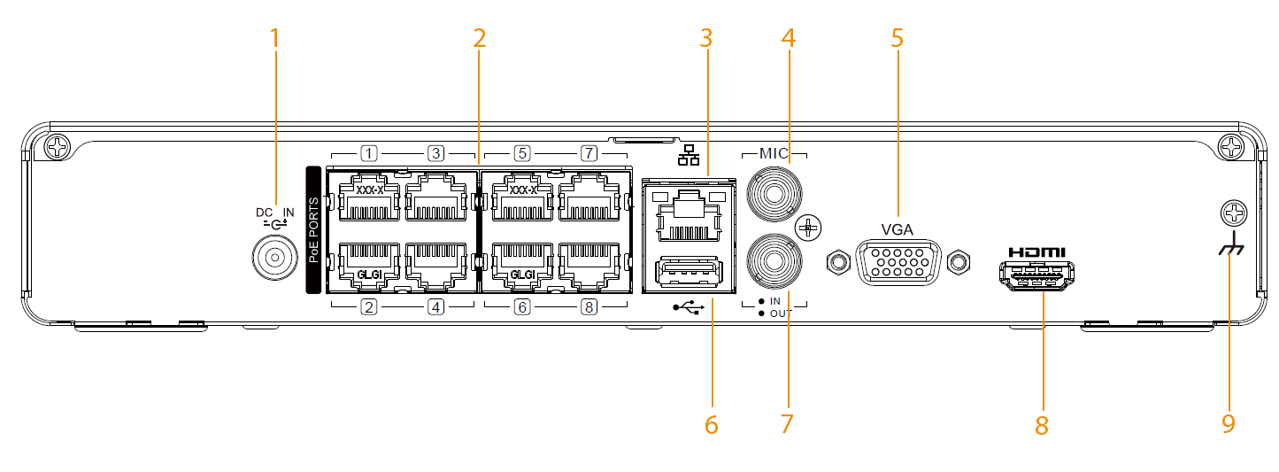
Table 3-2 Rear panel description
No. | Name | Description
1 | Power input port | Inputs power.
2 | PoE ports | Built-in switch. Support PoE function.  You can use this port to provide power to the network camera.
3 | Network port | Connects to the network cable.
4 | Audio input port | Two-way talk input port which receives the audio signals from the devices such as microphone and pickup.
5 | VGA port | Outputs analog video data to the connected display with VGA port.
6 | USB port | Connects to the external devices such as keyboard, mouse, and USB storage device.
7 | Audio output port | Outputs the audio signals to the devices such as the sound box.
8 | HDMI port | High Definition Media Interface. Transmits uncompressed high definition video and multiple-channel data to the HDMI port of the display device.
9 | Ground | —

3.2 Big 1U

3.2.1 Front Panel
Figure 3-4 Front panel
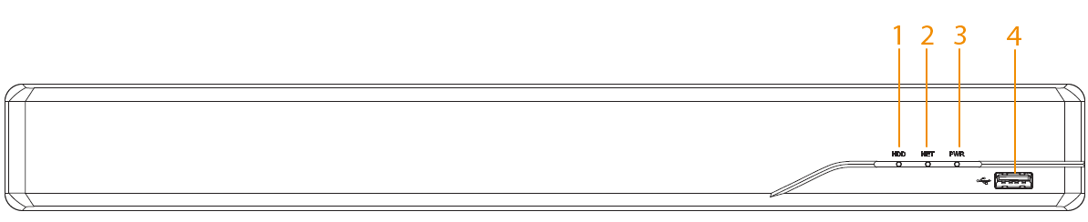
Table 3-3 Front panel description
No. | Name | Description
1 | HDD indicator light | The light is solid blue when the HDD is abnormal.
2 | Network indicator light | The light is solid blue when the network is abnormal.
3 | Power indicator light | The light is solid blue when the power is connected properly.
4 | USB port | Connects to peripheral devices such as USB storage device, keyboard, and mouse.

3.2.2 Rear Panel
Figure 3-5 Rear panel (8-PoE port)
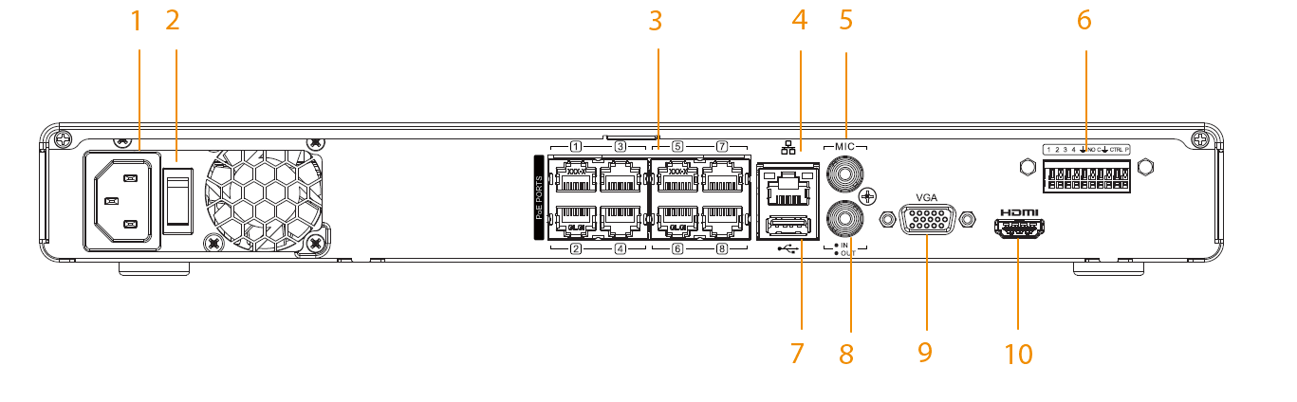
Figure 3-6 Rear panel (16-PoE port)
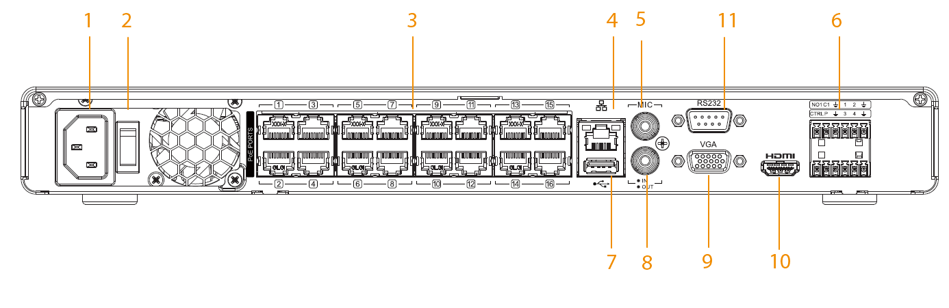
Table 3-4 Rear panel description
No. | Name | Description
1 | Power input port | Inputs power.
2 | Power switch | Turns on or off the Device.
3 | PoE ports | Built-in switch. Support PoE function.  You can use this port to provide power to the network camera.
4 | Network port | Connects to the network cable.
5 | Audio input port | Two-way talk input port which receives the audio signals from the devices such as microphone and pickup.
6 | Alarm output ports | Output alarm signals to the alarm device.  ● NO: Normally open alarm output port.  ● C: Common alarm output port.
 | CTRL (controllable 12 V power supply output) | Controls the output of the on-off button alarm relay. It controls the alarm device with the presence or absence of voltage. It can also be used as power input for some alarm devices such as alarm detectors.
 | P (12 V power output port) | Provides power to some peripheral devices such as camera and alarm devices. Make sure the power supply of peripheral device is below 1 A.
 | Alarm input ports 1–4 | Receive signals from the external alarm source.  When your alarm input device is using external power, make sure the device and the NVR have the same ground.
7 | USB port | Connects to the external devices such as keyboard, mouse, and USB storage device.
8 | Audio output port | Outputs the audio signals to the devices such as the sound box.
9 | VGA port | Outputs analog video data to the connected display with VGA port.
10 | HDMI port | High Definition Media Interface. Transmits uncompressed high definition video and multiple-channel data to the HDMI port of the display device.
11 | RS-232 port | Use the port for general COM debugging to configure IP address or transfer transparent COM data.

4 Installation
This chapter introduces the installation and connection of the Device.
Make sure to conform to your local safety rules while performing the operations.

4.1 Installing HDD
Before using the Device, check whether the HDD is already installed the Device. To install HDD, use the surveillance SATA hard drive recommended by the manufacturer.
Before installing HDD, make sure to unplug the power cord and put on anti-static gloves.

4.1.1 Compact 1U
Procedure
Step 1 Loosen the screws to remove the cover.
Figure 4-1 Remove cover
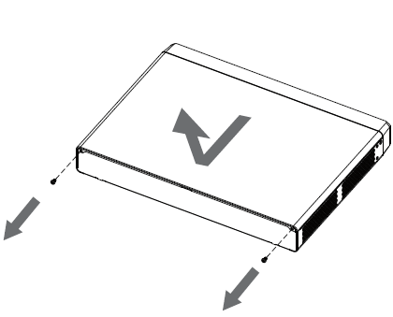
Step 2 Align 4 screw holes on the HDD with 4 holes on the Device and then tighten the screws.
Figure 4-2 Affix HDD
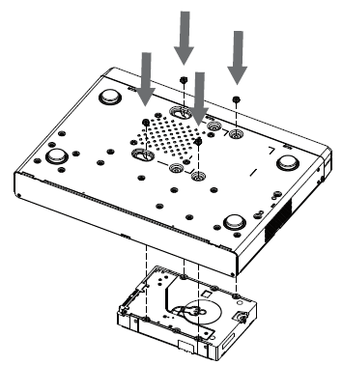
Step 3 Connect the data cable and power cord of the HDD to the Device.
Figure 4-3 Connect cables
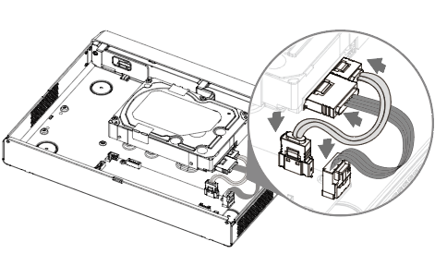
Step 4 Put back the cover and then fasten the screws to re-attach the cover.
Figure 4-4 Re-attach the cover
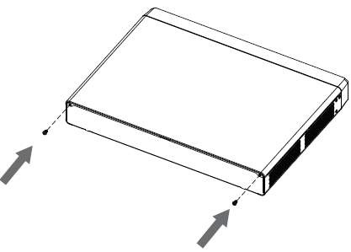

4.1.2 Big 1U
Procedure
Step 1 Loosen the screws to take off the cover.
Figure 4-5 Take off cover
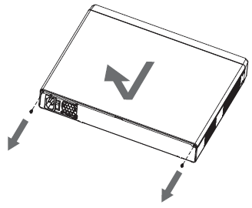
Step 2 Align the screw holes on the HDDs with the holes on the Device and then tighten the screws.
Figure 4-6 Affix HDD
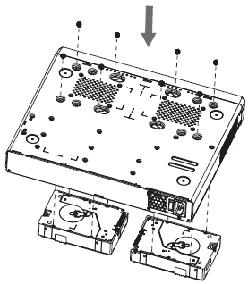
Step 3 Connect the data cable and power cord of the HDDs to the Device.
Figure 4-7 Connect cables
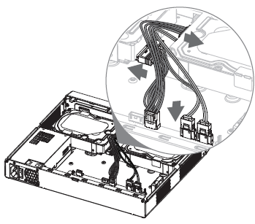
Step 4 Put back the cover and then fasten the screws to re-attach the cover.
Figure 4-8 Re-attach the cover
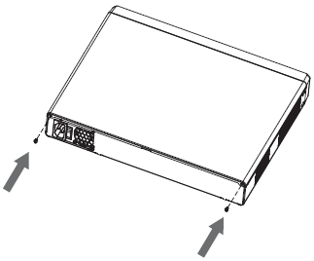

4.2 Connecting to Alarm Input and Output

4.2.1 Alarm Port Description
The following figure is for reference only. The number of alarm ports might differ depending on the model you are using.
Figure 4-9 Alarm ports
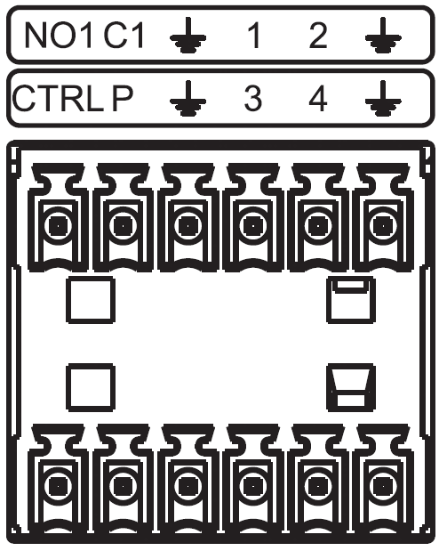
Table 4-1 Alarm port description
Icon | Description
1–4 | Alarm input ports. The alarm becomes active in low level.
NO1 C1 | Alarm output ports.  ● NO: Normally open port.  ● C: Common alarm output port.
 | Ground.
CTRL | Controllable 12 V power supply output. Disable power output when alarm is canceled.
P | Provides power to some peripheral devices such as camera and alarm devices. Make sure the power supply of peripheral device is below 1 A.

4.2.2 Alarm Input
● Connect the positive end (+) of the alarm input device to the alarm input port (ALARM IN 1–4) of the NVR.
● Connect the negative end (-) of the alarm input device to the ground end () of the NVR.
◇ When connecting the ground port of the alarm device to the NVR, you can use any of the GND ports ().
◇ Connect the NC port of the alarm device to the alarm input port (ALARM) of the NVR.
◇ When there is peripheral power supplying for the alarm device, please make sure it is earthed with the NVR.

4.2.3 Alarm Output
● Provide external power to external alarm device.
● To avoid overloading, read the following relay parameters carefully.
● RS-485 A/B cable is for the A/B cable of the PTZ decoder.
The parameters are for reference only.
Table 4-2 Alarm relay specifications
Model | Model | HFD23/005-1ZS | HRB1-S-DC5V
Material of the touch |  | AgNi + gold-plating | AuAg10/AgNi10/CuNi30
Rating (Resistance Load) | Rated switch capacity | 30 VDC, 1 A/125 VAC, 0.5 A | 24 VDC, 1 A/125 VAC, 2 A
 | Maximum switch power | 62.5 VAC/30 W | 250 VAC/48 W
 | Maximum switch voltage | 125 VAC/60 VDC | 125 VAC/60 VDC
 | Maximum switch currency | 2 A | 2 A
Insulation | Between touches | 400 VAC, 1 minute | 500 VAC, 1 minute
 | Between touch and winding | 1000 VAC, 1 minute | 1000 VAC, 1 minute
Turn-on Time |  | 5 ms maximum | 5 ms maximum
Turn-off Time |  | 5 ms maximum | 5 ms maximum
Longevity | Mechanical | 1 × 107 times  (300 times/minute) | 5 × 106 times  (300 times/minute)
 | Electrical | 1 × 105 times  (30 times/minute) | 2.5 × 104 times  (30 times/minute)
Working Temperature |  | -30 °C to +70 °C | -40 °C to +70 °C

5 Local Operations
The figures are for reference only and might differ from the actual interface.

5.1 Starting the Device
Prerequisites
● Make sure that the input voltage complies with the power requirements of the Device.
● To ensure the stable work of the Device and prolong the HDD life, follow related standards to use a power source that provides stable voltage with less interference from ripples. UPS power source is recommended.
● Make sure to connect the Device with the power adapter first, and then connect it to the power supply.
Procedure
Step 1 Connect the Device to the monitor, and then connect a mouse.
Step 2 Connect the power cord, and then turn on the power switch.

5.2 Initialization
Background Information
For first-time use, you need to configure the password and related protection for the default admin account.
For device security, we strongly recommend you properly keep the admin password and change it regularly.
Procedure
Step 1 Turn on the Device, select the language, and then click Next.
Figure 5-1 Select language
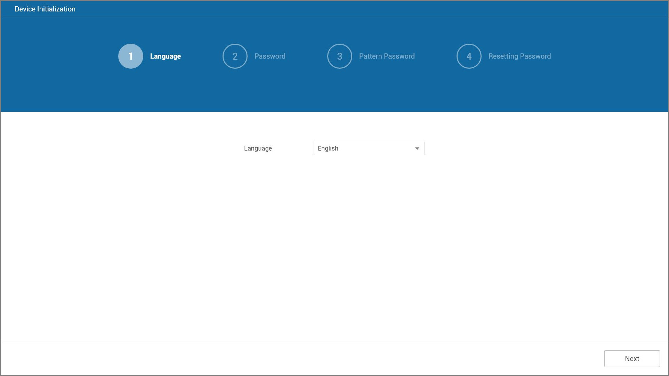
Step 2 Configure the password for admin, and then click Next.
Figure 5-2 Password setting
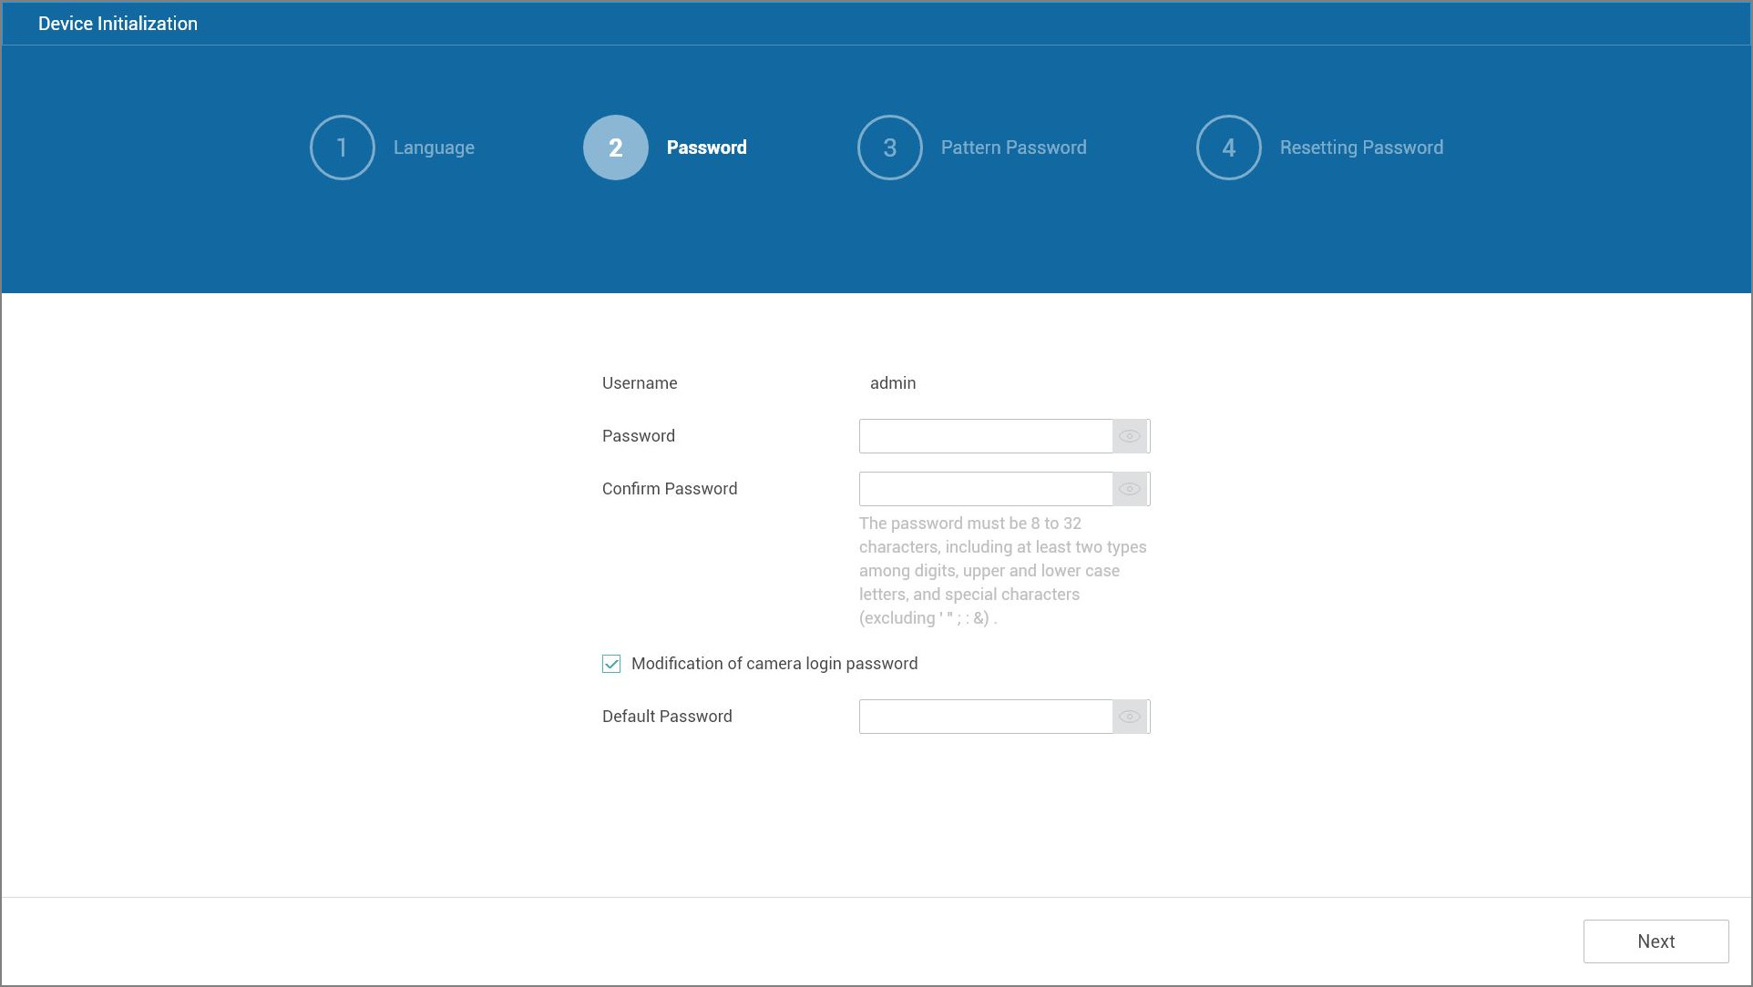
Table 5-1 Password parameters
Parameter | Description
Username | The username is admin by default.
Password | Enter and then confirm the password.
Confirm Password
Default Password | Click Modification of camera login password to configure the default password for adding the camera.
Modification of camera login password
Step 3 Set unlock pattern.
● The pattern that you want to set must cross at least four points.
● If you do not want to configure the unlock pattern, click Next.
● Once you have configured the unlock pattern, the system will require the unlock pattern as the default login method. If you did not configure the unlock pattern, you need to enter password for login.
Figure 5-3 Draw unlock pattern
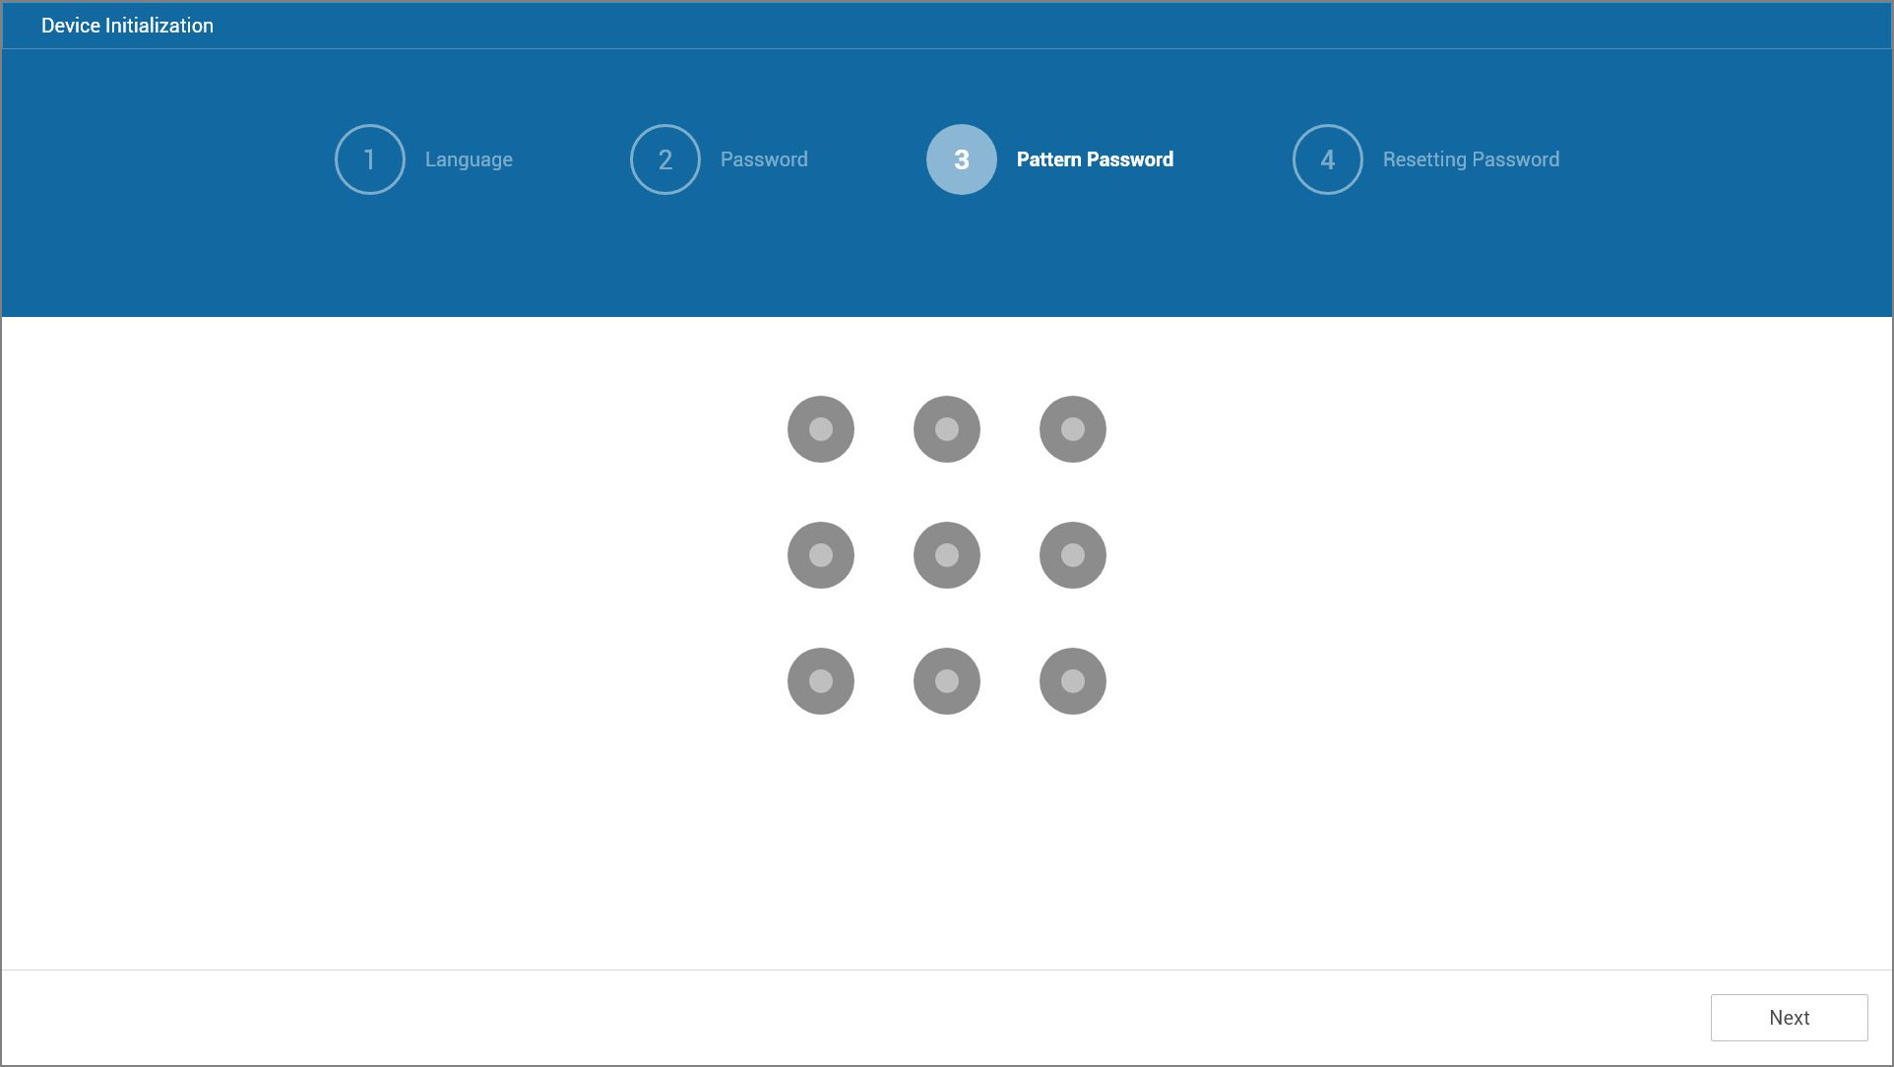
Step 4 Configure the password protection information.
● Reserved email address.
In the Reserved Email Address box, enter your email address. If you forget the password, you can use the email address to get the security code needed for password resetting.
● Security questions.
Select security questions and enter the corresponding answers. If you forget the password, enter the correct answers to the questions and then you can reset the password.
Figure 5-4 Password protection
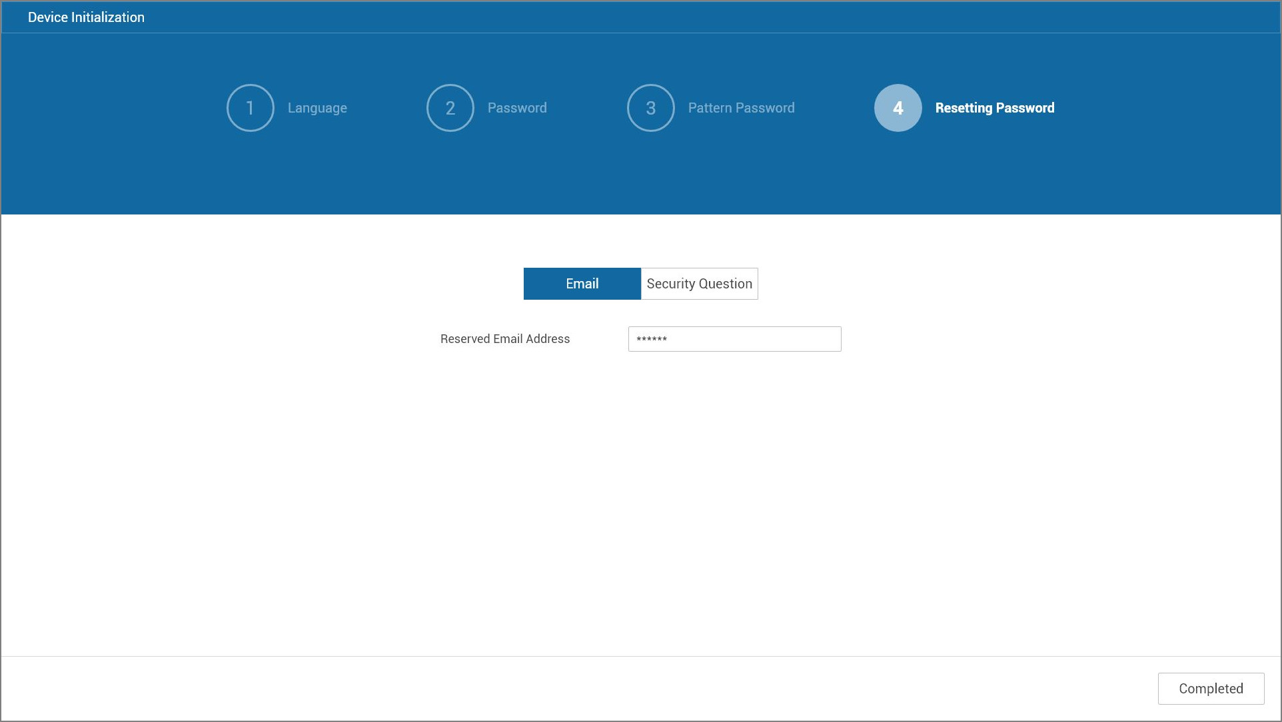
Step 5 Click Completed.
The Setup Wizard window appears.

5.3 Setup Wizard
Follow the setup wizard to complete basic settings.
Procedure
Step 1 Configure data and time, and then click Next.
You can select the time zone and data format, and set the system time.
Figure 5-5 Data and time
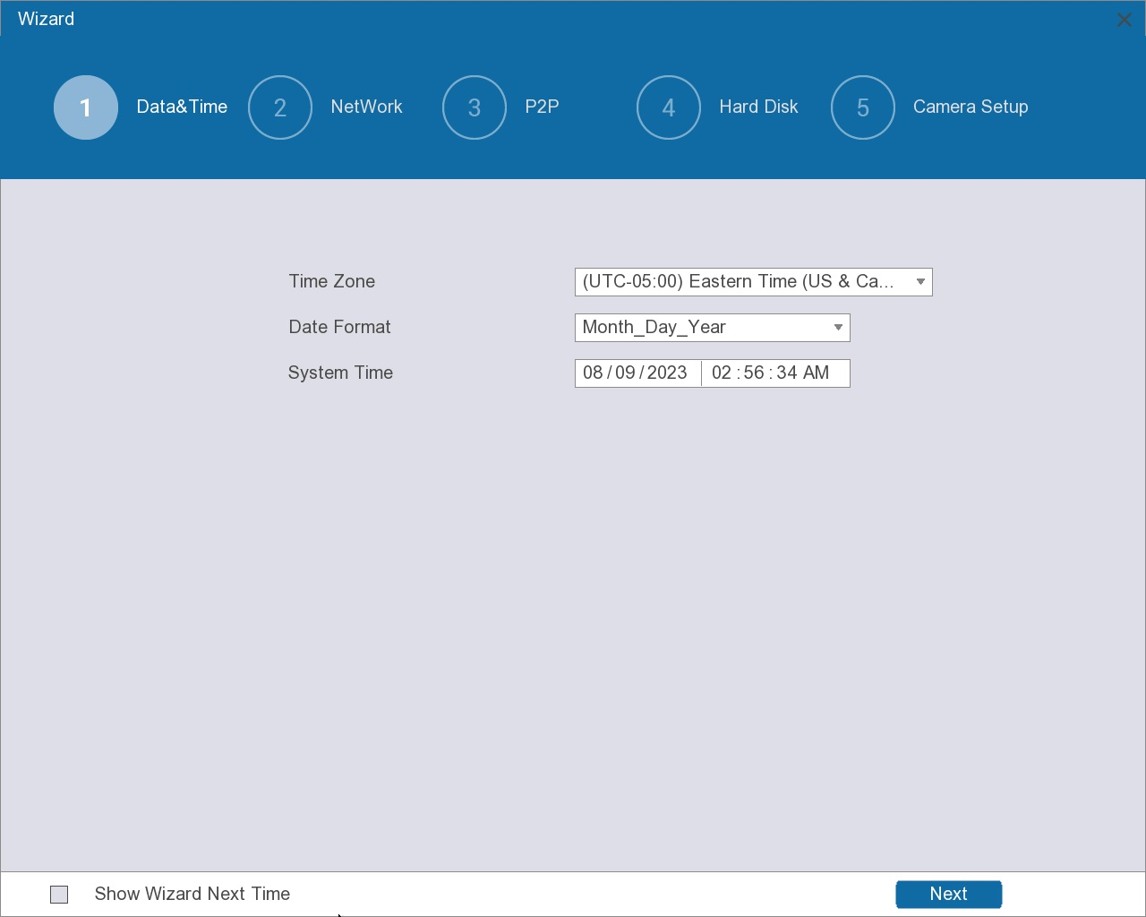
When you click the checkbox next to Show Wizard Next Time, the wizard page will appear again when the Device restarts.
Step 2 Configure network settings, and then click Next.
Figure 5-6 Network settings
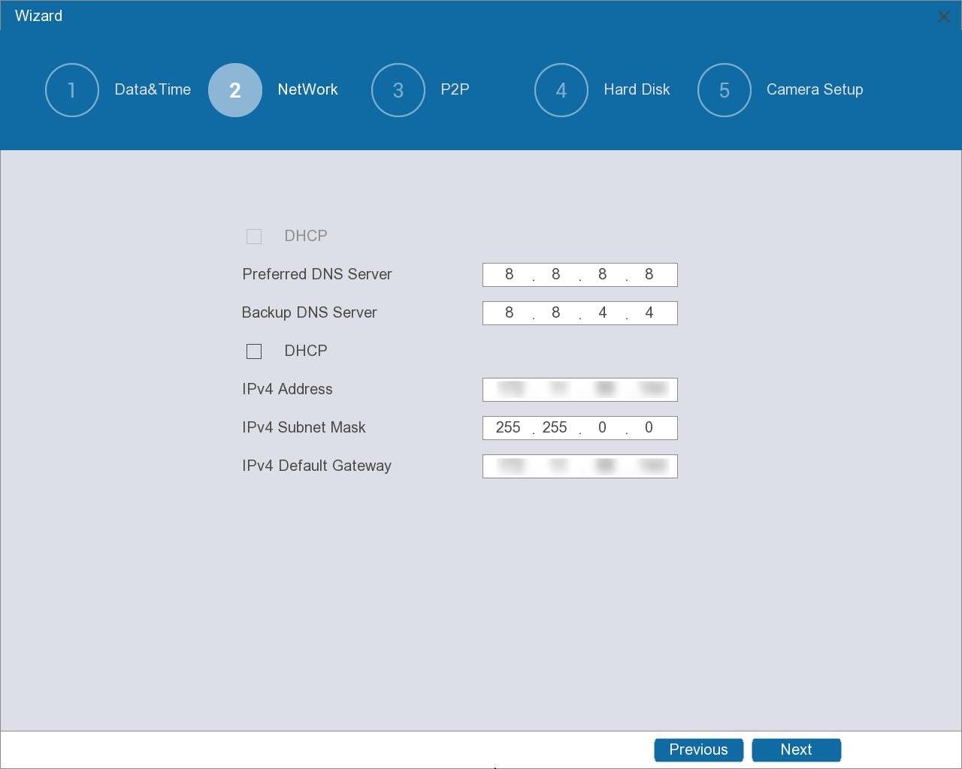
Table 5-2 Network parameters
Parameter | Description
DHCP | Enable the system to allocate a dynamic IP address to the Device. There is no need to set IP address manually.  ● The first DHCP is for the DNS server.  ● The second DHCP is for the Device.  Select the checkbox next to DHCP for IPv4, and then you can choose to enable or disable DHCP for DNS server.
Preferred DNS Server | Set preferred and backup DNS server address.
Backup DNS Server
IPv4 Address | Enter the IPv4 address and configure the corresponding subnet mask and default gateway.  The IPv4 address and the IPv4 default gateway must be on the same network segment.
IPv4 Subnet Mask
IPv4 Default Gateway
Step 3 Enable the P2P function, and then click Next.
You can use the mobile client to scan the QR code under Device SN to add the Device for remote management.
After you enable the P2P function and connect to the Internet, the system will collect the information such as email address and MAC address for remote access.
Figure 5-7 P2P
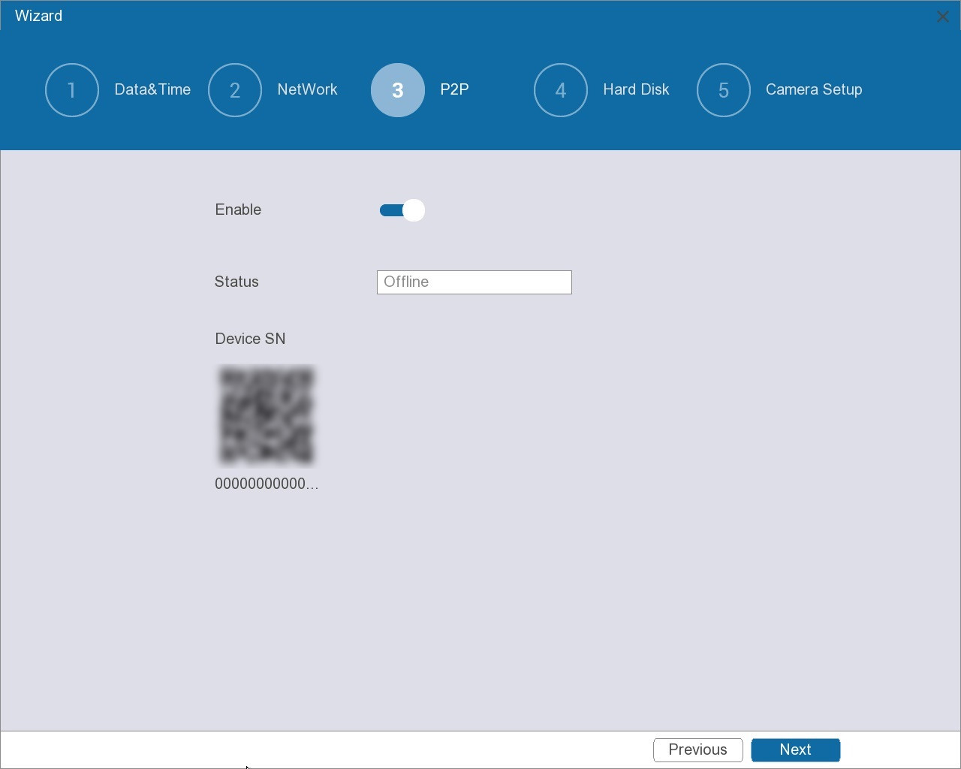
Step 4 On the disk list, view the HDD information and configure the HDD type, configure the storage strategy, and then click Next.
Figure 5-8 Hard disk
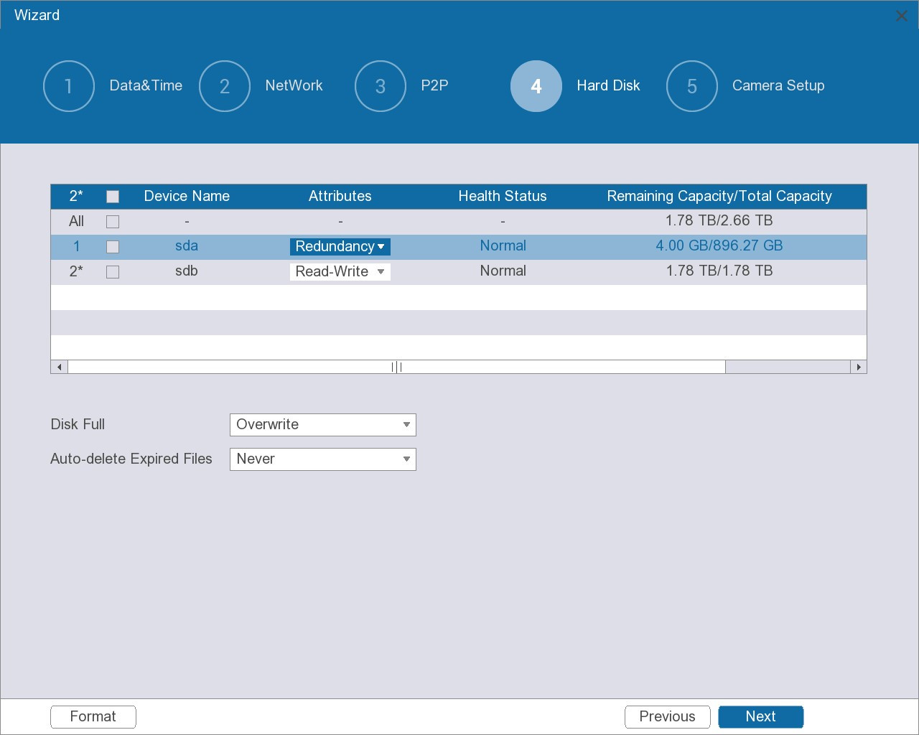
● Set HDD type.
In the Attributes column, select Read-Write, Read-only or Redundancy to set the HDD type.
● Format HDD.
Select an HDD, click Format, and then follow the on-screen prompt to format the HDD.
Formatting will erase all data on the HDD. Proceed with caution.
● Configure Disk Full and Auto-delete Expired Files.
Table 5-3 Disk management parameters
Parameter | Description
Disk Full | Configure the storage strategy to be used when no more storage space is available.  ● Stop: Stop Recording.  ● Overwrite: The newest files overwrite the oldest ones.
Auto-delete Expired Files | Configure whether to allow the Device to delete expired automatically.  ● Select Never if you do not want to use the function.  ● Select Custom and then configure how long you want to keep the old files.
Step 5 Connect remote devices.
You can add remote devices from search or add remote devices manually. This section uses adding from search as an example.
1) Click Search Device.
2) Select one or more remote devices from the search results, and then click Add in batches.
You can view the added devices on the page.
Figure 5-9 Remote device
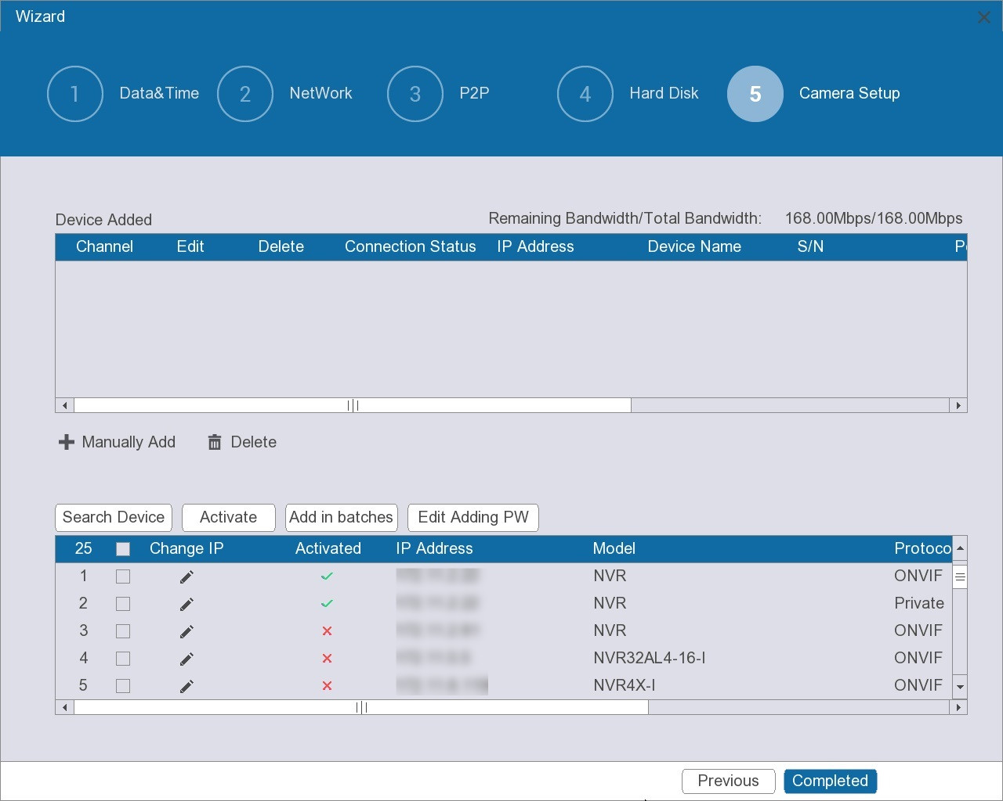
Step 6 Click Completed.

5.4 Login
Log in to the Device for more operations.
Procedure
Step 1 Click the live page.
● If you have configured unlock pattern, the unlock pattern login window is displayed. Click Forgot the Pattern to switch to password login.
● If you did not configure unlock pattern, the password login window is displayed.
● You can click Switch User to enter the password login window.
Step 2 Log in to the Device.
● Draw the unlock pattern.
Figure 5-10 Unlock pattern login
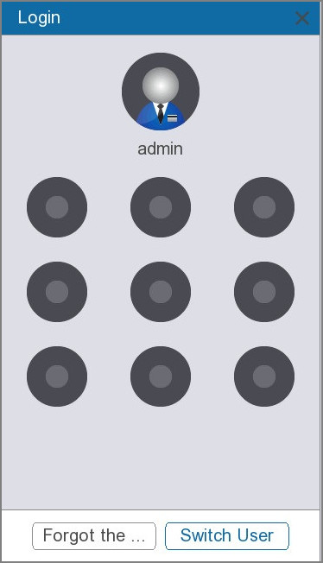
● Enter the password, and then Click OK.
Figure 5-11 Password login
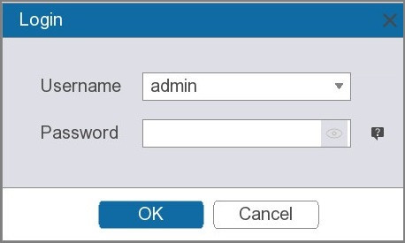
If you forget your password, click to reset the password.

5.5 Live View
On the live view page, you can view the video images of different channels.
Select a window, double-click a channel in the channel list, and then the channel will be displayed in the selected window.
The number of channels might vary depending on the model you are using.

5.5.1 Live View Control Bar
Point to the bottom middle of a channel window, and then the live control bar appears. Through the control bar, you can perform the operations such as instant playback, local zoom, manual snapshot, intercom, stream switching, and PTZ control.
Figure 5-12 Live view control bar
Table 5-4 Live view control bar description
Icon | Function | Description
 | Instant playback | You can play back the previous five minutes to sixty minutes of the recorded video.  Go to System > General > Basic Configuration to configure the length of time for instant playback.
 | Local zoom | ● Click the icon, and then select an area. The area is enlarged after you release the mouse button.  ● Point to the area that you want to enlarge or shrink and then scroll the mouse to zoom in or zoom out.  Right-click the channel window to return to the original status.
 | Manual snapshot | Take snapshots of the current video channel. The snapshots are automatically saved to the connected USB storage device.
 | Intercom | Enables voice interaction between the Device and remote devices.  This function is available only when the remote device supports bidirectional talk.
 | E-Tracking | Click the icon to enable the E-Tracking function, and then you can view local E-Tracking live videos.
 | Stream switching | Switch between the main stream and sub stream.  ● M: Main stream. Suitable for local recording and storage to achieve high-definition surveillance.  ● S: Sub stream. Suitable for network transmission when network bandwidth is limited.
 | PTZ Control | Open the PTZ Settings window.

5.5.2 Navigation Bar
At the bottom right side of the live page, you can access the functions to perform operations through the function icons on the navigation bar.
Figure 5-13 Navigation bar
Table 5-5 Navigation bar description
Icon | Description
 | Go to the next screen.
 | Go to the previous screen.
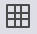 | Select view split mode.
 | Enable or disable auto switch.
 | Click the icon, and you can enter the full screen mode.
 | Click the icon, and you can restore the sequence of channel windows.
 | Click the icon, and you can switch back and forth between the auxiliary screen and the home screen.

5.5.3 Shortcut Menu
Right-click the live page, and then the shortcut menu appears. You can enter into the full screen mode, and then select a view split mode.
Figure 5-14 Shortcut menu
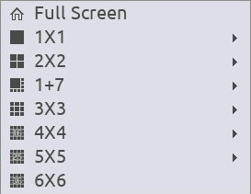

5.5.4 PTZ
PTZ is a mechanical platform that carries a camera and a protective cover and performs overall control remotely. A PTZ can move horizontally and vertically to provide all-around view to the camera.

5.5.4.1 Operating PTZ Control Panel
You can click on the live view control bar, and the PTZ control panel appears.
Figure 5-15 PTZ control panel
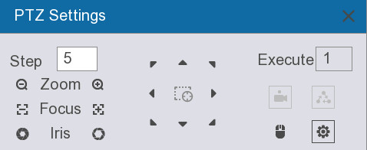
Table 5-6 PTZ control panel description
Parameter | Description
Step | The bigger the value, the faster the PTZ movement speed.
Zoom | ● : Zoom out.  ● : Zoom in.
Focus | ● : Focus far.  ● : Focus near.
Iris | ● : Image darker.  ● : Image brighter.
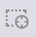 | Fast positioning button.  ● Positioning: Click the icon, and the click any point on the live page. The PTZ will turn to this point and locate this point in the center.  ● Zooming: Click the icon, and then drag to draw a square on the view. The square supports zooming.  ◇ Dragging upward is to zoom out, and dragging downward is to zoom in.  ◇ The smaller the square, the larger the zoom effect.  This function is available on select models.
 | Enable direction control through mouse operation.
 | Enable the preset point.
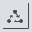 | Enable the patrol group.
 | Click the icon, and you can set parameters of Preset Point and Patrol Group.

5.5.4.2 Configuring PTZ Functions

5.5.4.2.1 Configuring Presets
Procedure
Step 1 On the PTZ control panel, click , and then select Preset Point.
Figure 5-16 Preset
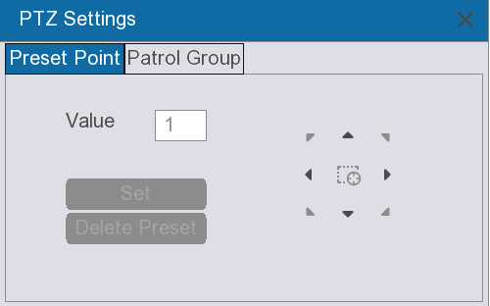
Step 2 Click the direction arrows to rotate the camera to a desired position.
Step 3 Enter a number to represent the preset point.
Step 4 Click Set to complete settings.

5.5.4.2.2 Configuring Patrol Group
Procedure
Step 1 On the PTZ control panel, click , and then select Patrol Group.
Step 2 Click the direction arrows to rotate the camera to a desired position.
Step 3 Enter a patrol number.
Step 4 Enter a number for the preset point, and then click Set.
A preset point is set for this patrol. You can continue to set more presets.
Click Delete Preset to delete the preset. Some protocols do not support deleting.

5.5.4.3 Using PTZ Functions
After you have configured the PTZ settings, you can use the PTZ functions from the PTZ control panel.

5.5.4.3.1 Using Presets
Procedure
Step 1 On the PTZ control panel, in the Execute box, enter the preset number.
Step 2 Click to call the preset.
Step 3 Click again to stop calling.

5.5.4.3.2 Using Patrol Groups
Procedure
Step 1 On the PTZ control panel, in the Execute box, enter the patrol number.
Step 2 Click to call the patrol group.
Step 3 Click again to stop calling.

5.6 Main Menu
After logging in, you can directly see the Live page, and you can select tiles in the top middle of the Live page as required to enter the corresponding configuration pages.
Figure 5-17 Main menu
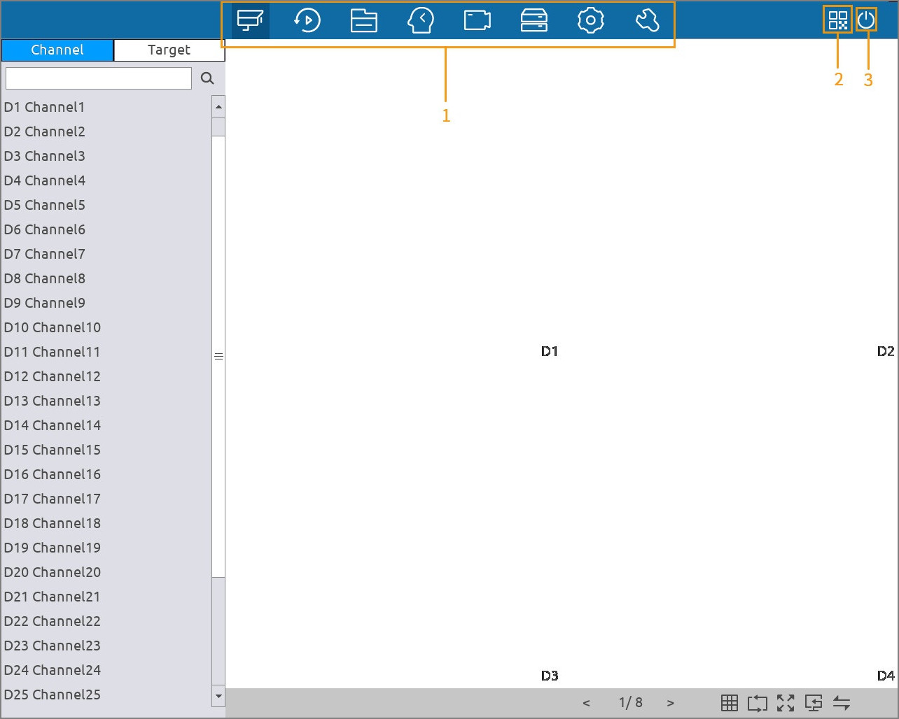
Table 5-7 Main menu description
No. | Name | Description
1 | Function tiles | Click the selected tile to open the corresponding configuration page.
2 | QR code | Scan the QR code under to add the Device for remote management.
3 | Shutdown | Log out of the current account, restart or shut down the Device.

5.7 Playback

5.7.1 Instant Playback
You can quickly view the recorded video of previous 5 to 60 minutes from the live view control bar. For details on instant playback, see "5.5.1 Live View Control Bar".

5.7.2 Playback Page
Click Playback. The Playback page is displayed.
The following figure is for reference only.
Figure 5-18 Playback
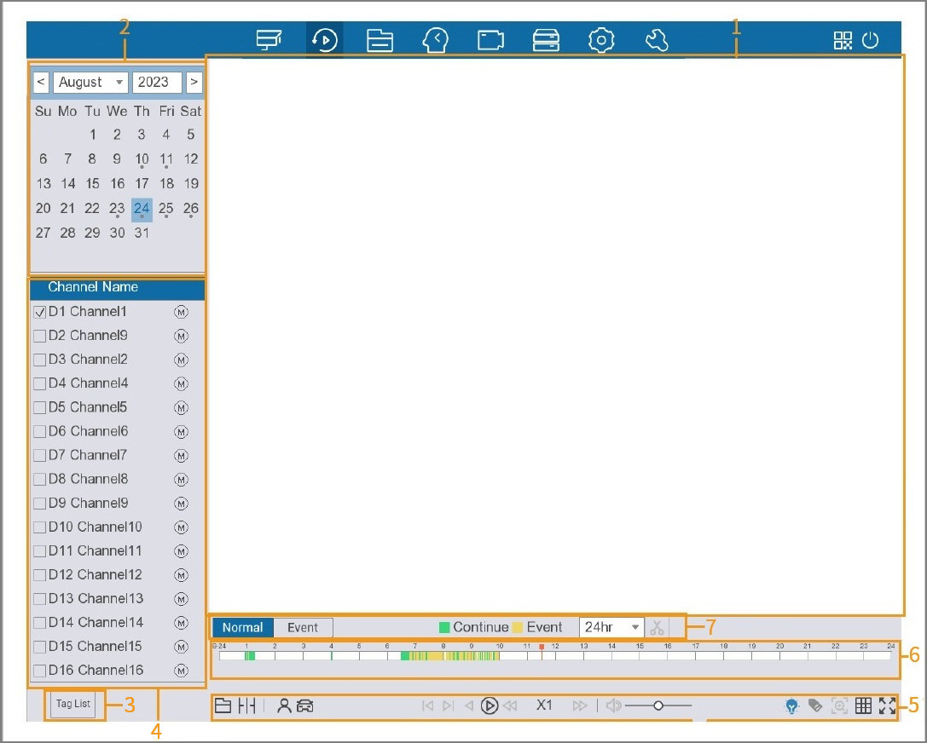
Table 5-8 Playback page description
No. | Function | Description
1 | Display window | Displays the recorded video. It supports playing in single-channel or multi-channel mode.  ● The display window defaults to displaying in the single-channel mode.  ● Click  to split the display window as required.  ● When playing back in the single-channel mode, click and hold to select an area that you want to enlarge, and then release to enlarge the selected area. To exit the enlarged status, right-click on the image.
2 | Calendar | Select the search time.  The selected date is highlighted.  appears below the date with the recorded video.
3 | Tag list | View and manage the tagged videos found after search.
4 | Channel list | On the channel list, select one or more channels to play back.  ● The window split is decided by the number of selected channels. If you select one channel, the playback is displayed in the single-channel view; if you select two to four channels, the playback is displayed in the four-channel view.  ● Click  or switch the streams.  ◇ : Main stream.  ◇ : Sub stream.
5 | Playback controls bar | Playback control buttons. See "5.7.3 Playback Controls" for detailed information.
6 | Time Bar | Displays the type and time period of the current recorded video.  ● In the 4-channel layout, four time bars are displayed; in the other view layouts, only one time bar is displayed.  ● Click the colored area to start playback from a certain time.  ● Scroll on the time bar, and then the time bar zooms in.  ● Click and hold the time bar. When the mouse pointer changes to a hand icon, you can drag to view the playback of the target time.  ● You can drag the vertical line on the time bar to rapidly view the playback in I-frame format.  ● When playing back video in the single-channel mode, you can point to time bar to display thumbnail images for the current video.
7 | Record type | Select the recording type to search for.  ● Normal displays all recordings.  Green represents general recordings on the time bar.  ● Event displays motion recordings, alarm recordings, and smart recordings.  Yellow represents event recordings on the time bar.
 | Time bar unit | Select 24hr, 2hr, 1hr, or 30min as the unit of time bar.
 | Clip | Click to clip the recorded recording and then save specified footages.

5.7.3 Playback Controls
You can search for and play back videos, images or video clips. The operations are similar. This section uses video playback as an example.
Procedure
Step 1 Select Playback, and then click  to play the recording from the external device.
Step 2 Select the Normal or Event as the search type.
Step 3 Select the date, channel.
Step 4 Click or any position on the time bar.
The system starts playback. You can operate the playback controls to control the playback process.
Figure 5-19 Playback controls
Table 5-9 Playback controls description
Icon | Function
Click the icon to play the recording from the external device.
Click to exit the current playback mode.
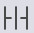 | Click the icon to split the recordings of one day as required, and then display them on the display window.  Click to exit the current playback mode.
 | Select a target type for smart playback. You can select Human or Vehicle.
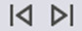 | Displays previous frame/next frame.  ● When the playback is paused, click or 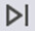 to play back the video frame by frame.  ● In frame by frame playback mode, click to resume normal playback mode.
Rewind.
● In normal play mode, click the icon the rewind the video.
● In rewinding mode, click  to resume normal playback mode.
 | Click the icon the play the video. Click again to stop.
 | Stop the current playback process.
Slow playback.
● In normal playback mode, click the icon to set the speed of slow playback.
● In fast playback mode, click the icon to slow down the speed of fast playback.
Fast playback.
● In normal playback mode, click the icon to set the speed of fast playback.
● In slow playback mode, click the icon to speed up slow playback.
 | Adjust the volume of playback video.
 | Click the icon to display or hide AI rules.
 | Click the icon to tag the video.
 | Click the icon to enable smart playback.
 | Click the icon to display 1, 4, 9 or 16 videos on the display window.
 | Click the icon to enter the full screen mode.

5.7.4 Quick Search
When playing back videos, the Device can detect motion event in the defined region on the video image. The system will display the video footages with motion events.
Prerequisites
Go to System > Video Detection > Motion Detection to enable motion detection.
Procedure
Step 1 Select Playback.
Step 2 Set the search conditions and play back the video of a channel. For details, see "5.7.3 Playback Controls".
Smart playback is available only in the single-channel mode. If you select multiple channels, double-click the channel window to display this channel only on the screen.
Step 3 Click 
Step 4 Set the detection area.
Step 5 Click to view the video footages with motion detected.
Step 6 Click again to display all recordings.
● The motion detection area must not be the full screen.
● You cannot change the time bar unit, play backward, or play frame by frame are null when the Device is playing motion detection footages.

5.7.5 Clip
During playback, you can clip sections of videos and save to the USB storage device.
Procedure
Step 1 Select Playback.
Step 2 Set the search criteria and play back video. For details, see "5.7.3 Playback Controls".
Step 3 Click the time bar to select the start time, and then click .
Step 4 Click the time bar to select the end time, and then click .
Step 5 Click  to save the file.

5.7.6 Tag Playback
When you are playing back a video, you can add a tag to mark an important point in time of the video. After playback, you can use time or the tag keywords to search for the corresponding video and then play.
Adding Tag
When system is playing back, click , and then configure the tag name.
Playing back Tag
During single-channel playback, click 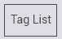, and then on the tag list, double-click a file to play back.
Managing Tags
On the tag list, click .
Figure 5-20 Tag management
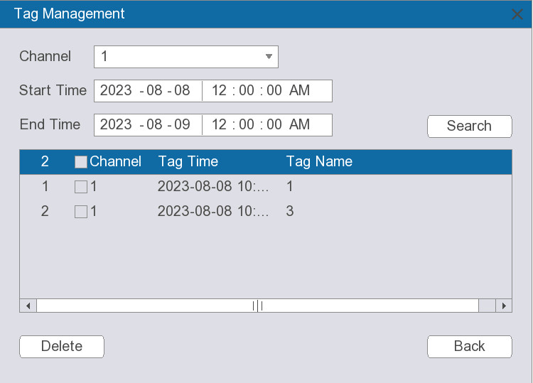
● To search for the tagged video, select channel number, start time and end time, and then click Search.
● To change the tag name, double-click a tagged video, and then enter the new name.
● To delete tags, select one or more tagged videos, and then click Delete.

5.8 File Search
You can search videos, pictures, smart events, and smart reports.

5.8.1 Searching for Video
Procedure
Step 1 Select File Search > Video, and then select Search by Time or Search by Event as required.
Step 2 Set parameters, and then click Search.
You can click Clear to clear the completed information.
The search results are displayed on the bottom of the page, and you can back up them.
Figure 5-21 Search by event
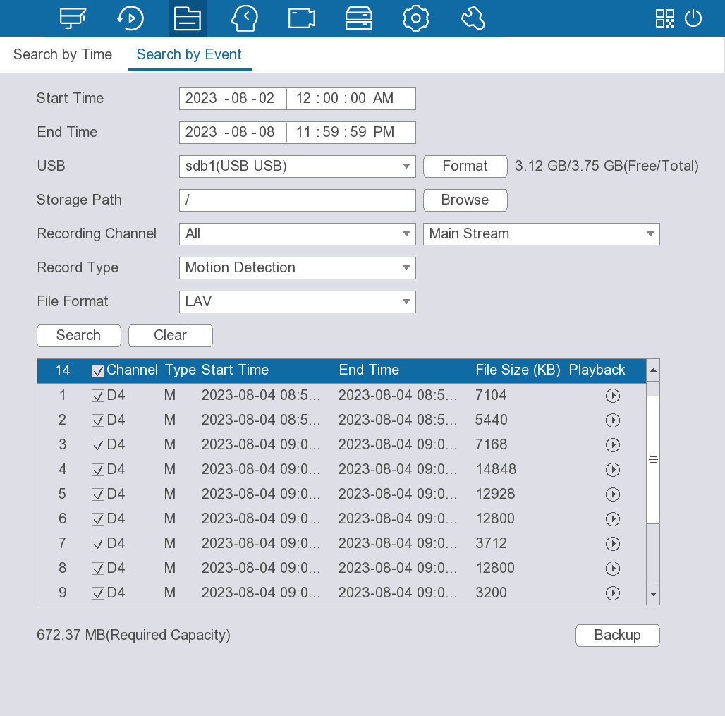
Table 5-10 Video search parameters
Parameter | Description
Start Time | Configure the start time and end time for the video search.
End Time
USB | Select a USB from the drop-down list.  Click Format to format the USB.
Storage Path | Click Browse to select the storage path.
Recording Channel | Select the recording channel, and then select Main Stream or Sub Stream as required.
Record Type | Select the record type as required.  Supports selecting All, External Alarms, Motion Detection, Continues Recording, or VCA.
File Format | Select the file format as required.  Supports selecting LAV or MP4.

5.8.2 Searching for Picture
Procedure
Step 1 Select File Search > Picture.
Step 2 Set parameters, and then click Search.
You can click Clear to clear the completed information.
The search results are displayed on the bottom of the page, and you can back up them.
Figure 5-22 Search for picture
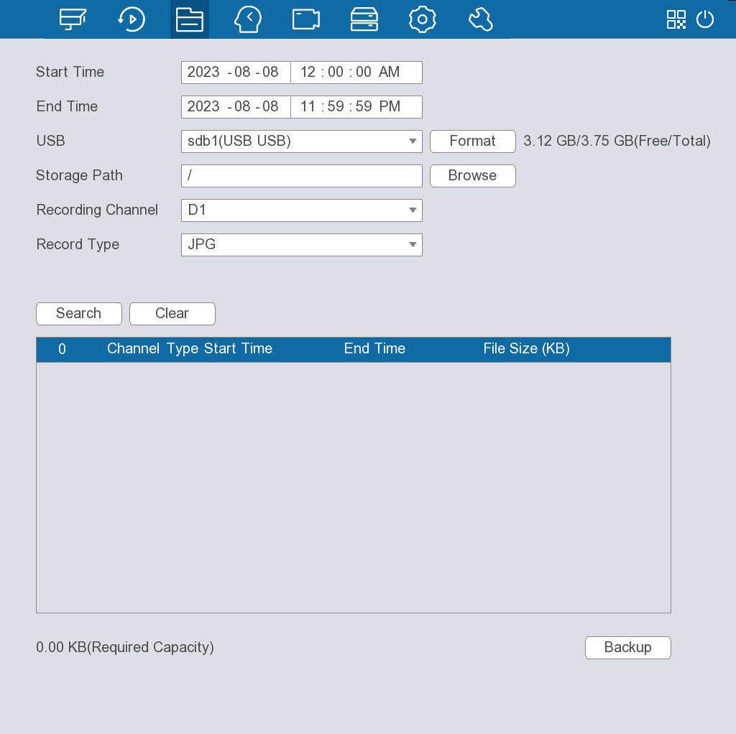
Table 5-11 Video search parameters
Parameter | Description
Start Time | Configure the start time and end time for the picture search.
End Time
USB | Select a USB from the drop-down list.  Click Format to format the USB.
Storage Path | Click Browse to select the storage path.
Recording Channel | Select the recording channel.
Record Type | Select the record type as required.  Only supports selecting JPG.

5.8.3 Smart Search
Supports face search, VCA search, LPR search, and MD2.0 search.

5.8.3.1 Face Search

5.8.3.1.1 Face Detection
You can search for and play back detected faces.
Procedure
Step 1 Select File Search > Smart Search > Face Search > Face Detection.
Figure 5-23 Face detection
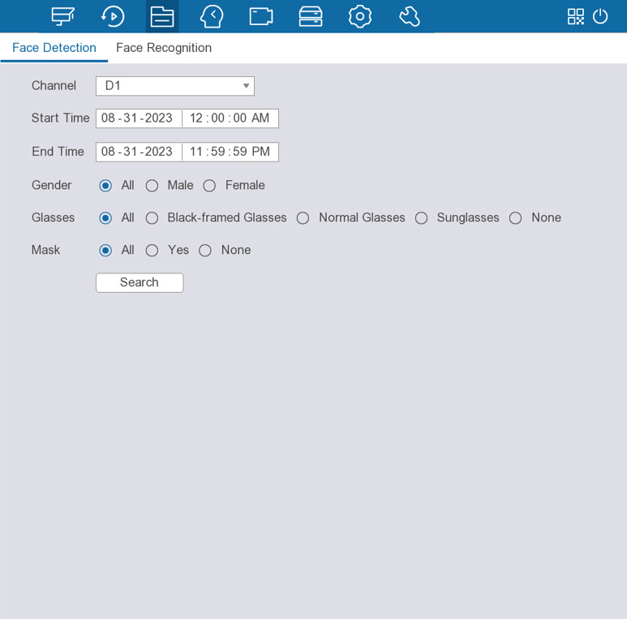
Step 2 Select a channel, set the search period, and then select the attributes.
You can select one or more channels, or select All.
Step 3 Click Search.
The results are displayed.
Related Operations
● Play.
Select an image and then click  to play back.
Double-click the playing image to switch between full-screen playing and thumbnail playing.
● Sort.
Click to sort the images by time.
● Export.
Click to export the search results in an Excel document.
● Back up.
Select one or more images, click , and then select the storage path.
● Add tag.
Select one or more images, and then click .

5.8.3.1.2 Face Recognition
You can search for the face recognition results by attributes or by image.
Search by Attributes
Procedure
Step 1 Select File Search > Smart Search > Face Search > Face Recognition.
Figure 5-24 Search by attributes
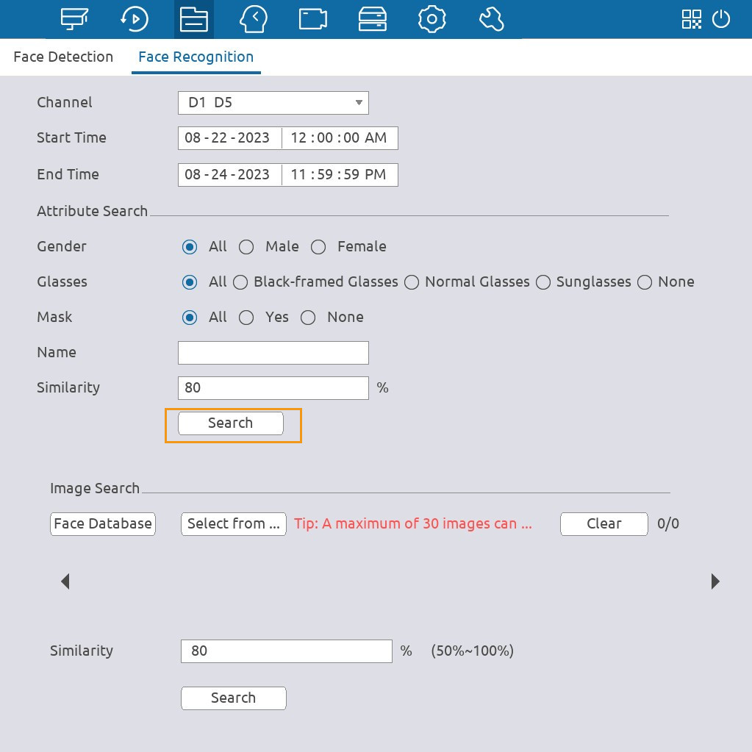
Step 2 Select a channel, set the search period, and then select the attributes including gender, glass, mask, name and similarity.
You can select one or more channels, or select All.
Step 3 Click Search in the Attribute Search section.
The results are displayed.
The faces in the image are intentionally blurred for privacy protection. The actual images are clear.
Figure 5-25 Search results
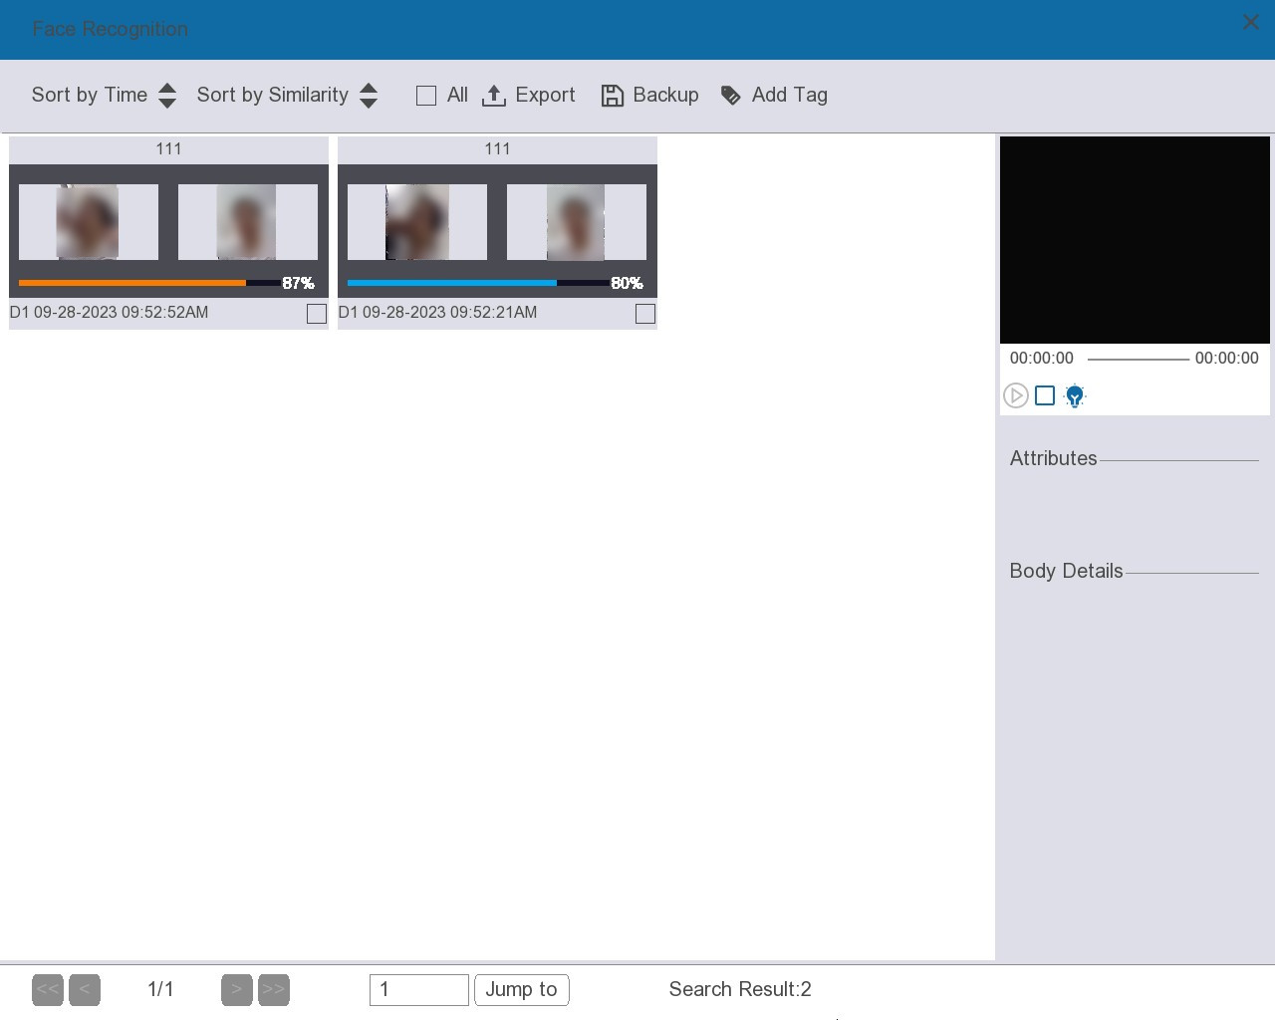
Related Operations
● Play.
Select an image and then click to play back.
Double-click the playing image to switch between full-screen playing and thumbnail playing.
● Sort.
Click to sort the images by time or similarity.
● Export.
Click to export the search results in an Excel document.
● Back up.
Select one or more images, click , and then select the storage path.
● Add tag.
Select one or more images, and then click .
Search by Image
Procedure
Step 1 Select File Search > Smart Search > Face Search > Face Recognition.
Figure 5-26 Search by image
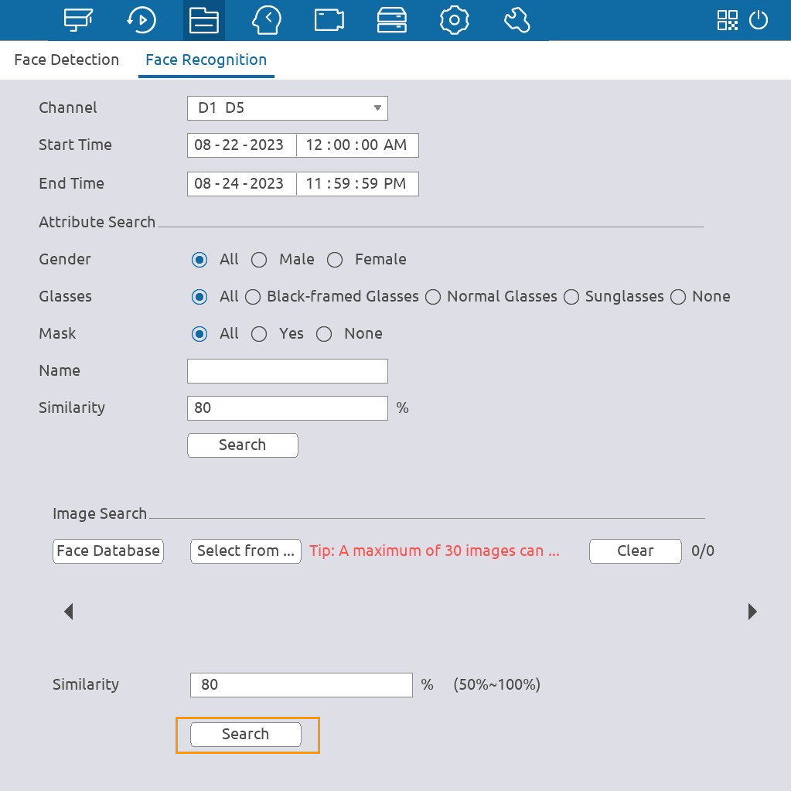
Step 2 Select a channel, and then set the search period.
You can select one or more channels, or select All.
Step 3 Upload face images.
● Face Database: Upload face images from database.
● Select from Local: Upload face images from external storage device.
Step 4 Select the image used to search, and select the similarity.
Step 5 Click Search in the Image Search section.
The results are displayed.
Related Operations
● Play.
Select an image and then click to play back.
Double-click the playing image to switch between full-screen playing and thumbnail playing.
● Sort.
Click to sort the images by time or similarity.
● Export.
Click to export the search results in an Excel document.
● Back up.
Select one or more images, click , and then select the storage path.
● Add tag.
Select one or more images, and then click .

5.8.3.2 VCA Search
You can search for the VCA detection results.
Procedure
Step 1 Select File Search > Smart Search > VCA Search.
Figure 5-27 VCA search
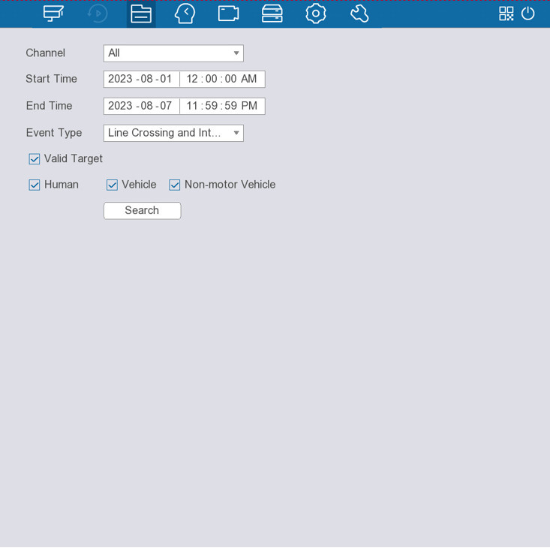
Step 2 Select a channel, and then set the start time and end time.
You can select one or more channels, or select All.
Step 3 Select an event type.
Step 4 Click Search.
The results are displayed.
Figure 5-28 Search results
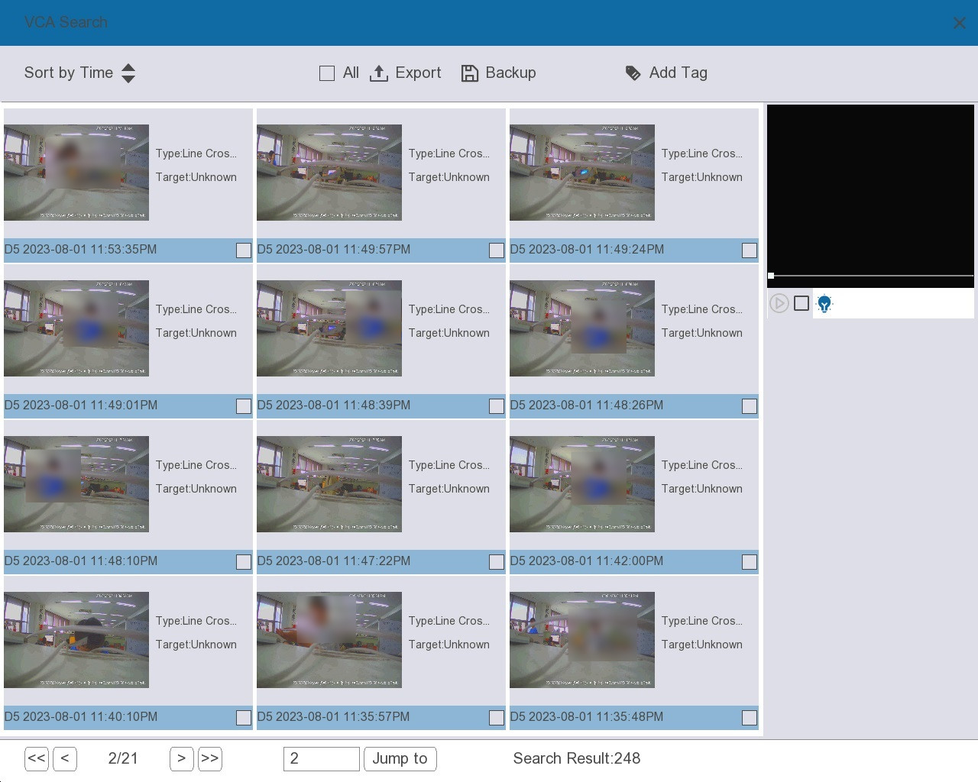
Related Operations
● Play.
Select an image and then click to play back.
● Sort.
Click to sort the images by time.
● Export.
Click to export the search results in an Excel document.
● Back up.
Select one or more images, click , and then select the storage path.
● Add tag.
Select one or more images, and then click .

5.8.3.3 LPR Search
You can search for the license plate results.
Procedure
Step 1 Select File Search > Smart Search > LPR Search.
Figure 5-29 LPR search
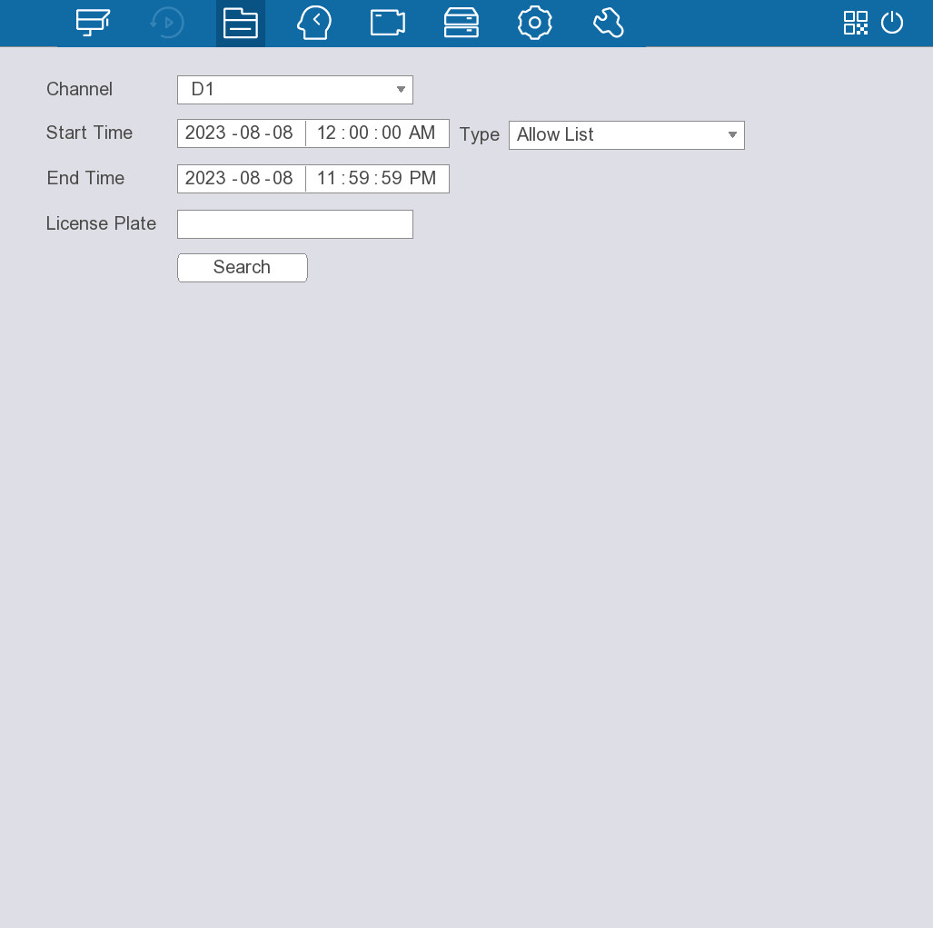
Step 2 Select a channel, and then select the target type from Allow List, Block List, Standard, or All.
You can select one or more channels, or select All.
Step 3 Set the start time and end time.
Step 4 Click Search.
The results are displayed.
Related Operations
● Play.
Select an image and then click to play back.
● Sort.
Click to sort the images by time.
● Export.
Click to export the search results in an Excel document.
● Back up.
Select one or more images, click , and then select the storage path.
● Add tag.
Select one or more images, and then click .

5.8.3.4 MD2.0 Search
You can search for the motion detection results.
Procedure
Step 1 Select File Search > Smart Search > MD2.0 Search.
Figure 5-30 MD2.0 search
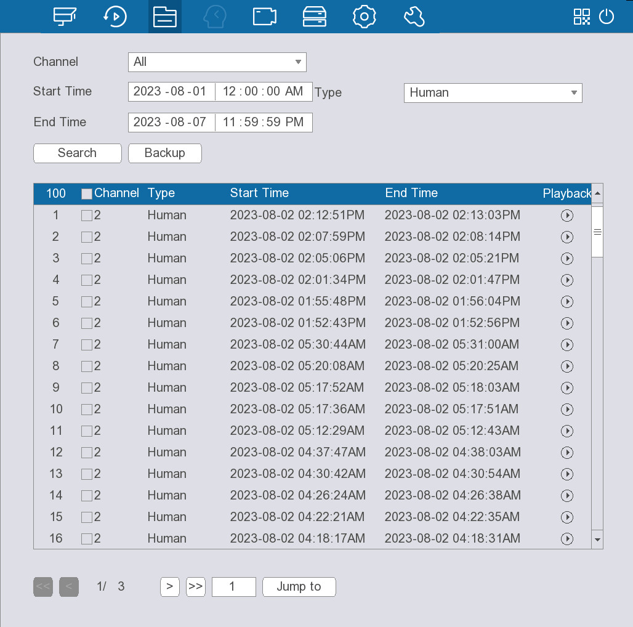
Step 2 Select a channel, and then select the target type from All, Human and Vehicle.
You can select one or more channels, or select All.
Step 3 Set the start time and end time.
Step 4 Click Search.
The results are displayed.
Related Operations
● Play.
Select an event, and then click to play back.
● Back up.
Select one or more events, click Backup, and then select the storage path to back up the search result.

5.8.4 Smart Report

5.8.4.1 People Counting
Procedure
Step 1 Select File Search > Smart Report > People Counting.
Figure 5-31 People counting
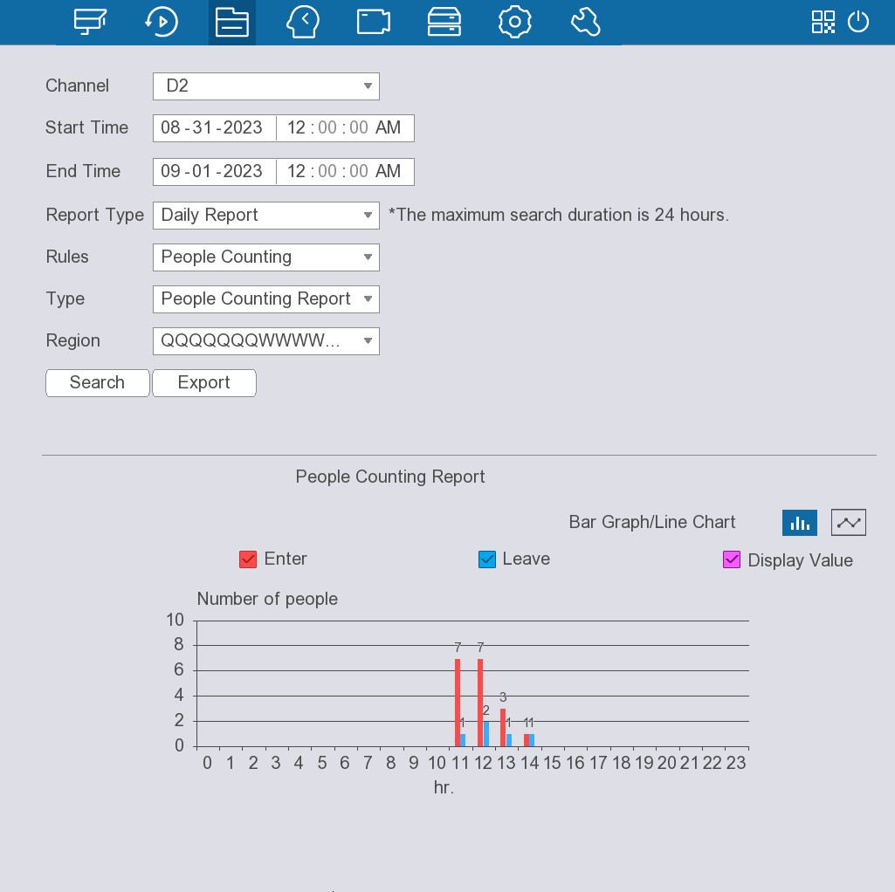
Step 2 Select a channel, set the search period, and then select the rules and the report type.
● You can select People Counting or Regional People Counting from Rules.
● You can select Daily Report, Monthly Report or Yearly Report from Report Type.
Step 3 Set Type to People Counting Report.
Step 4 Click Search.
The results are displayed.
Related Operations
● Export.
Click Export to export the search results in an Excel document.
● 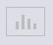
Click the icon to display the results in a bar graph.
● 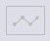
Click the icon to display the results in a line chart.

5.8.4.2 Heat Map
Procedure
Step 1 Select File Search > Smart Report > Heat Map.
Figure 5-32 Heat map
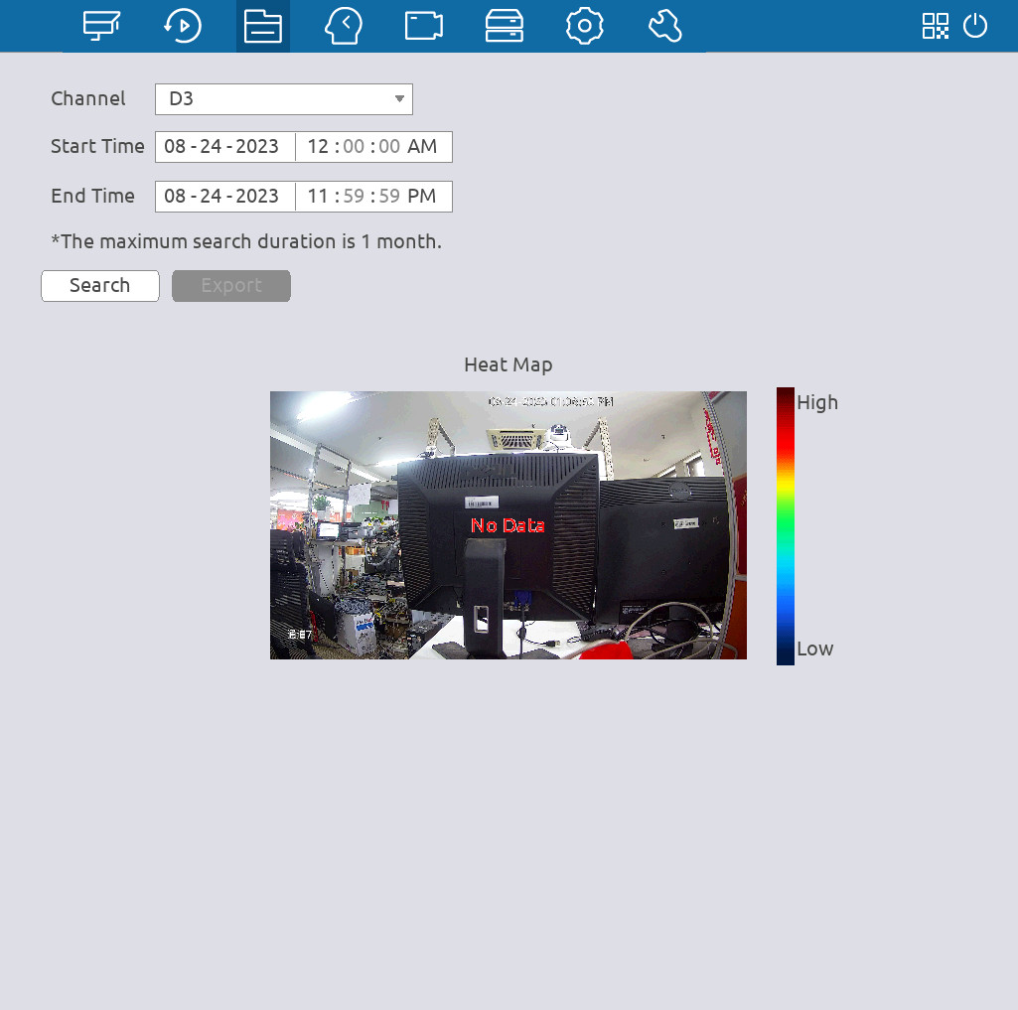
Step 2 Select a channel, and then set the search period.
Step 3 Click Search.
The results are displayed.
Related Operations
Export.
Click Export to export the search results in an Excel document.

5.9 Smart Analysis

5.9.1 VCA Settings

5.9.1.1 VCA Option
To use face detection, VCA and other smart functions supported by the smart network cameras, you need to enable the corresponding smart plan.
Procedure
Step 1 Select Smart Analysis > VCA Settings > VCA Option.
Step 2 Select a channel.
The system displays the smart functions available on the connected camera.
The smart functions available are different depending on the camera.
Figure 5-33 VCA option
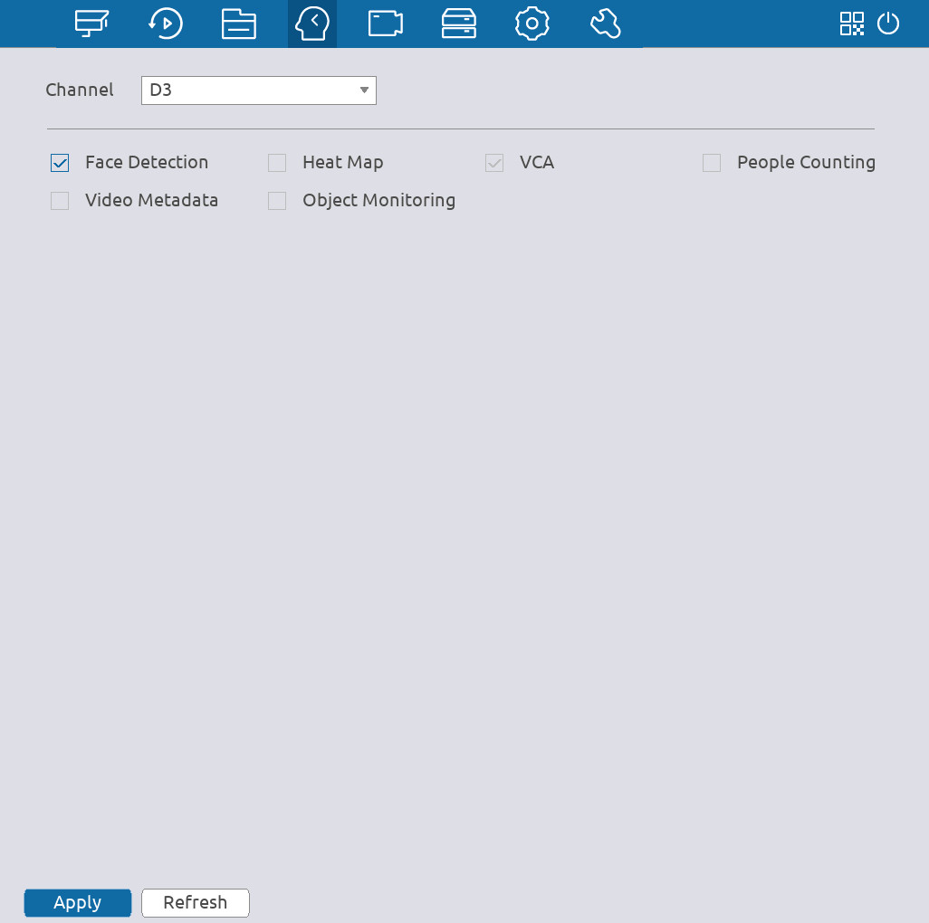
Step 3 Click the checkbox next to the corresponding the smart plan to enable it.
If the channel is connected to a PTZ camera, you can set smart functions separately for each preset point.
Step 4 Click Apply.

5.9.1.2 Configuring Face Detection
Configure alarm rule of face detection. An alarm is triggered when human faces are detected in the detection area.
Procedure
Step 1 Select Smart Analysis > VCA Settings > Face Detection.
Figure 5-34 Face detection
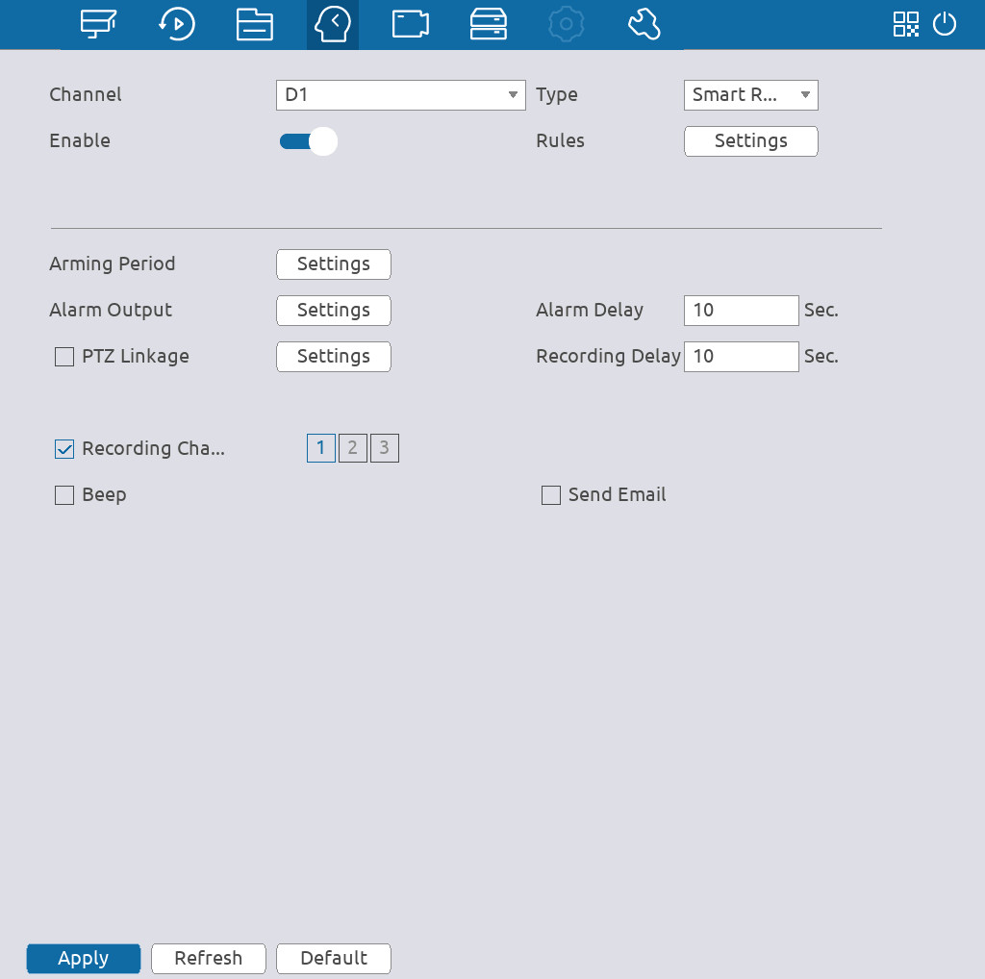
Step 2 Select a channel, and then click 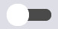 to enable the face detection.
Step 3 Select Smart Recorder Function in the Type list.
Step 4 Click Settings next to Rules to draw the minimum size or maximum size to filter the target.
The system triggers an alarm when the size of detected target is between the maximum size and the minimum size.
Figure 5-35 Draw rules
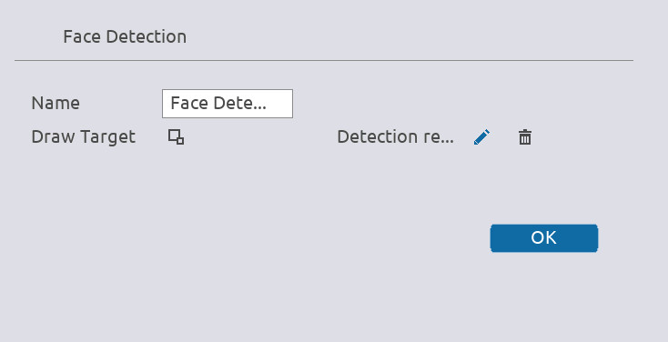
Step 5 Click Settings next to Arming Period to configure the arming period.
The arming period is highlighted. There are two ways to configure the period.
● Drag on the time line to define the period. You can click the blue part to disarm the period.
Figure 5-36 Arming period (1)
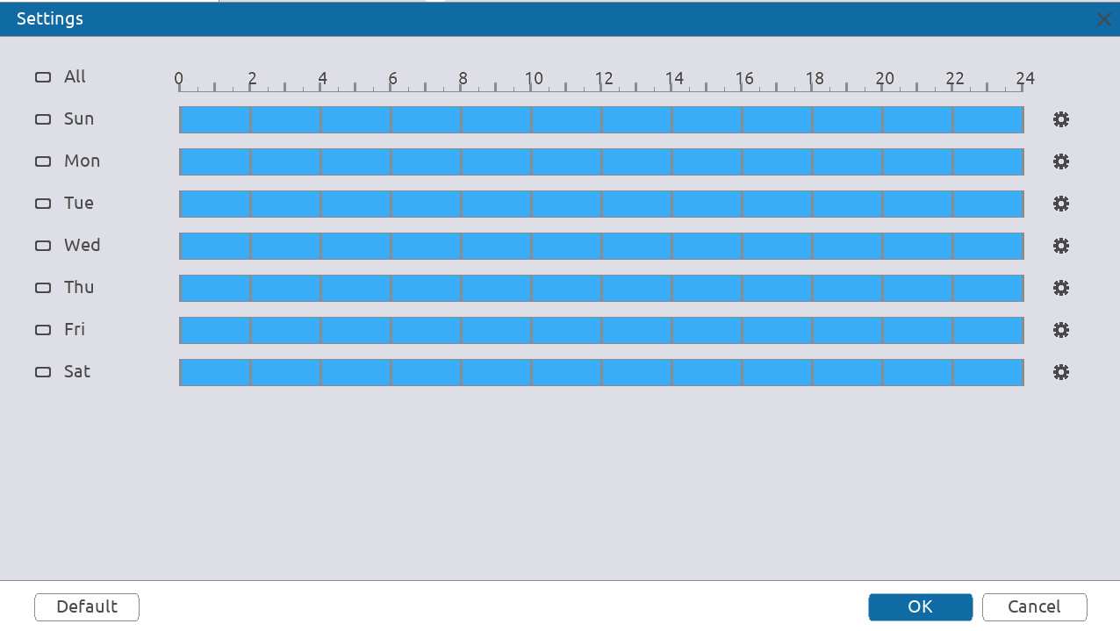
● Click to define the arming period for each day in a week.
◇ There are six periods for you to set for each day.
◇ Under Copy to, select All to apply the settings to all the days of the week, or select specific days that you want to apply the settings to.
Figure 5-37 Arming period (2)
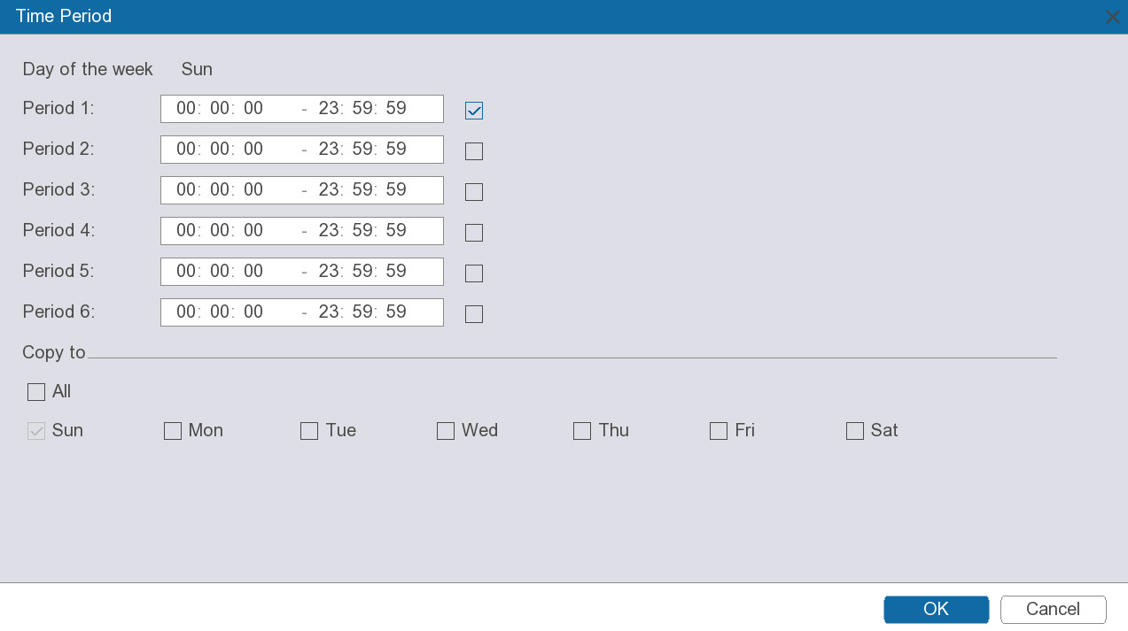
Step 6 Configure the alarm linkage.
Table 5-12 Alarm linkage
Parameter | Description
Alarm Output | Click Settings next to Alarm Output, click to enable the local alarm, and then select alarm output port as required.  Make sure that the alarm state of the alarm output port has been configured. For details, see "5.12.4.3.3 Configuring Alarm Output".
PTZ Linkage | Select the checkbox, and then click Settings to configure PTZ linkage.  Make sure that the PTZ control has been configured. For details, see "5.5.4 PTZ".
Recording Channel | Select the checkbox, and then select one or more channels for recording.  Make sure that the recording plan and recording mode has been configured in Storage > Recording Plan > Video Recording.
Beep | Select the checkbox to enable the device to make a beep noise when an alarm occurs.
Alarm Delay | When alarm delay is configured, alarm continues for an extended period after the alarm ends.
Recording Delay | Configure the length of time for the device to continue recording after the alarm ends.
Send Email | Enable the system to send an email to notify you of an alarm event.  ● This function is available on select models.  ● Make sure that the email function has been configured in System > Network > Basic > Email.
Step 7 Click Apply.

5.9.1.3 Configuring Face Recognition
Procedure
Step 1 Select Smart Analysis > VCA Settings > Face Recognition.
Figure 5-38 Face recognition
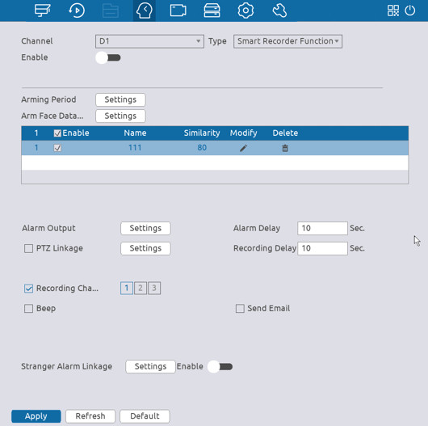
Step 2 Select the channel, and then click 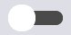 to enable the function.
Step 3 Select Smart Recorder Function in the Type list.
Step 4 Click Setting next to Arming Period to configure arming periods. The corresponding alarm actions are linked by the alarm events triggered during armed period.
Step 5 Configure the alarm mode.
1) General mode.
The alarm is triggered when the similarity of detected faces reaches the defined value.
a. Click Setting next to Arm Face Database.
b. Select the face database that you want to arm, and then click OK.
c. Click to modify similarity.
d. Configure the alarm linkage.
Table 5-13 Alarm linkage
Parameter | Description
Alarm Output | Click Settings next to Alarm Output, click to enable the local alarm, and then select alarm output port as required.  Make sure that the alarm state of the alarm output port has been configured. For details, see "5.12.4.3.3 Configuring Alarm Output".
PTZ Linkage | Select the checkbox, and then click Settings to configure PTZ linkage.  Make sure that the PTZ control has been configured. For details, see "5.5.4 PTZ".
Recording Channel | Select the checkbox, and then select one or more channels for recording.  Make sure that the recording plan and recording mode has been configured in Storage > Recording Plan > Video Recording.
Beep | Select the checkbox to enable the device to make a beep noise when an alarm occurs.
Alarm Delay | When alarm delay is configured, alarm continues for an extended period after the alarm ends.
Recording Delay | Configure the length of time for the device to continue recording after the alarm ends.
Send Email | Enable the system to send an email to notify you of an alarm event.  ● This function is available on select models.  ● Make sure that the email function has been configured in System > Network > Basic > Email.
2) Stranger mode.
The alarm is triggered when the similarity of detected faces does not reach the defined value.
a. Click enable the function.
b. Click Settings next to Stranger Alarm Linkage, and then configure the alarm linkage actions. For details on alarm linkage, see Table 5-13.
Step 6 Click Apply.

5.9.1.4 Configuring VCA
Background Information
Configure VCA alarm rules. An alarm is triggered when the system detects a certain behavior.
Table 5-14 VCA functions
Function | Description | Scene
Cross Fence | When the target crosses the warning line toward the defined direction, an alarm is triggered and then the system performs configured alarm linkages. | Scenes with median strips such as roads, and airports.
Line crossing and intrusion | When the target crosses the tripwire from the defined motion direction, an alarm is triggered, and then the system performs configured alarm linkages. | Scenes with sparse targets and no occlusion among targets, such as the perimeter protection of unattended area.
Abandoned Object | When an object is abandoned in the detection area longer than the configured time, an alarm is triggered, and then the system performs configured alarm linkages. | Scenes with sparse targets and without obvious and frequent light change. Simple scene in the detection area is recommended.  ● Missed alarm might increase in the scenes with dense targets, frequent occlusion, and people staying.  ● In scenes with complex foreground and background, false alarm might be triggered for abandoned or missing object.
Missing Object | When an object is taken out of the detection area over the defined time, an alarm is triggered, and then the system performs configured alarm linkages.
Parking Detection | When the vehicle stays in the detection area longer than the configured duration, an alarm is triggered, and then the system performs configured alarm linkages. | Road monitoring and traffic management.
People Gathering | When people gather and stay in the detection area longer than the defined duration, an alarm is triggered, and then the system performs configured alarm linkages. | Scenes with medium or long distance, such as outdoor plaza, government entrance, station entrance and exit. It is not suitable for short-distance view analysis.
Fast Moving | When the target moves fast in the detection area, an alarm is triggered, and then the system performs configured alarm linkages. | Scenes with sparse targets and less occlusion. The camera should be installed right above the monitoring area. The light direction should be vertical to the motion direction.
Loitering Detection | When the target loiters over the shortest alarm time, an alarm is triggered, and then the system performs configured alarm linkages. | Scenes such as park and hall.
In this section, line crossing and intrusion acts as an example of how to configure the VCA rules.
Procedure
Step 1 Select Smart Analysis > VCA Settings > VCA.
Figure 5-39 VCA
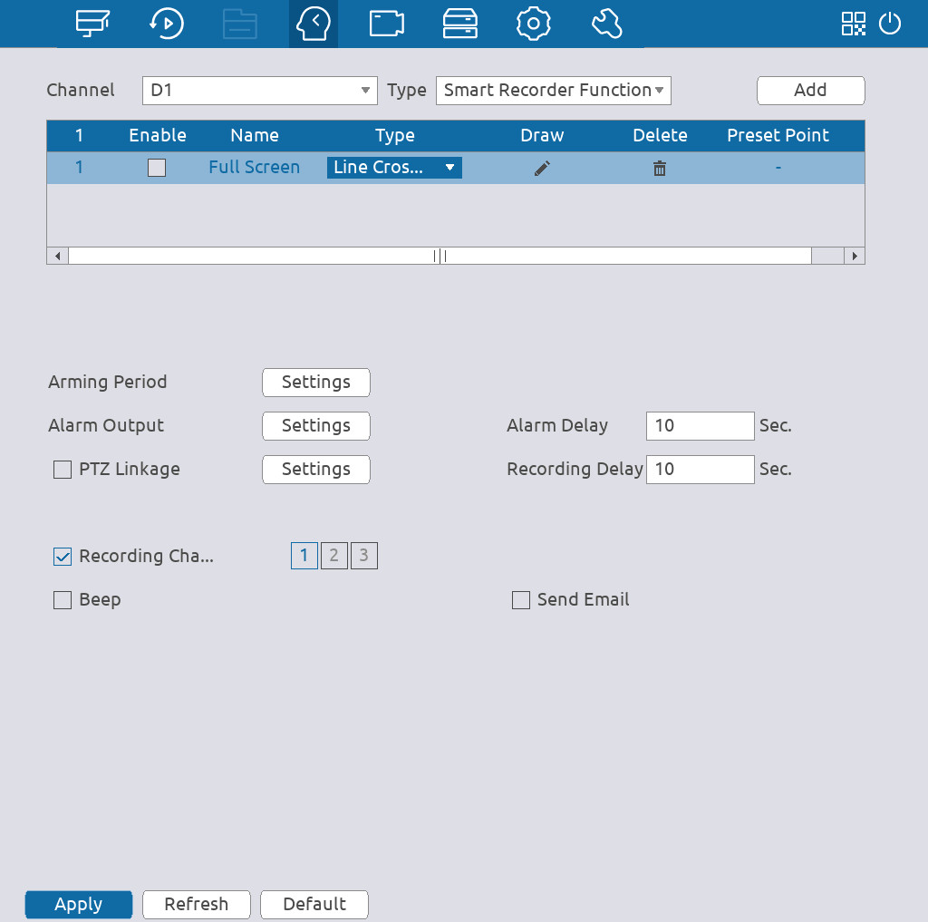
Step 2 Select a channel, select Smart Recorder Function in the Type list, and then click Add to add a rule.
Step 3 Configure the rule.
1. In the Type column, select Line crossing and intrusion.
2. Click .
Figure 5-40 Line crossing and intrusion
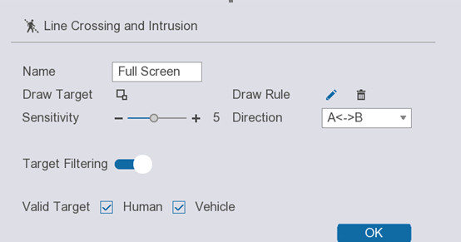
3. Configure the parameters.
Table 5-15 Line crossing and intrusion parameters
Parameter | Description
Name | Enter the rule name.
Draw Target | Click to draw the minimum size or maximum size to filter the target.  The system triggers an alarm only when the size of detected target is between the maximum size and the minimum size.
Draw Rule | Drag to draw a line. The line can be a straight line, broken line or polygon.
Sensitivity | You can set alarm sensitivity.  The higher the value, the easier to detect a fast moving object but meanwhile the higher false alarm rate.
Direction | Select a line direction, including A→B, B→A and A↔B.
Target Filtering | Click and then select valid target.  Human and Vehicle are selected by default.
Valid Target
4. Click OK.
Step 4 Click Settings next to Arming Period to configure the arming period.
The arming period is highlighted. There are two ways to configure the period.
● Drag on the time line to define the period. You can click the blue part to disarm the period.
Figure 5-41 Arming period (1)
● Click to define the arming period for each day in a week.
◇ There are six periods for you to set for each day.
◇ Under Copy to, select All to apply the settings to all the days of the week, or select specific days that you want to apply the settings to.
Figure 5-42 Arming period (2)
Step 5 Configure the alarm linkage.
Table 5-16 Alarm linkage
Parameter | Description
Alarm Output | Click Settings next to Alarm Output, click to enable the local alarm, and then select alarm output port as required.  Make sure that the alarm state of the alarm output port has been configured. For details, see "5.12.4.3.3 Configuring Alarm Output".
PTZ Linkage | Select the checkbox and then click Settings to configure PTZ linkage.  Make sure that the PTZ control has been configured. For details, see "5.5.4 PTZ".
Recording Channel | Select the checkbox, and then select one or more channels for recording.  Make sure that the recording plan and recording mode has been configured in Storage > Recording Plan > Video Recording.
Beep | Select the checkbox to enable the device to make a beep noise when an alarm occurs.
Alarm Delay | When alarm delay is configured, alarm continues for an extended period after the alarm ends.
Recording Delay | Configure the length of time for the device to continue recording after the alarm ends.
Send Email | Enable the system to send an email to notify you of an alarm event.  ● This function is available on select models.  ● Make sure that the email function has been configured in System > Network > Basic > Email.
Step 6 Click Apply.

5.9.1.5 Configuring People Counting
The system counts the number of people in and out of the detection area. When the number of entry, exit or staying people exceeds the threshold, an alarm is triggered.
Procedure
Step 1 Select Smart Analysis > VCA Settings > People Counting.
Figure 5-43 People counting
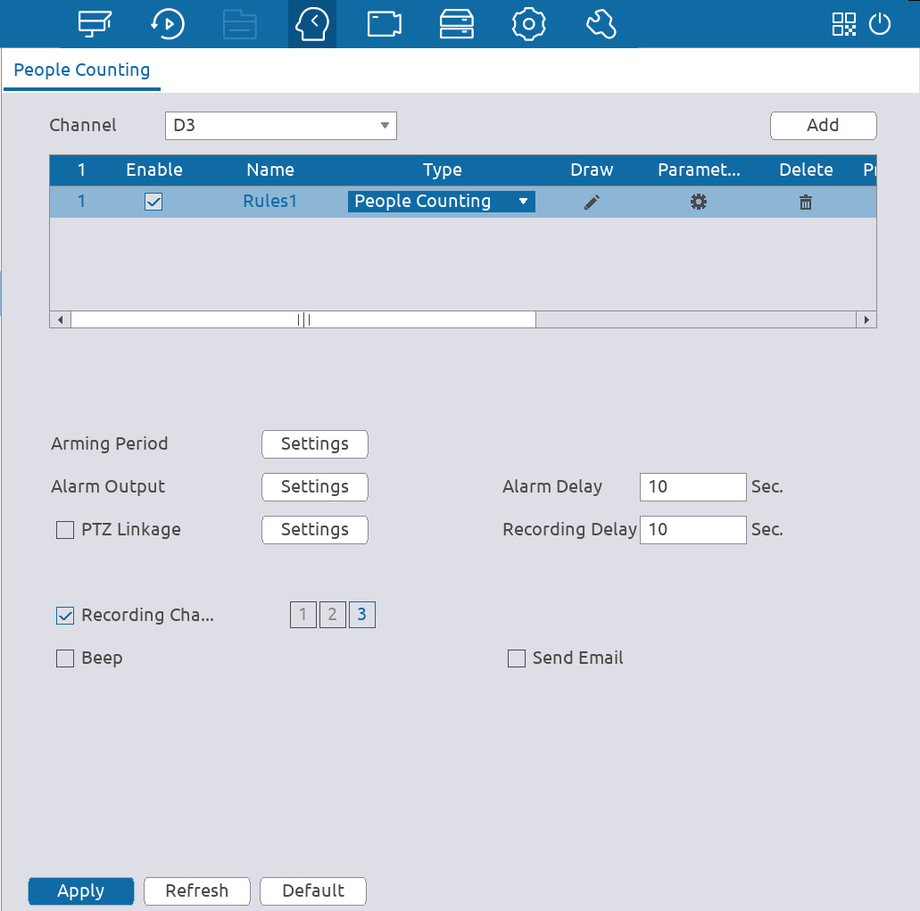
Step 2 Select a channel and then click Add.
Step 3 Select the Enable checkbox, and then set Type to People Counting.
Step 4 Draw people counting rule.
1) Click to draw people counting rule. Right-click the image to stop drawing.
Figure 5-44 People counting rule
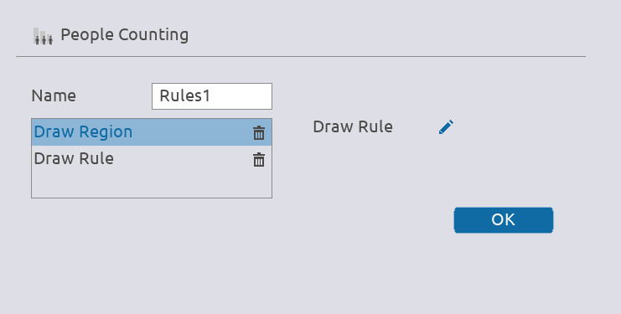
2) Customize the rule name and then select direction.
3) Click OK.
Step 5 Click under Parameters and then configure the parameters.
Figure 5-45 Configure parameters
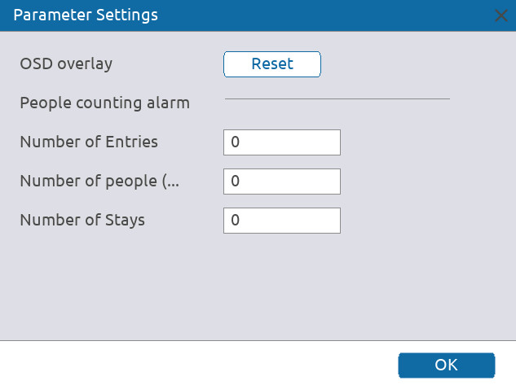
Table 5-17 People counting parameters
Parameter | Description
Number of Entries | An alarm is triggered when the number of people entering the detection zone exceeds the defined threshold.
Number of People (Exit) | An alarm is triggered when the number of people leaving the detection zone exceeds the defined threshold.
Number of Stays | An alarm is triggered when the number of people staying the detection zone exceeds the defined threshold.
Step 6 Click Settings next to Arming Period to configure the arming period.
The arming period is highlighted. There are two ways to configure the period.
● Drag on the time line to define the period. You can click the blue part to disarm the period.
Figure 5-46 Arming period (1)
● Click to define the arming period for each day in a week.
◇ There are six periods for you to set for each day.
◇ Under Copy to, select All to apply the settings to all the days of the week, or select specific days that you want to apply the settings to.
Figure 5-47 Arming period (2)
Step 7 Configure the alarm linkage.
Table 5-18 Alarm linkage
Parameter | Description
Alarm Output | Click Settings next to Alarm Output, click to enable the local alarm, and then select alarm output port as required.  Make sure that the alarm state of the alarm output port has been configured. For details, see "5.12.4.3.3 Configuring Alarm Output".
PTZ Linkage | Select the checkbox and then click Settings to configure PTZ linkage.  Make sure that the PTZ control has been configured. For details, see "5.5.4 PTZ".
Recording Channel | Select the checkbox, and then select one or more channels for recording.  Make sure that the recording plan and recording mode has been configured in Storage > Recording Plan > Video Recording.
Beep | Select the checkbox to enable the device to make a beep noise when an alarm occurs.
Alarm Delay | When alarm delay is configured, alarm continues for an extended period after the alarm ends.
Recording Delay | Configure the length of time for the device to continue recording after the alarm ends.
Send Email | Enable the system to send an email to notify you of an alarm event.  ● This function is available on select models.  ● Make sure that the email function has been configured in System > Network > Basic > Email.
Step 8 Click Apply.

5.9.1.6 Configuring Heat Map
Heat map technology can monitor the active objects distribution status on the specified zone during a period of time, and use different colors to display on the heat map.
Procedure
Step 1 Select Smart Analysis > VCA Settings > Heat Map.
Figure 5-48 Heat map
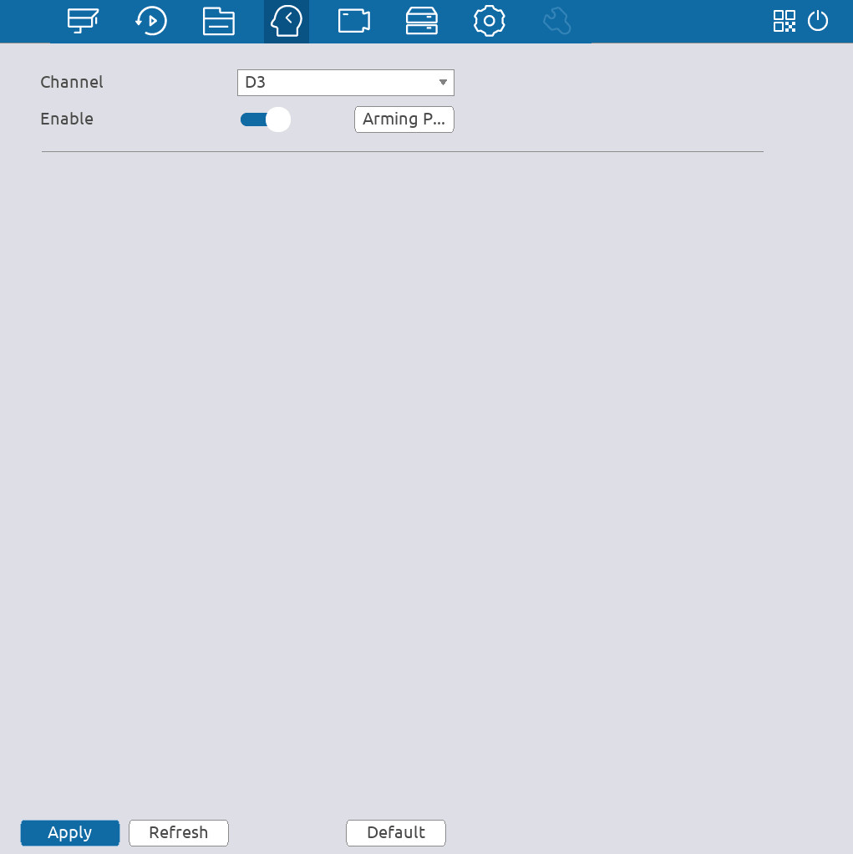
Step 2 Click to enable the function.
Step 3 Click Arming Period to configure the arming period.
The arming period is highlighted. There are two ways to configure the period.
● Drag on the time line to define the period. You can click the blue part to disarm the period.
Figure 5-49 Arming period (1)
● Click to define the arming period for each day in a week.
◇ There are six periods for you to set for each day.
◇ Under Copy to, select All to apply the settings to all the days of the week, or select specific days that you want to apply the settings to.
Figure 5-50 Arming period (2)

5.9.1.7 Configuring LPR
Configure LPR alarm rules. An alarm is triggered when the system detects a certain license plate.
Procedure
Step 1 Select Smart Analysis > VCA Settings > LPR.
Step 2 Select a channel, click to enable LPR, and then select the target type from Allow List, Block List, Standard, or All.
Step 3 Click Settings next to Arming Period to configure the arming period.
The arming period is highlighted. There are two ways to configure the period.
● Drag on the time line to define the period. You can click the blue part to disarm the period.
Figure 5-51 Arming period (1)
● Click to define the arming period for each day in a week.
◇ There are six periods for you to set for each day.
◇ Under Copy to, select All to apply the settings to all the days of the week, or select specific days that you want to apply the settings to.
Figure 5-52 Arming period (2)
Step 4 Configure the alarm linkage.
Table 5-19 Alarm linkage
Parameter | Description
Alarm Output | Click Settings next to Alarm Output, click to enable the local alarm, and then select alarm output port as required.  Make sure that the alarm state of the alarm output port has been configured. For details, see "5.12.4.3.3 Configuring Alarm Output".
PTZ Linkage | Select the checkbox and then click Settings to configure PTZ linkage.  Make sure that the PTZ control has been configured. For details, see "5.5.4 PTZ".
Recording Channel | Select the checkbox, and then select one or more channels for recording.  Make sure that the recording plan and recording mode has been configured in Storage > Recording Plan > Video Recording.
Beep | Select the checkbox to enable the device to make a beep noise when an alarm occurs.
Alarm Delay | When alarm delay is configured, alarm continues for an extended period after the alarm ends.
Recording Delay | Configure the length of time for the device to continue recording after the alarm ends.
Send Email | Enable the system to send an email to notify you of an alarm event.  ● This function is available on select models.  ● Make sure that the email function has been configured in System > Network > Basic > Email.
Step 5 Click Apply.

5.9.2 Database

5.9.2.1 Configuring Face Database
Configure face databases to manage face images for face recognition.

5.9.2.1.1 Creating Local Face Database
You can create face databases on the Device to manage face images for face recognition by Device.
Procedure
Step 1 Select Smart Analysis > Database > Face Database Configuration.
Figure 5-53 Face database configuration
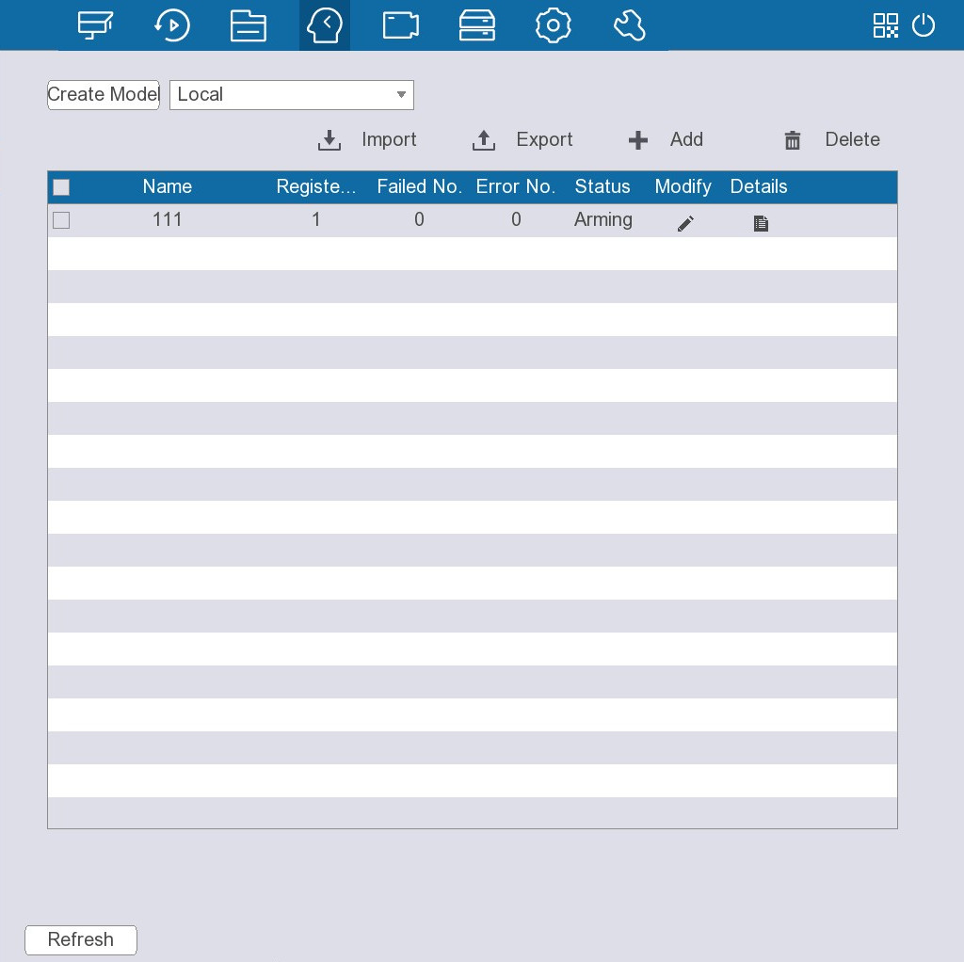
Step 2 Select Local next to Create Model, and then click Add.
Figure 5-54 Add face database
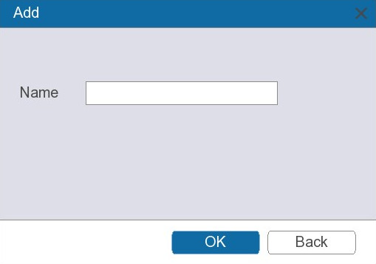
Step 3 Enter database name.
Step 4 Click OK.
Related Operations
● Import and export face database information.
◇ Import: Click  to import, select the corresponding file, and then click Browse to import the file.
◇ Export: Click to export, select the file storage path, and then click Save.
● Delete face database.
Select one or more databases, and then click to delete the database.

5.9.2.1.2 Creating Remote Face Database
The Device can get face databases from the remote devices, and also allows creating face databases for remote devices. The remote device face database is suitable for face recognition by Camera.
Procedure
Step 1 Select Smart Analysis > Database > Face Database Configuration.
Step 2 Select Remote next to Create Model, select a channel and then click Add.
Step 3 Enter database name.
Step 4 Click OK.

5.9.2.2 Adding Images to Face Database
You can add face images to the existing databases one by one or in batches.

5.9.2.2.1 Adding Face Images One by One
You can add one face image to the database. It is for the scenario that the number of registered human face picture is small.
Procedure
Step 1 Select Smart Analysis > Database > Face Database Configuration.
Step 2 Click of the database that you want to configure.
Figure 5-55 Databases details
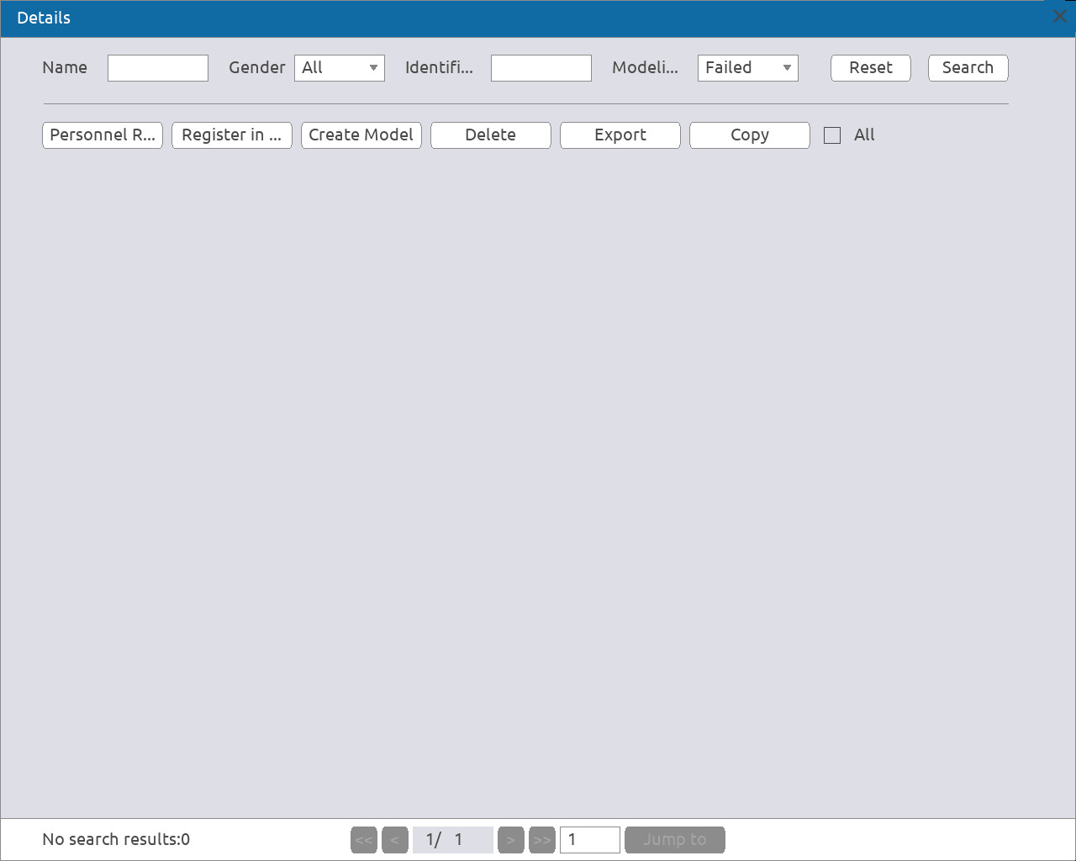
Step 3 Click Personal Registration.
Figure 5-56 Register
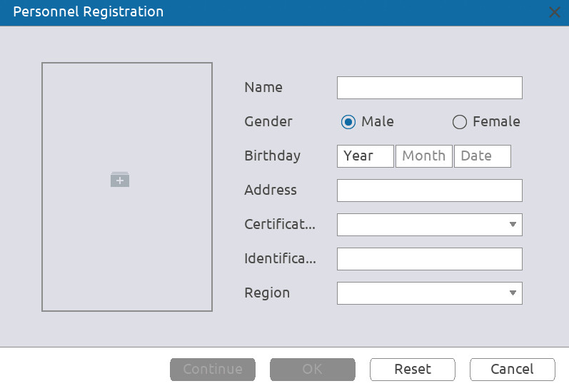
Step 4 Click to add a face image.
Figure 5-57 Browse
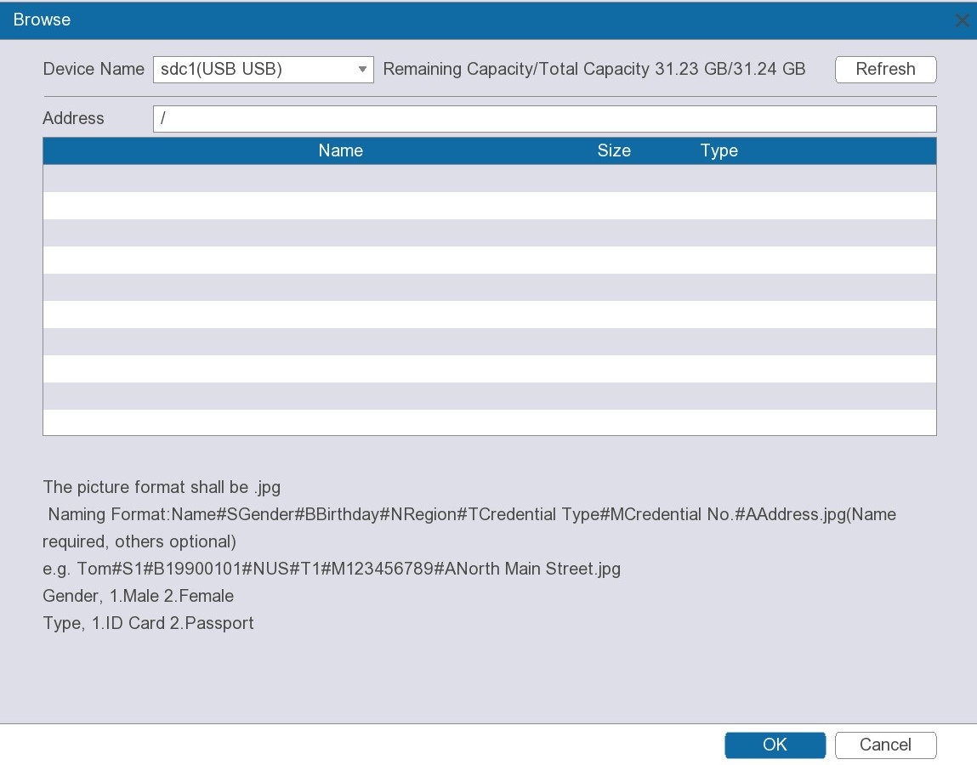
Step 5 Select a face image, and then enter the registration information.
Step 6 Click OK.
The system prompts the registration is successful.
Step 7 On the Details page, click Search.
The system prompts modeling is successful.
If the system prompts modeling is in process, wait a while and then click Search again. If modeling failed, the registered face image cannot be used for face recognition.
Related Operations
● Edit registration information.
Click to modify the registration information.
● Model face images.
The face images are modeled automatically after added to face database. You can also model face images manually.
◇ On the Database Configuration page, select a database, and then click Create Model to model all the face images in the database.
◇ On the Details page, select one or more face images, and then click Create Model to model the selected images.
● Export face images.
Select one or more face images, and then click Export.
● Delete face images.
Select one or more face images, and then click Delete.

5.9.2.2.2 Adding Face Images in Batches
The system supports batch add if you want to import several human face images at the same time.
Procedure
Step 1 Give a name to the face picture by referring to the following table.
Table 5-20 Naming rule
Naming format | Description
Name | Enter the name.
Gender | Enter 1 or 2. 1 represents male, and 2 represents female.
Birthday | Enter numbers in the format of yyyy-mm-dd.
Region | Enter the abbreviation of region. For example, CN for China.
Credential Type | 1 represents ID card; 2 represents passport; 3 represents officer card.
Credential No. | Enter the credential number.
Address | Enter the address.
Step 2 Select Smart Analysis > Database > Face Database Configuration.
Step 3 Click of the database that you want to configure.
Step 4 Click Register in Batches.
Figure 5-58 Batch register
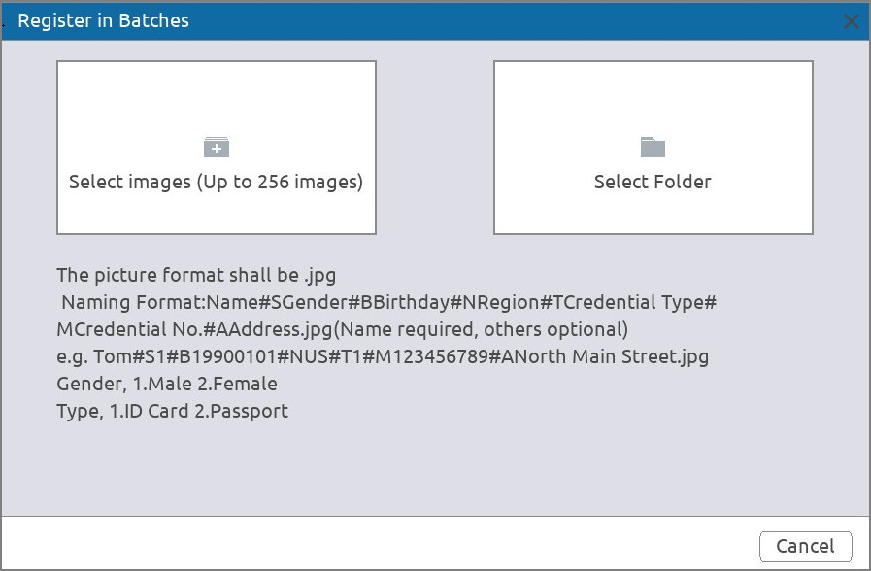
Step 5 Click  or  to import face images.
Step 6 Click OK.
Related Operations
● Edit registration information.
Click to modify the registration information.
● Model face images.
The face images are modeled automatically after added to face database. You can also model face images manually.
◇ On the Database Configuration page, select a database, and then click Create Model to model all the face images in the database.
◇ On the Details page, select one or more face images, and then click Create Model to model the selected images.
● Export face images.
Select one or more face images, and then click Export.
● Delete face images.
Select one or more face images, and then click Delete.

5.9.2.3 Configuring Blocklist and Allowlist
To facilitate vehicle management, you can add the plate numbers to the blocklist or allowlist. The system can compare the detected plate information with the plate on the blocklist and allowlist and then trigger the corresponding alarm linkage.
Procedure
Step 1 Select Smart Analysis > Database > Blocklist and Allowlist.
Figure 5-59 Blocklist and allowlist
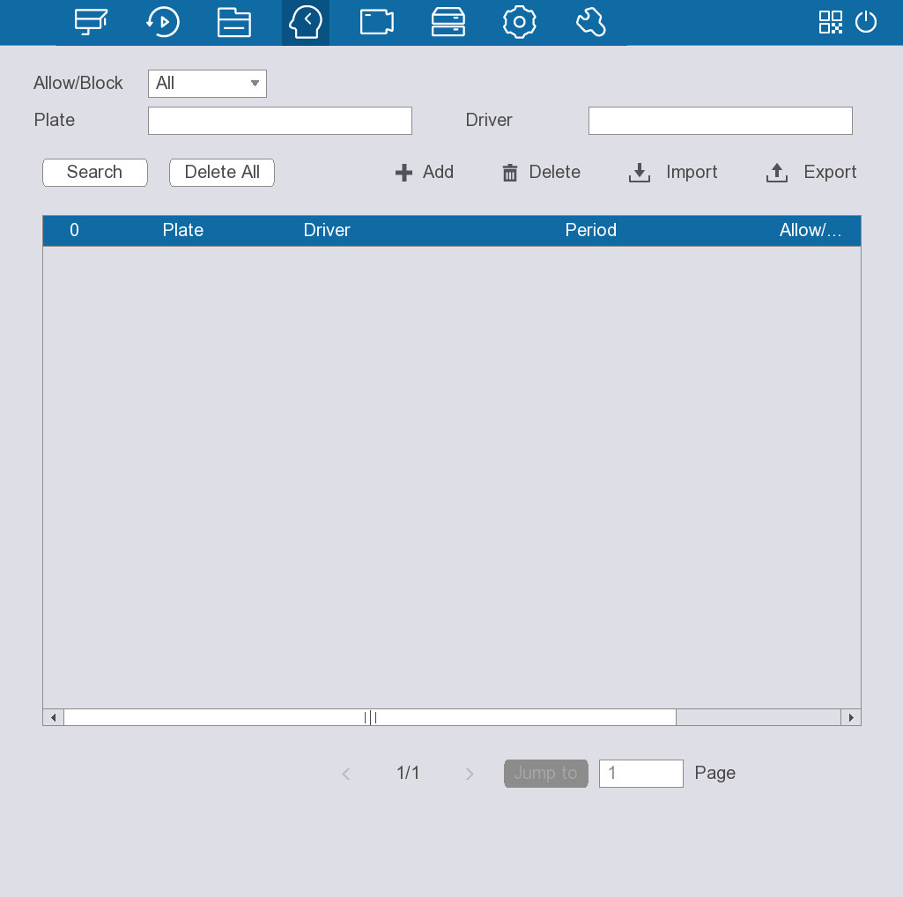
Step 2 Click to manually add.
Step 3 Set plate information such as plate number, driver name, select Block List or Allow List, and then set validity period.
Step 4 Click OK.
Related Operations
● Search.
Enter keywords for Plate and Driver, select type and then click Search.
● Import and export plate information.
◇ Import: Click to import, select the corresponding file, and then click Browse to import the file.
◇ Export: Click to export, select the file storage path and then click Save.
● Delete plate information.
◇ Delete one by one: Select the plate number to be deleted, and then click .
◇ Delete in batches: Select the plate numbers to be deleted, and then click Delete All.

5.10 Camera
You can configure camera registration, image attributes, overlay information, video parameters and other settings of the cameras connected to the device.

5.10.1 Configuring Remote Devices

5.10.1.1 Adding Remote Devices
Add remote devices to the NVR to receive, store, and manage the video streams of the remote device.
Before adding the remote devices, make sure that the devices have been initialized.

5.10.1.1.1 Adding Remote Devices from Search
Background Information
Search for the remote devices on the same network with the NVR, and then add the remote devices from the search results.
We recommend this method when you do not know the specific IP address of the remote device.
Procedure
Step 1 Select Camera > Camera Registration > Camera Registration.
Figure 5-60 Remote device
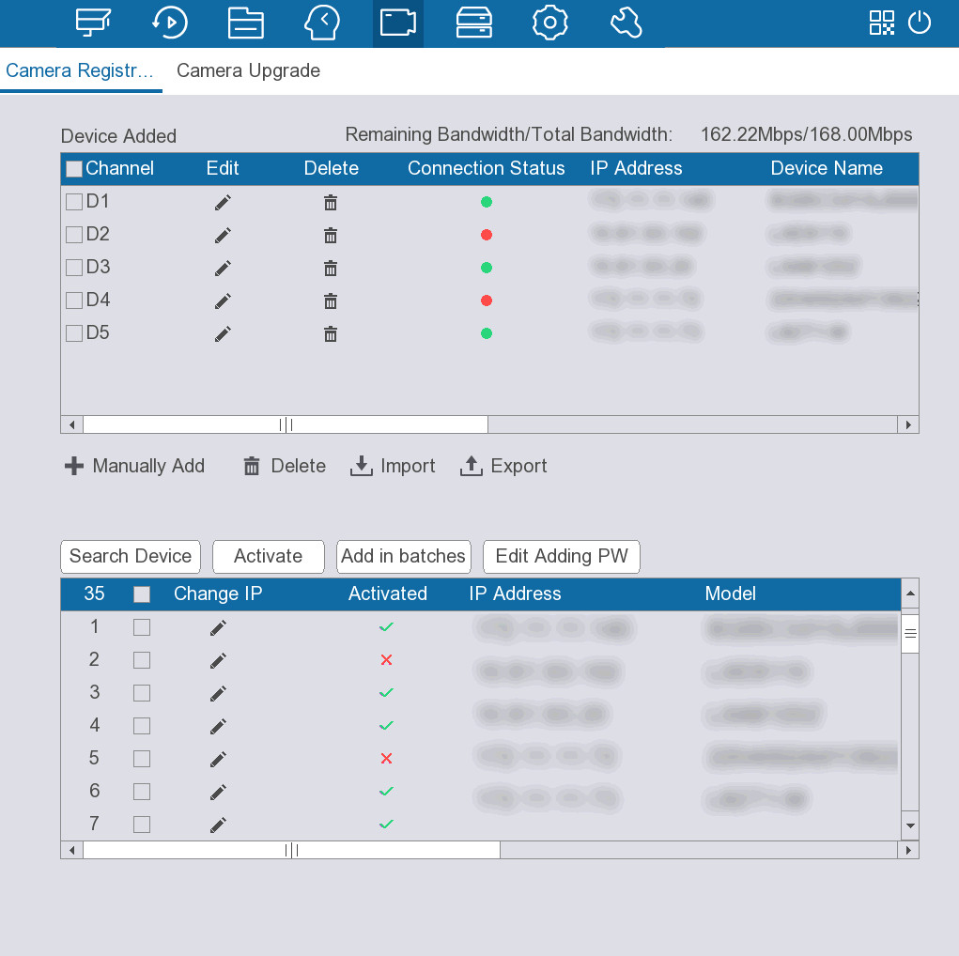
Step 2 Click Search Device.
Step 3 Select one or more remote devices from the search results and then click Add in batches.
You can view the added devices on the list under Device Added.
Related Operations
You can click under Change IP to change IP addresses.
● DHCP: There is no need to enter IP address, subnet mask, and default gateway. Device automatically allocates the IP address to the camera.
● Static: You need to enter IP address, subnet mask, and default gateway.
When you are changing IP addresses of several devices at the same time, enter incremental value. The system can add the fourth decimal digit of the IP address one by one to automatically allocate the IP addresses.
If an IP conflict occurs when you change static IP address, the system will notify you of the issue. If you change IP addresses in batches, the system automatically skips the conflicted IP and begins the allocation according to the incremental value.

5.10.1.1.2 Adding Remote Devices Manually
Background Information
Configure the IP address, username, password and other information of the remote device manually to add the Device.
We recommend this method when you want to add only a few remote devices and know their IP addresses, usernames and passwords.
Procedure
Step 1 Select Camera > Camera Registration > Camera Registration.
Step 2 Click to manually add.
Figure 5-61 Manually add
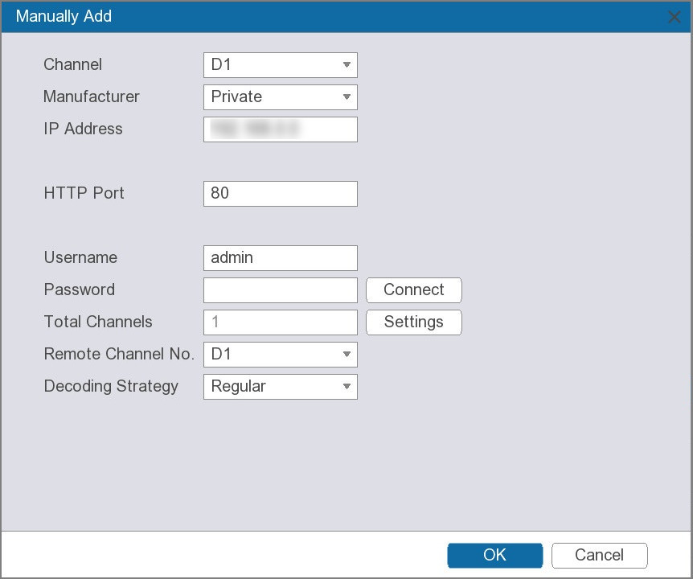
Step 3 Configure the parameters.
Table 5-21 Parameters of manual add
Parameter | Description
Channel | Designate a channel for the remote device.
Manufacturer | Select the manufacturer of the remote device.
IP Address | Enter the IP address of the remote device.
HTTP Port | Enter the HTTP port of the remote device.
Username | Enter the username and password used to log in to the remote device.
Password
Total Channels | Click Connect to get the total number of channels of the remote device.
Remote Channel No. | Select one or more remote channels that you want to connect to.
Decoding strategy | Select a decoding strategy from Real-time, Regular, and Smooth.
Encrypt | Select an encrypting strategy from Automatic, TCP, UDP, and MULTICAST.
Step 4 Click OK.
Related Operations
● Click under Edit to modify information of the added device.
● Click to delete the added device.
● Click Edit Adding PW to change the camera login password.

5.10.1.1.3 Importing Remote Devices
Prerequisites
Connect a USB storage device to the Device.
Background Information
You can import remote devices in batches.
We recommend this method when you want to add lots of remote devices whose IP addresses, usernames and passwords are not the same.
Procedure
Step 1 Select Camera > Camera Registration > Camera Registration.
Step 2 Click to export the template.
You need to disable backup encryption when exporting the template.
Step 3 Fill in the template.
Step 4 Click to import the template.
Step 5 Click OK.

5.10.1.2 Upgrading Remote Devices
Select Camera > Camera Registration > Camera Update to update the remote devices.
Figure 5-62 Camera upgrade
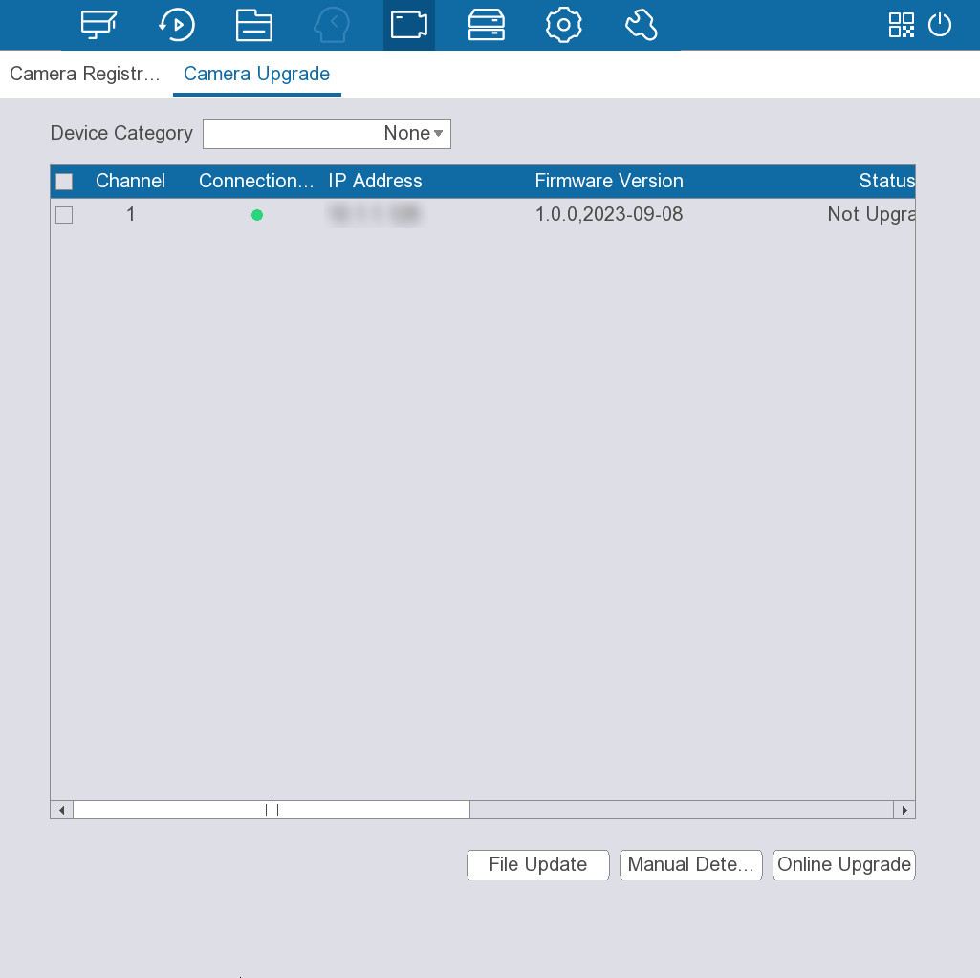
● File update.
1. Connect a USB storage device containing the update file to the Device.
2. Select one or more remote devices.
3. Click File Update.
4. Select the update file to update.
● Online update.
1. Select one or more remote devices and then click Manual Detection.
The system starts detecting whether there is a new version available.
2. Select the remote devices with a new version available, and then click Online Upgrade.
You can filter the remote devices through the Device Category list.

5.10.2 Checking PoE Status
Select Camera > PoE to check the status of the PoE ports.
You can select Signal Enhancement Mode from On or Close.
Figure 5-63 PoE
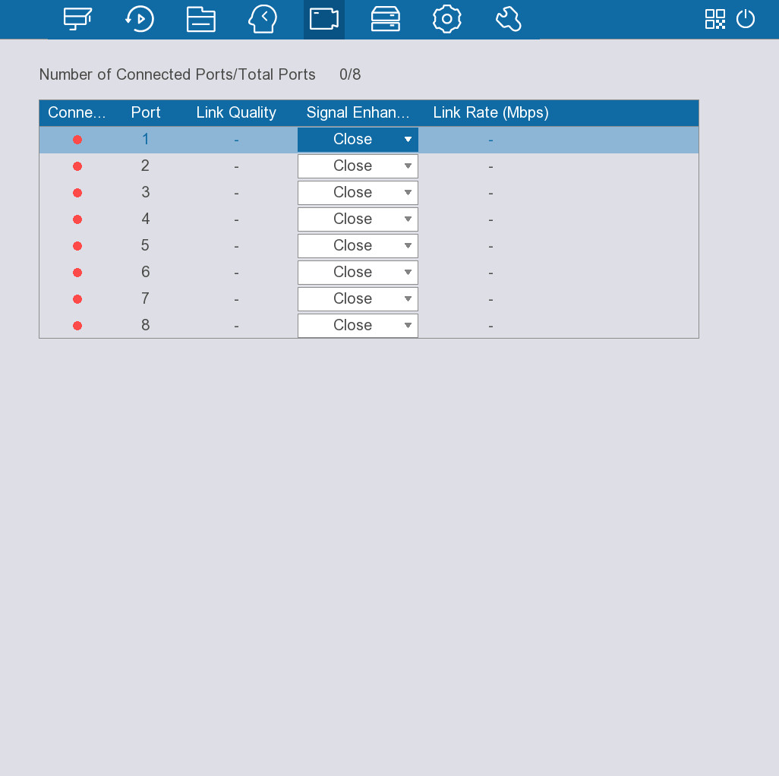

5.10.3 Configuring Image Attributes
Background Information
Configure the image attributes, such as saturation, brightness, contrast, and chromaticity.
Procedure
Step 1 Select Camera > Image Attributes.
Figure 5-64 Image attributes
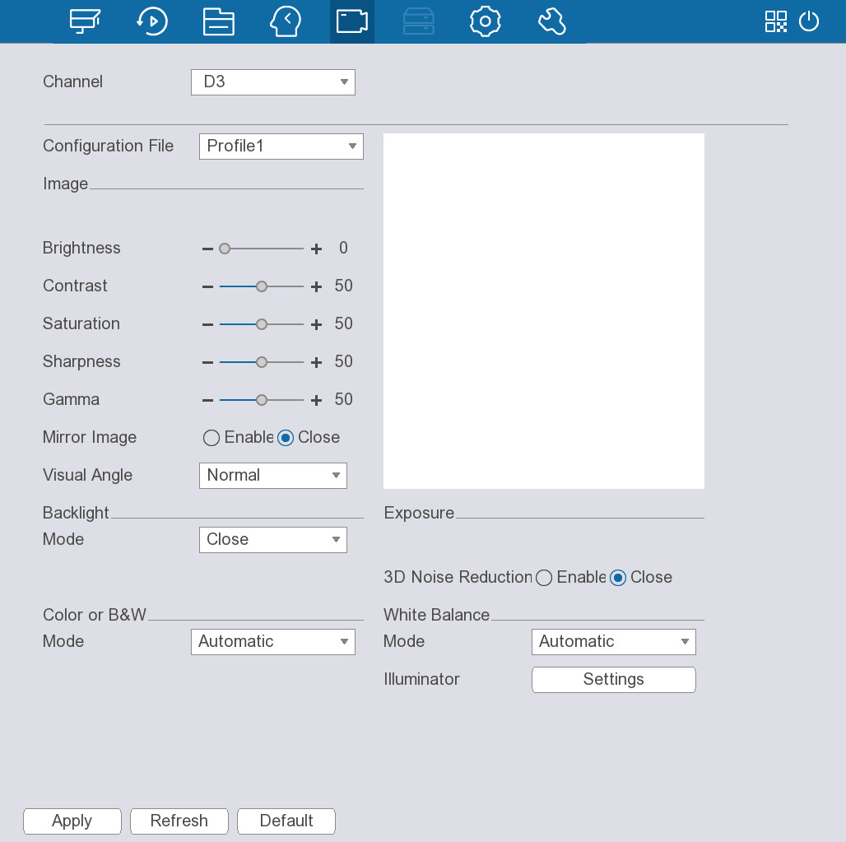
Step 2 Select a channel and then configure the parameters.
Table 5-22 Parameters of image attributes
Parameter | Description
Configuration File | Select a configuration file from Profile1 or Profile2. The image attributes vary with the configuration files.
Brightness | The bigger the value, the brighter the image.
Contrast | The bigger the value, the more obvious the contrast between the light area and dark area.
Saturation | The bigger the value, the more intense the color.
Sharpness | The bigger the value, the more obvious the image edge.
Gamma | Adjust the image brightness and enhance the image dynamic display range. The bigger the value is, the brighter the image.
Mirror Image | Select Enable to switch the left and right side of the video image.  This function is available on select models.
Visual Angle | Set the video display direction.
Backlight Mode | ● Close: Disable backlight mode.  ● Backlight Compensation: Enable the camera to get a clearer image of the dark areas on the target when shooting against light.  ● Wide Dynamic Range: The system dims bright areas and enhances the brightness of the dark areas to ensure the overall clarity of the image.  ● Highlight Compensation: Select this mode when extremely strong light exists in the environment. The system lowers the brightness of the brightest section and reduces the area of the halo to lower the brightness of the whole image.
3D Noise Reduction | Reduces the noise of multiple-frame images by using inter-frame information between two adjacent frames in a video.
White Balance Mode | Enable white balance to make the image color display precisely as it is. This function changes the overall hue of the image.  The white balance modes might differ depending on the camera.
Day and Night Modes | Switches the video image between the color mode and the black & white mode.  ● Automatic: The camera outputs color images or black and white images according to ambient conditions.  ● Full Color: The camera outputs color images only.  ● Black & White: The camera outputs black and white images only.
Illuminator | The illuminator ensures the brightness and definition of video images in a dark environment.  ● Automatic: The system adjusts the illuminator brightness automatically.  ● Manual: Set the illuminator brightness manually.  ● Close: Turn off the illuminator.
Step 3 Click Apply.

5.10.4 Configuring Overlay Settings
Configure the overlay information on the live page.
Procedure
Step 1 Select Camera > Video Overlay.
Figure 5-65 Overlay
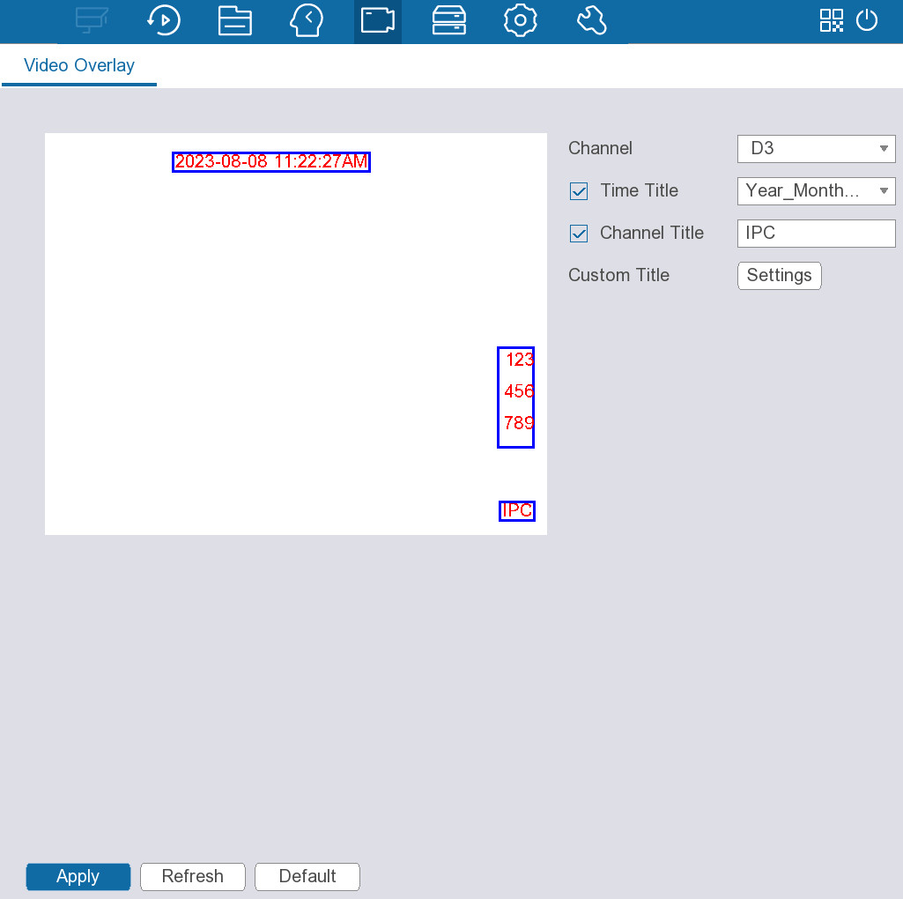
Step 2 Select a channel and then configure the overlay information.
● Time Title: Select the checkbox, and then configure the time format.
● Channel Title: Select the checkbox, and then configure the channel name.
Click Settings next to Custom Title to add custom titles for the channel.
Step 3 Click Apply.

5.10.5 Configuring Privacy Masking
You can mask part of the image for privacy protection.
Procedure
Step 1 Select Camera > Privacy Masking.
Figure 5-66 Privacy masking
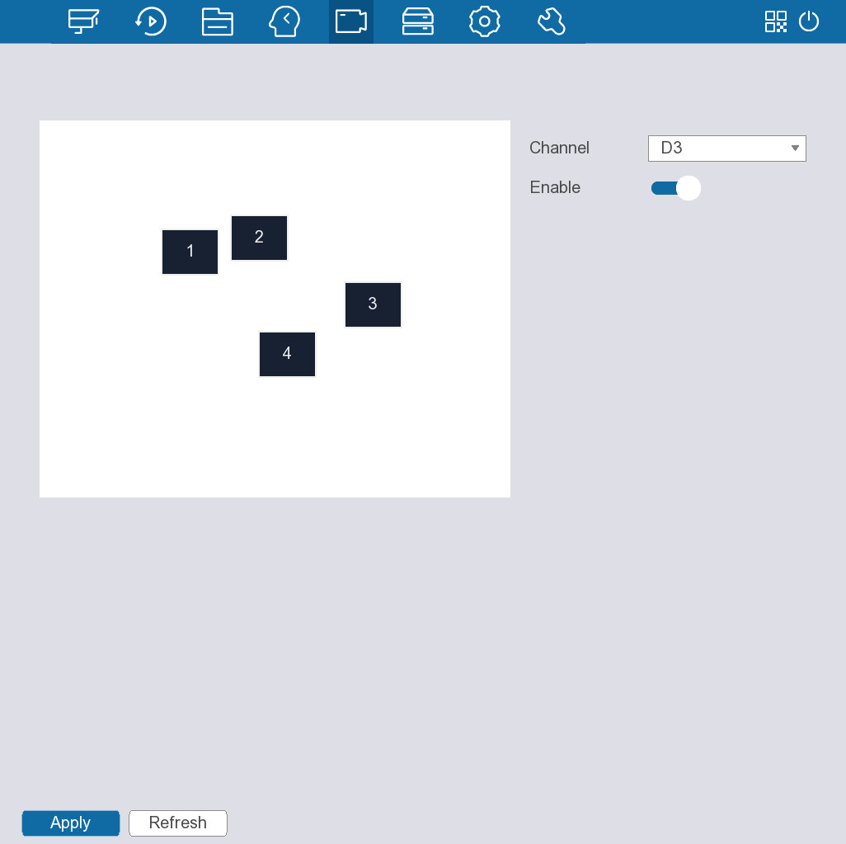
Step 2 Select a channel, and then configure the masking.
1. Click to enable privacy masking.
2. Click 1, 2, 3 or 4 to add a masking block to the image.
You can add up to four masking blocks for each channel.
3. Adjust the size and position of the masking block.
Step 3 Click Apply.

5.10.6 Configuring Video Settings
Configure the video encoding setting according to the actual bandwidth.
Procedure
Step 1 Select Camera > Video Parameters.
Figure 5-67 Video parameters
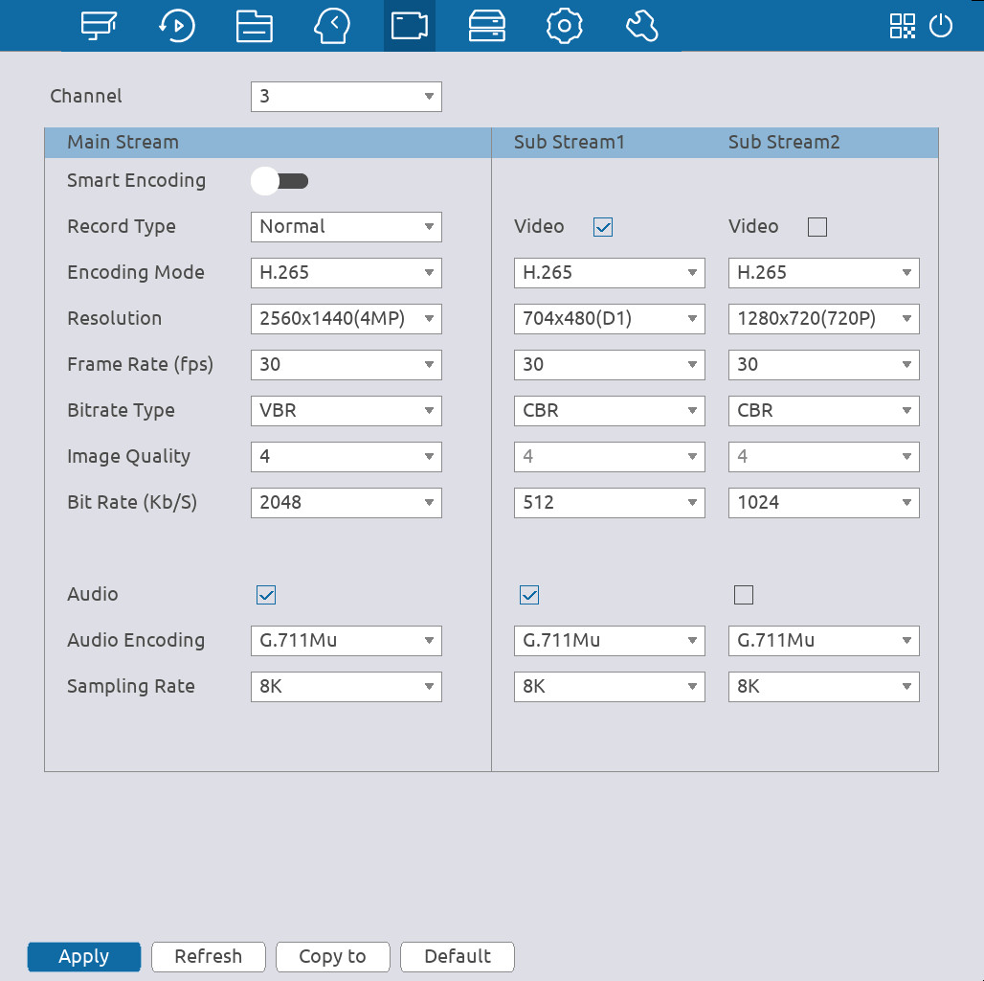
Step 2 Configure the parameters.
Table 5-23 Video settings
Parameter | Description
Channel | Select a channel for which you want to configure the settings.
Smart Encoding | Enable this function to reduce the bit stream for non-important recorded video to maximize the storage space.
Record Type | Select Normal, Motion detection or Alarm for main stream.
Encoding Mode | ● H.265 (recommended): Main profile encoding. This format is recommended.  ● H.264H: High profile encoding. Low bit stream with high definition.  ● H.264: General profile encoding.  ● H.264B: Baseline profile encoding.  ● MJPEG: In this format, the image requires bigger bit rate value to ensure clarity.
Resolution | Select a resolution for the video.  The maximum resolution available might vary with the models.
Frame Rate (FPS) | Configure the frames per second for the video. The bigger the value, the clearer and smoother the image. Frame rate changes along with the resolution.
Bitrate Type | ● CBR (Constant Bitrate): The bit rate changes slightly around the defined value. We recommended selecting constant stream when there might be only small changes in the monitoring environment.  ● VBR (Variable Bitrate): The bit rate changes with monitoring scenes. Select variable stream when there might be big changes in the monitoring environment.
Image Quality | The bigger the value, the better the image quality.  This parameter is available when the Bitrate Type is VBR.
Bit Rate (Kb/S) | ● Main stream: The higher the bitrate, the better the image quality.  ● Sub stream: For constant stream, the bitrate changes near the defined value; for variable stream, the bitrate changes along with the image but the maximum value still stays near the defined value.
Audio Encoding | Select an audio encoding format.
Sampling Rate | Set how many times per second a sound is sampled. The bigger the value, the more natural the sound.
Step 3 Click Apply.

5.10.7 Configuring E-Tracking
This function can simultaneously zoom in and track multiple persons and vehicles that trigger alarms. It provides rich details and a panoramic view at the same time.
Procedure
Step 1 Select CAMERA > E-Tracking.
Step 2 Configure the parameters.
Figure 5-68 E-Tracking
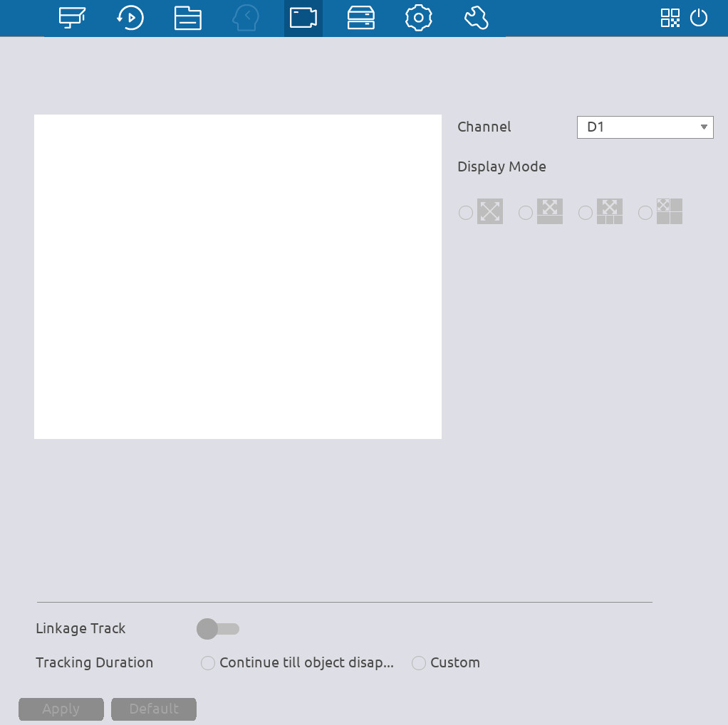
Table 5-24 E-Tracking parameters description
Parameter | Description
Channel | Select the linkage channel.
Display Mode | Select the number of tracked channels. Full screen, 1+1, and 1+3 modes are available, and full screen is selected by default.
Linkage Track | After Linkage Track is enabled, intelligent events will be tracked. It is disabled by default.
Tracking Duration | ● Custom: Select the tracking duration time manually. For example, if you set from 30 s to 60 s, after tracking object A for 30 seconds, if object B appears, the camera will start tracking object B; if no other object appears in the process of tracking A, the camera will stop tracking object A after 60 seconds.  ● Continue till object disappears: The camera will stop tracking when the detected object disappears in the image.
Step 3 Click Apply.

5.11 Storage
You can configure the recording plan, recording mode, storage strategy, and more.

5.11.1 Configuring Recording Plan
Configure the recording plans for videos and snapshots. This section uses video recording as an example. The configuration of snapshot plan is similar.
Procedure
Step 1 Select Storage > Recording Plan.
Figure 5-69 Video recording
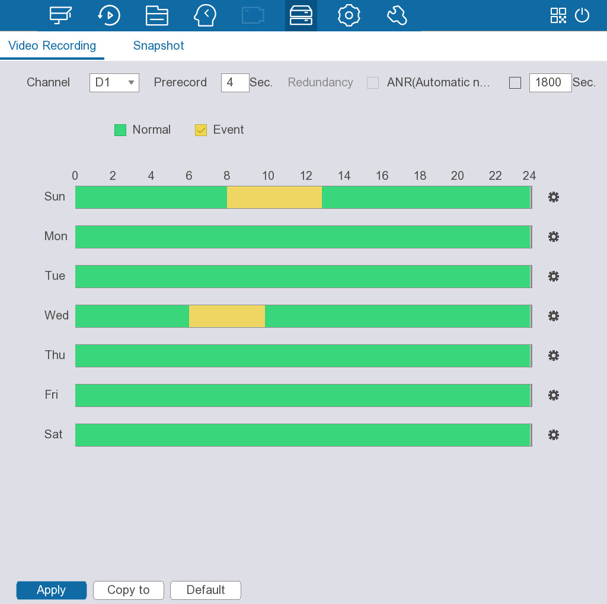
Step 2 Configure recording settings.
Table 5-25 Video recording parameters
Parameter | Description
Channel | Select a channel to record videos.
Prerecord | Set how long the device records before an event.
Redundancy | Enable redundancy for the channel. If there are two or more HDDs installed on the Device, you can set one of the HDDs as the redundant HDD to back up the recorded files.  ● If the selected channel is not recording, the redundancy function takes effect next time you record no matter you select the checkbox or not.  ● If the selected channel is recording, the current recorded files will be packed, and then the Device starts recording according to the new schedule.  ● This function is available on select models.  ● The redundant HDD only backs up videos but not snapshots.
Automatic network replenishment (ANR) | You can set the ANR (auto network resume) function.  ● The IPC continues recording once the NVR and IPC connection fails. After the network becomes normal, the NVR can download recording files while it is disconnected from the IPC. This is to help protect against data loss from the current IPD channel that is connected.  ● Set the maximum recording upload period. If the offline period is longer than the period you set, IPC will only upload the recording file during the specified period.  Make sure that SD card is installed and the recording function is enabled on the IPC.
Event type | Select Normal or Event, and the default is Normal.
Time Period | Set a period during which the configured recording settings are active.  ● On the time line, drag to set the period.  ● You can also click to set the period.
Default | Restore the recording plan to default settings.
Copy to | Copy the recording plan to other channels.
Step 3 Click Apply.

5.11.2 Configuring Storage Strategy
Configure storage strategy and manage the HDDs.
Procedure
Step 1 Select Storage > Disk Management.
Step 2 Configure the storage strategy.
Figure 5-70 Disk management
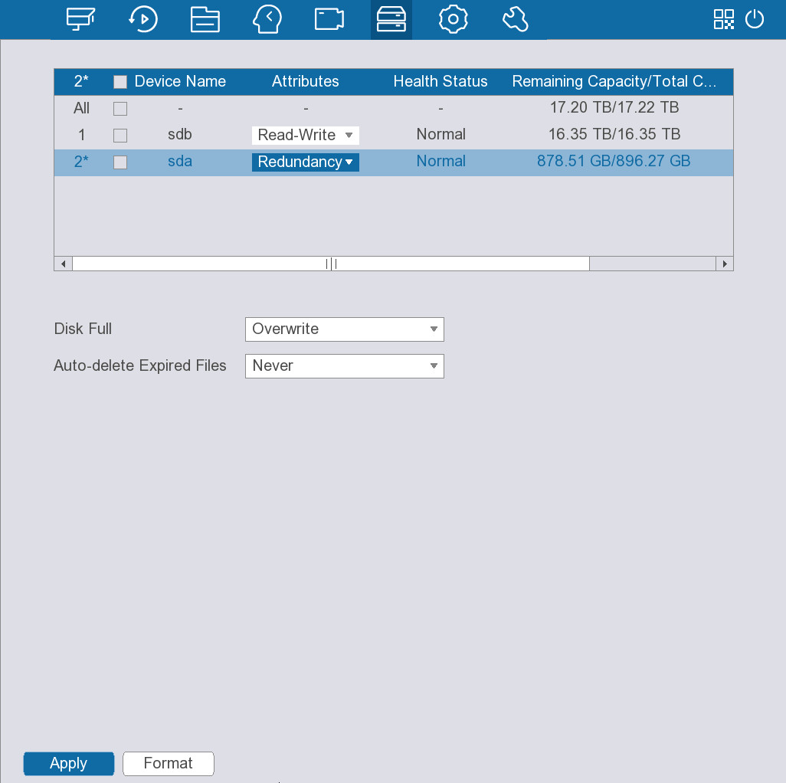
Table 5-26 Disk management parameters
Parameter | Description
Disk Full | Configure the storage strategy to be used when no more storage space is available.  ● Stop: Stop recording.  ● Overwrite: The newest files overwrite the oldest ones.
Auto-delete expired files | Configure whether to allow the Device to delete expired automatically.  ● Select Never if you do not want to use the function.  ● Select Custom and then configure how long you want to keep the old files.
Step 3 On the disk list, view the HDD information and configure the HDD type.
● Set HDD type.
In the Attributes column, select Read-Write, Read-only or Redundancy to set the HDD type.
● Format HDD.
Select an HDD and then click Format, and then follow the on-screen prompt to format the HDD.
Formatting will erase all data on the HDD. Please be advised.

5.11.3 Configuring Disk Group
By default, the installed HDD and created RAID are in Disk Group 1. You can set HDD group, and HDD group setup for main stream, sub stream and snapshot operation.
Procedure
Step 1 Select Storage > Disk Group > Disk Group.
Figure 5-71 Disk group
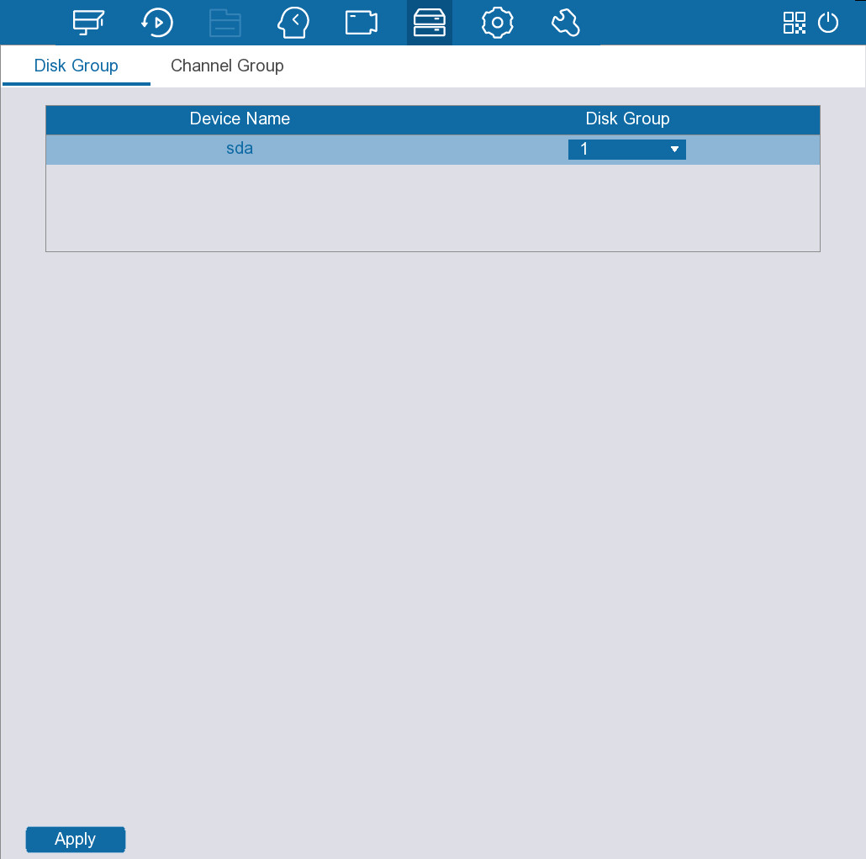
Step 2 Select the group for each HDD, and then click Apply.
After configuring HDD group, under the Channel Group tab, configure settings to save the main stream, sub stream and snapshot to different disk groups, and then click Apply.
Figure 5-72 Channel Group
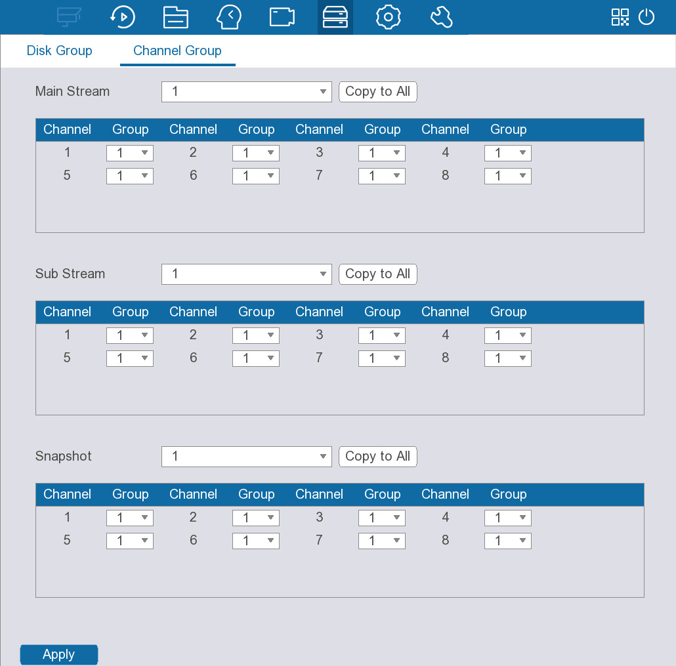

5.11.4 Configuring Recording Mode
Enable or disable the video recording for each channel. The device keeps recording all the time.
Procedure
Step 1 Select Storage > Recording Mode.
Figure 5-73 Recording mode
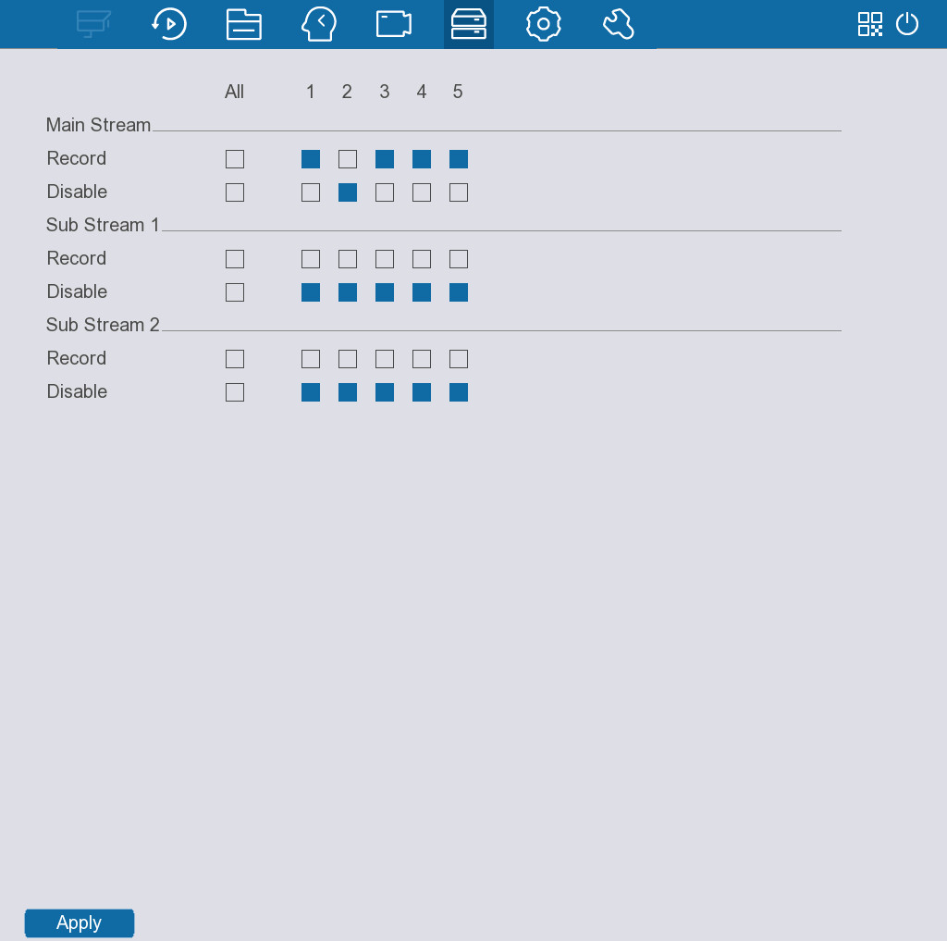
Step 2 Enable recording for each channel.
You can select All if you want to configure the same recording mode for all channels.
Step 3 Click Apply.

5.12 System
You can configure the system settings, including date, accounts, display output and more.

5.12.1 Configuring General System Settings
Configure general system settings, such as device name, date and holiday.

5.12.1.1 Configuring Basic Configuration
Configure basic configurations such as video standard, logout time, and mouse sensitivity.
Procedure
Step 1 Select System > General > Basic Configuration.
Figure 5-74 Basic configuration
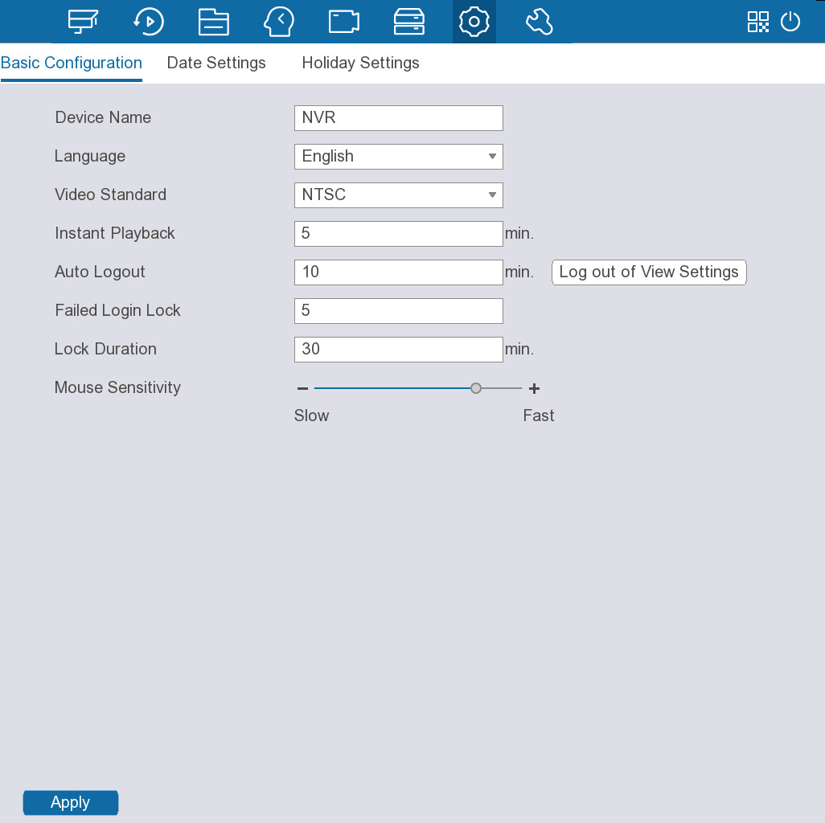
Step 2 Configure the parameters.
Table 5-27 Parameters of basic configuration
Parameter | Description
Device Name | Configure the device name.
Language | Displays the system language.
Video Standard | Select PAL or NTSC as needed.
Instant Playback | Configure the length of time for instant playback.  On the live page, you can click to play back recorded file of previous 5 to 60 minutes.
Auto Logout | Enter the time of inactivity before logout. The Device logs out automatically after the period of inactivity.  Click Log out of View Settings to select the channels that you want to continue monitoring after logout.
Failed Login Lock | Configure the number of allowed failed login attempts before the account is locked for a defined period.
Duration | Configure the duration, and if the number of failed login attempts reaches the defined threshold, the account will be locked for the defined duration.
Mouse Sensitivity | Adjust the speed of double-clicking.
Step 3 Click Apply.

5.12.1.2 Configuring Date Settings
Configure date and time settings.
Procedure
Step 1 Select System > General > Date Settings.
Figure 5-75 Date settings
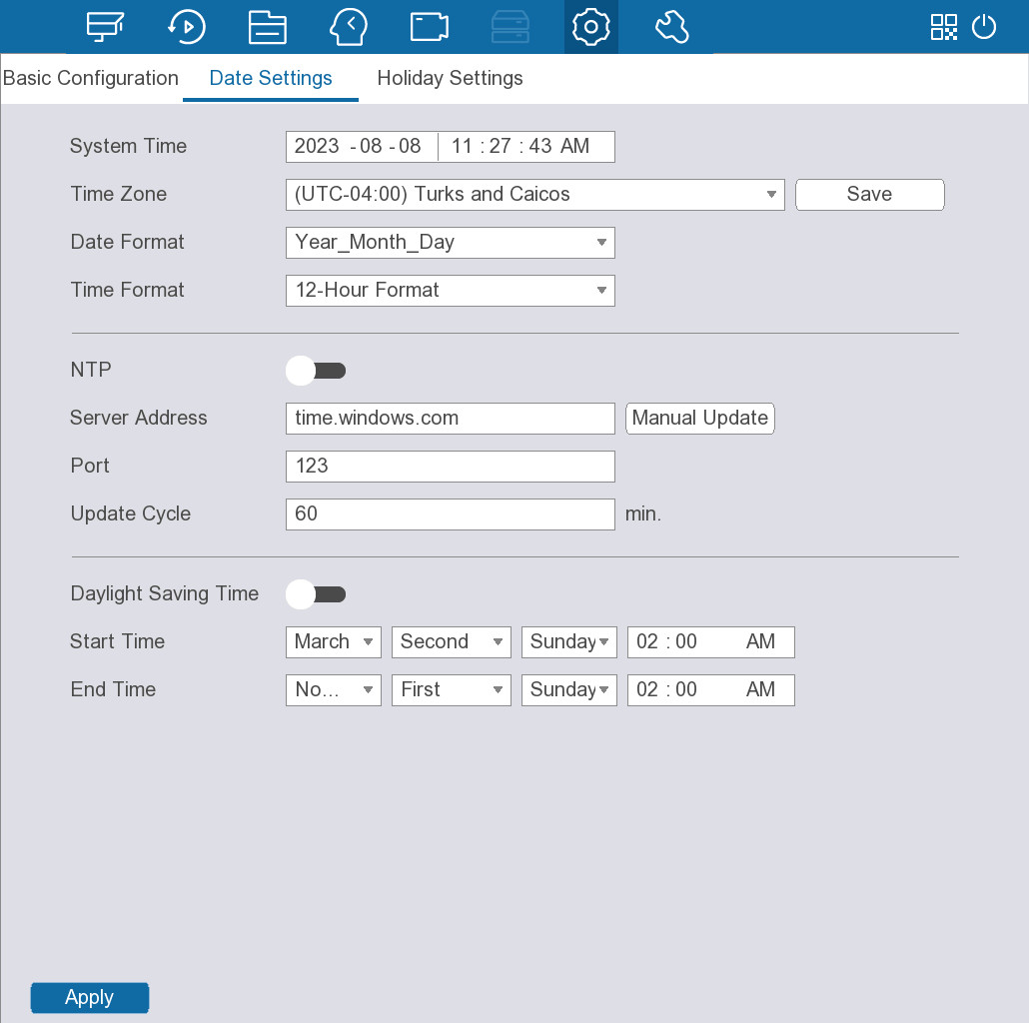
Step 2 Configure the parameters.
Table 5-28 Parameters of date and time
Parameter | Description
System Time | In the System Time box, enter time for the system.  Click the time zone list, you can select a time zone for the system, and the time in adjust automatically.  Do not change the system time randomly; otherwise the recorded video cannot be searched. It is recommended to avoid the recording period or stop recording first before you change the system time.
Time Zone | Select a time zone and then click Save.
Date Format | Select a date format.
Time Format | Select 12-Hour Format or 24-Hour Format.
NTP | After enabling the NTP function, the system time will be automatically synchronized with the NTP server.  1. Click to enable the function.  2. Configure the address and port of the NTP server.  3. Set the update cycle.
Daylight Saving Time | If your country or region adopts the practice of daylight saving time, you can enable the function to ensure that the system time is correct.  1. Click to enable the function.  2. Set the start time and end time.
Step 3 Click Apply.

5.12.1.3 Configuring Holiday Settings
You can add holidays for which you can configure recording plan separately.
Procedure
Step 1 Select System > General > Holiday Settings, and then click Add.
Figure 5-76 Add holidays
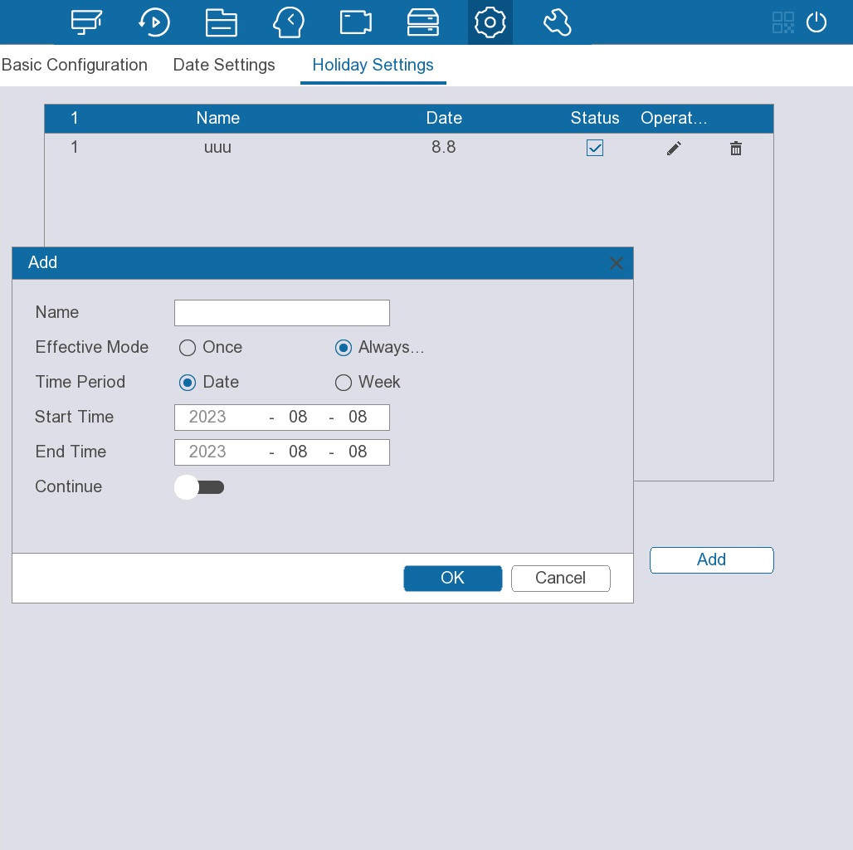
Step 2 Configure the holiday name, effective mode, and time period.
Step 3 (Optional) Enable Continue to add more holidays.
Step 4 Click OK, you can add current holiday to the list.
Click to change the holiday information. Click to delete current date.
Related Operations
Go to Storage > Recording Plan to configure the recording plan for the holiday. For details, see "5.11.1 Configuring Recording Plan".

5.12.2 Configuring Account Settings
You can add and manage users, ONVIF users, and user groups and set information for password reset.

5.12.2.1 Adding Users
A user can access and manage the Device. The default administrator of the Device is admin, which cannot be modified or deleted. You can add more users and grant the users permissions within the permission range of the corresponding user group.
Procedure
Step 1 Select System > User Management > User.
Step 2 Click Add.
Figure 5-77 Add user
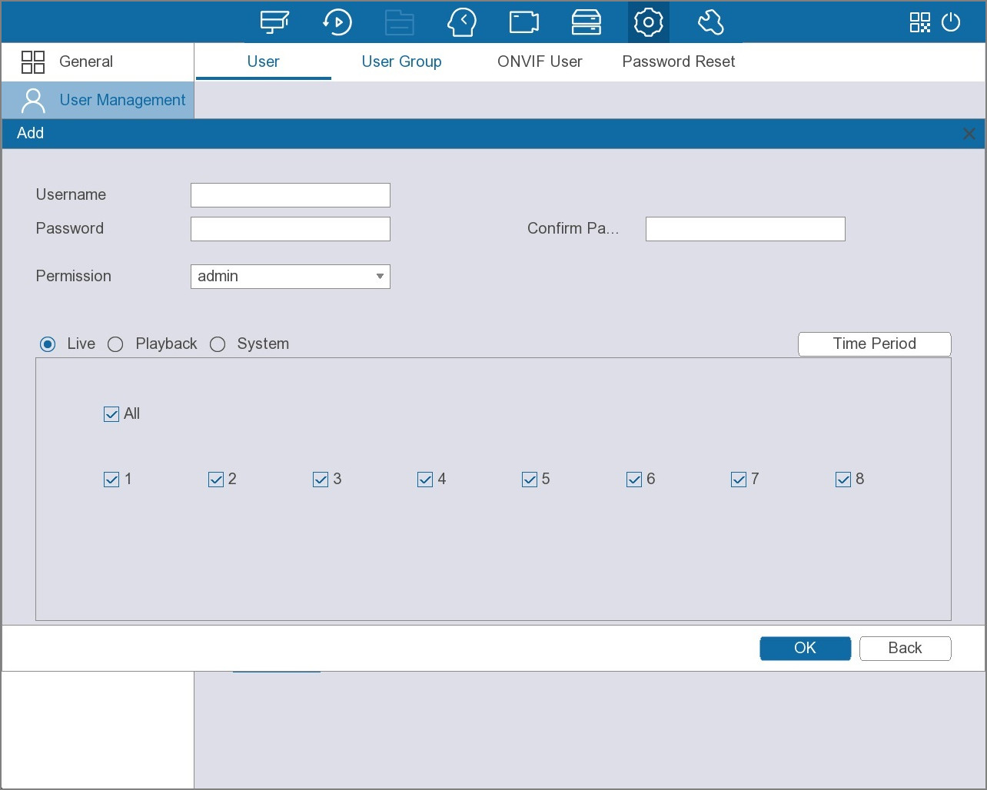
Step 3 Configure the parameters.
Table 5-29 Parameters of adding user
Parameter | Description
Username | Enter a name for the user.
Password | Enter the password, and then enter the password again to confirm it.
Confirm Password
Password Expires in | Select the password expiration time as needed, and you can also customize the time.
Time Period | Click Time Period to set a period during which the new user can log in to the device. The user cannot access the device in other periods.
Permission | Select a group for the user.  The permissions of the user must not exceed the permissions of the user group.
Step 4 Select the checkbox under the Live tab, Playback tab, and System tab as required respectively.
Step 5 Click OK.

5.12.2.2 Adding User Groups
The accounts of the device adopt two-level management mode: user and user group. Every user must belong to a group, and one user only belongs to one group. The admin and user group are two default user groups that cannot be deleted. You can add more groups and define corresponding permissions.
Procedure
Step 1 Select System > User Management > User Group.
Figure 5-78 User group
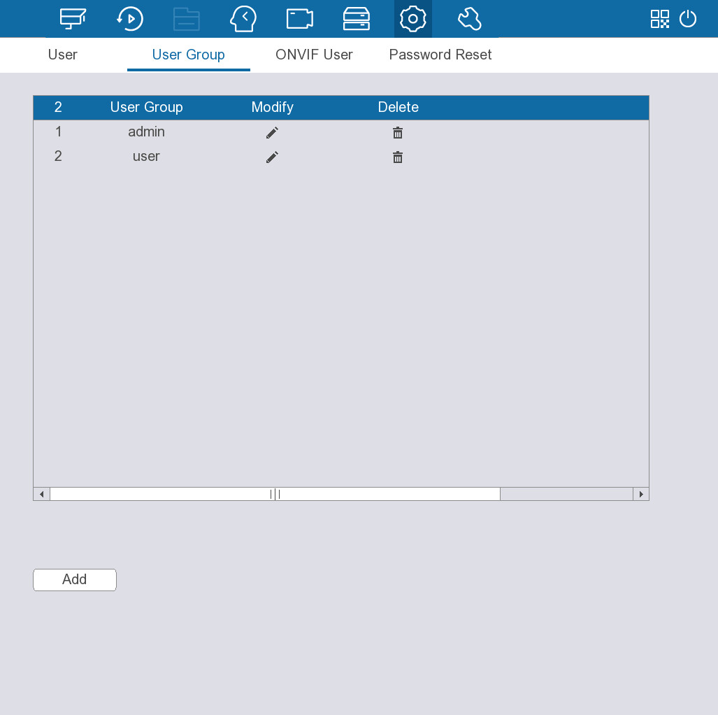
Step 2 Click Add.
Figure 5-79 Add user group
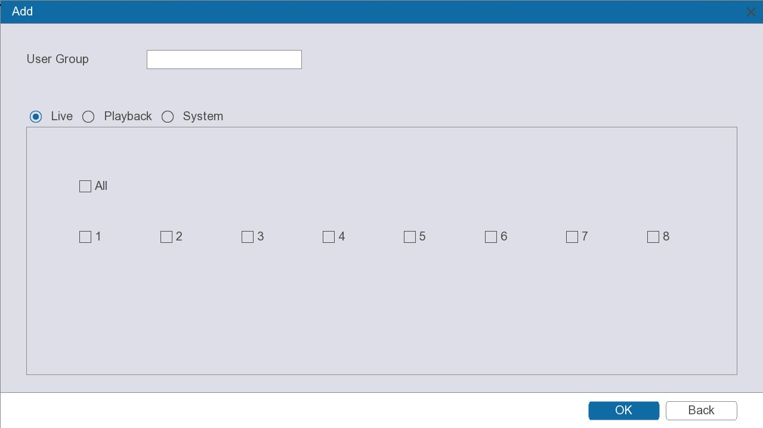
Step 3 Enter group name.
Step 4 Select the checkbox under the Live tab, Playback tab, and System tab as required respectively.
Step 5 Click OK.

5.12.2.3 Adding ONVIF Users
The devices from other manufacturers can connect with the device through ONVIF protocol by using a verified ONVIF account.
Procedure
Step 1 Select System > User Management > ONVIF User.
Step 2 Click Add.
Figure 5-80 Add ONVIF user
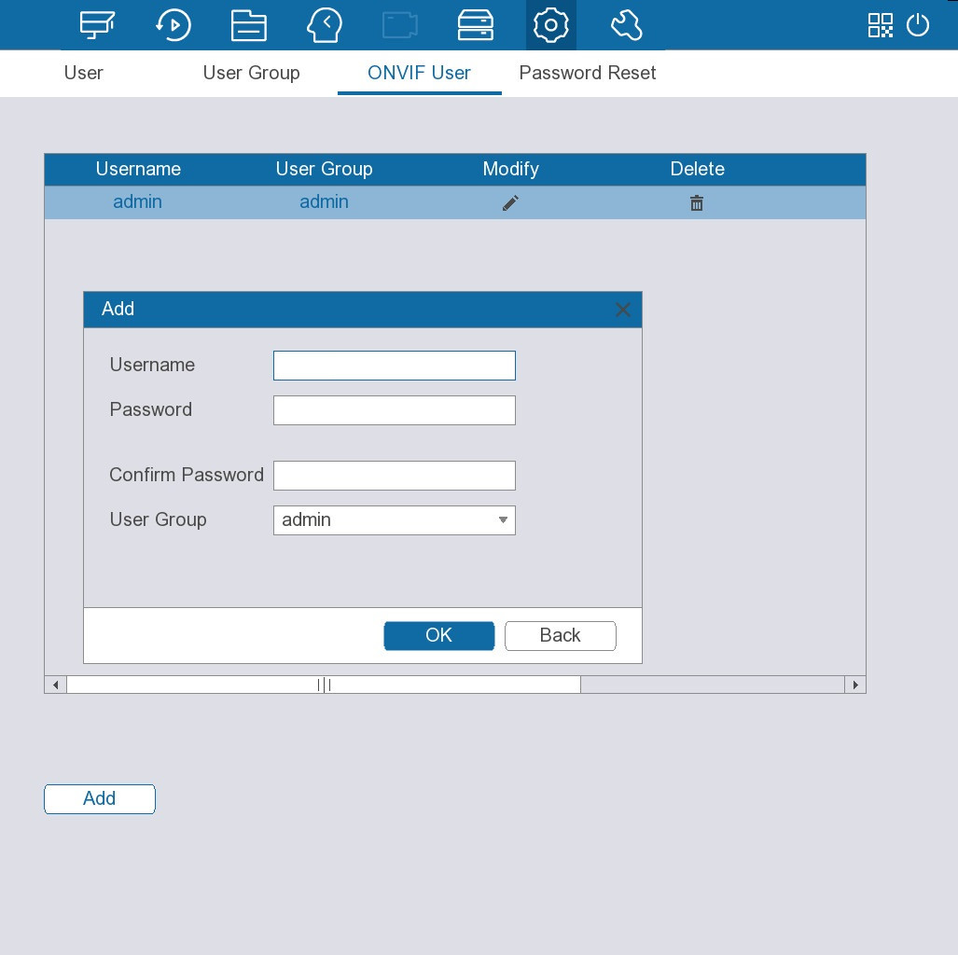
Step 3 Configure username, password and user group.
There are three ONVIF user groups by default: admin, operator and user. You cannot add ONVIF user group manually.
Step 4 Click OK.

5.12.2.4 Resetting Password
You can use email address or answer the security questions to reset password if you forgot it.

5.12.2.4.1 Configuring Password Reset
Configure the linked email address and security questions that are used to reset the password.
Procedure
Step 1 Select System > User Management > Password Reset.
Figure 5-81 Password reset
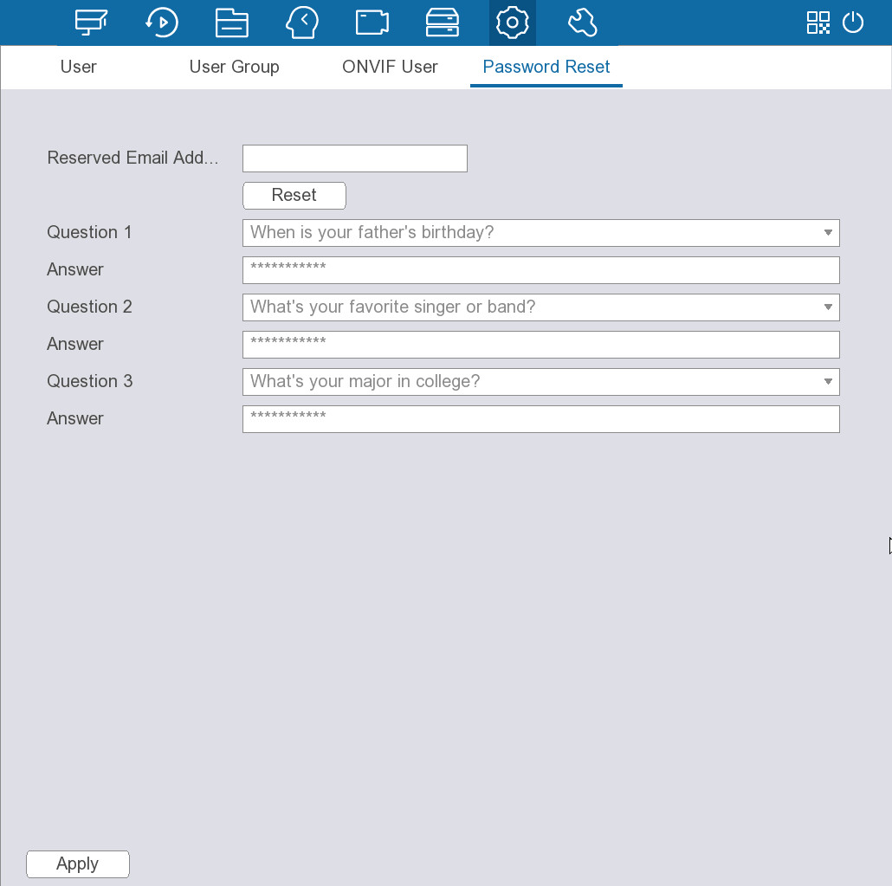
Step 2 Enter an email address to receive the security code used to reset the password.
Step 3 Set security questions.
Step 4 Click Apply.

5.12.2.4.2 Resetting Password on Local Interface
Procedure
Step 1 After the Device starts, click the live page.
Figure 5-82 Login
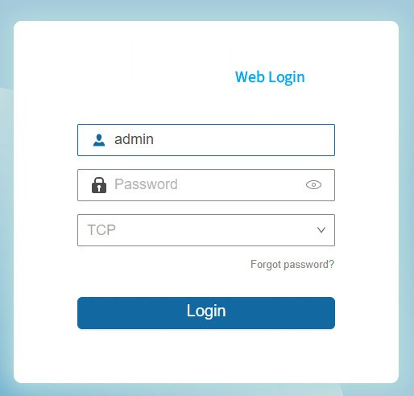
Step 2 Click Forgot password?.
● If you have configured the linked email address, the system will notify you of data collection required for resetting password.
● If you have not configured the linked email address, the system prompts you to enter an email address. Enter the email address and then click Next. Then the system will notify you of data collection required for resetting password.
Step 3 Read the prompt, and then click OK.
Figure 5-83 Prompt
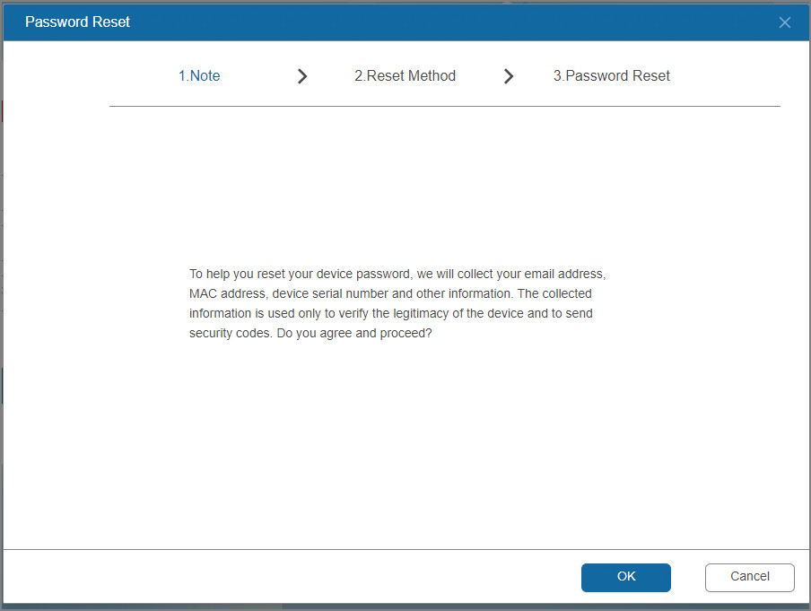
Step 4 Reset the password by means of mail recovery.
Figure 5-84 Reset password
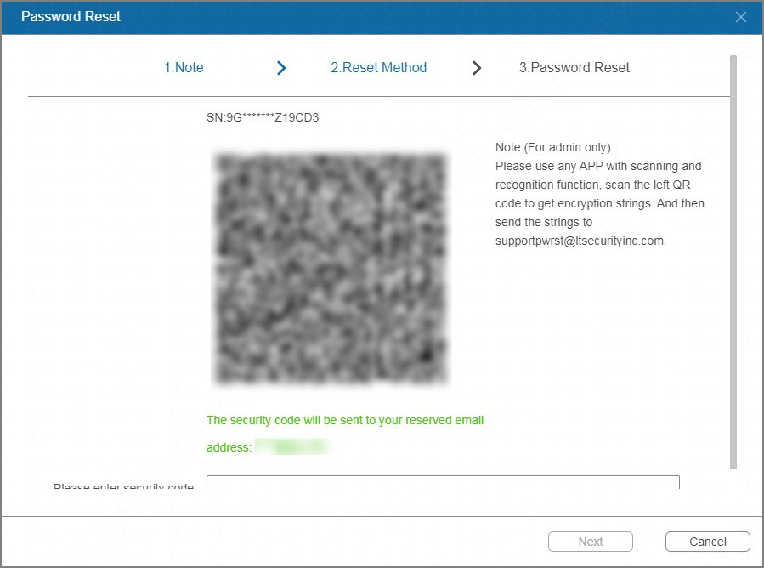
Follow the on-screen instructions to obtain the security code in your linked email address, and then enter the security code.
● You can get the security code twice by scanning the same QR code. After that, you need refresh the page and then scan the QR code to get the security code.
● The security code sent to your email box is valid within 24 hours. Check your email box in time.
Step 5 Click Next.
Step 6 Enter the new password, and then enter the password again to confirm it.
Step 7 Click OK.

5.12.3 Configuring Network Settings
Configure the network settings to ensure the Device can communicate with other devices.

5.12.3.1 Configuring Basic Settings

5.12.3.1.1 Configuring TCP/IP Settings
You can configure the settings for the device such as IP address, DNS according to the networking plan.
Procedure
Step 1 Select System > Network > Basic > TCP/IP.
Figure 5-85 TCP/IP
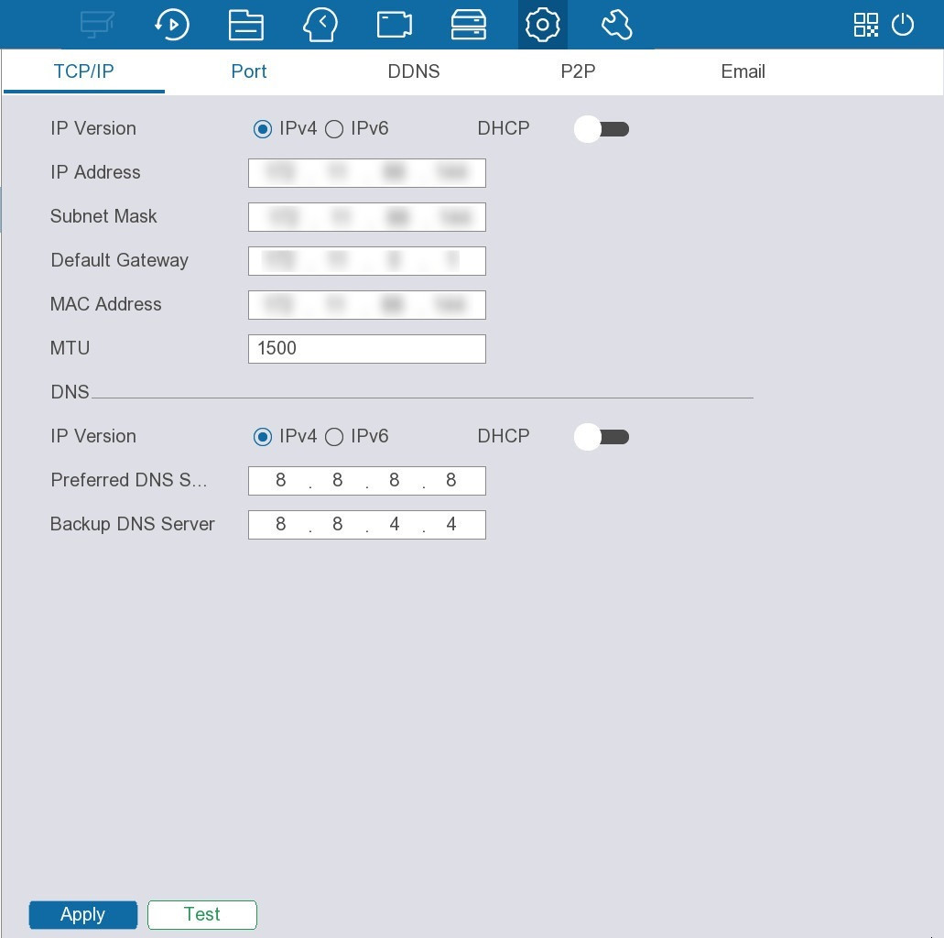
Step 2 Configure the network adapter.
Table 5-30 Network adapter parameters
Parameter | Description
IP Version | Both IPv4 and IPv6 are available.
DHCP | Enable the system to allocate a dynamic IP address to the Device. There is no need to set IP address manually.
IP Address | Enter the IP address and configure the corresponding subnet mask and default gateway.  ● The IP address and the default gateway must be on the same network segment.  ● Click Test to test whether the IP address is available.
Subnet Mask
Default Gateway
MAC Address | Displays the MAC address of the Device.
MTU | Displays the MTU value of the network adapter.
Step 3 Configure the DNS server information, including IP version, and the IP addresses of the preferred DNS server, and backup DNS server.
Step 4 Click Apply.

5.12.3.1.2 Configuring Port Settings
You can configure the maximum connection for accessing the device from web, platform, mobile phone or other clients at the same time, and configure each port settings.
Procedure
Step 1 Select System > Network > Basic > Port.
Figure 5-86 Port
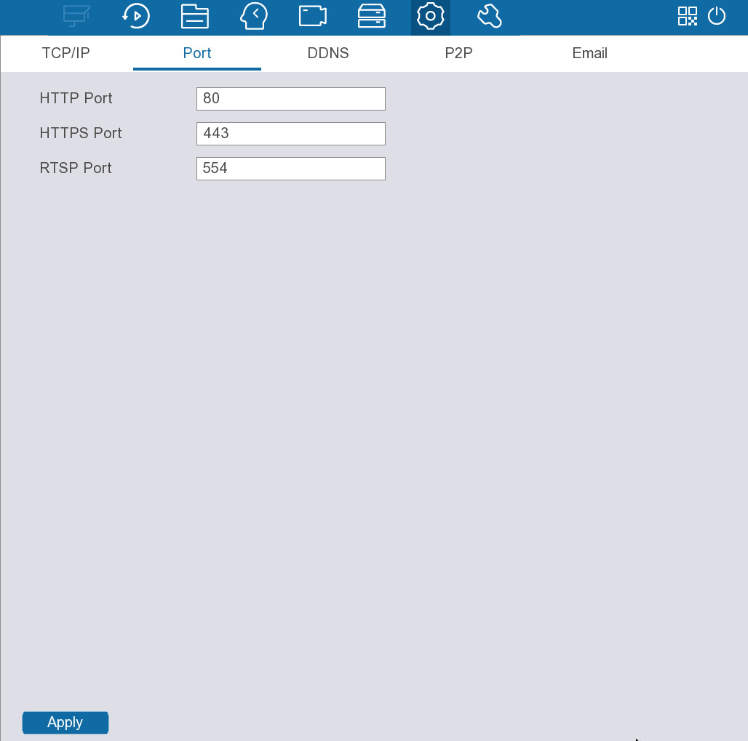
Step 2 Configure the parameters.
Table 5-31 Port parameters
Parameter | Description
HTTP Port | The default value setting is 80.  If you change the port number, for example, 90, then you should enter 90 after the IP address when logging in to the web interface of the Device.
HTTPS Port | HTTPS communication port. The default value is 443. You can enter the value according to your actual situation.
RTSP Port | The default value setting is 554. You can enter the value according to your actual situation.
Step 3 Click Apply.

5.12.3.1.3 Configuring DDNS Settings
After you enable DDNS, when the IP address of the Device changes frequently, the system dynamically updates the relation between domain name and IP address on DNS server. You can use domain name to remotely access the Device.
Prerequisites
Check the type of DDNS that the Device supports and then log in to the website provided by the DDNS service provider to register domain and other information.
After registration, you can log in to the DDNS website to view the information of all the connected devices under the registered account.
Procedure
Step 1 Select System > Network > Basic > DDNS.
Figure 5-87 DDNS
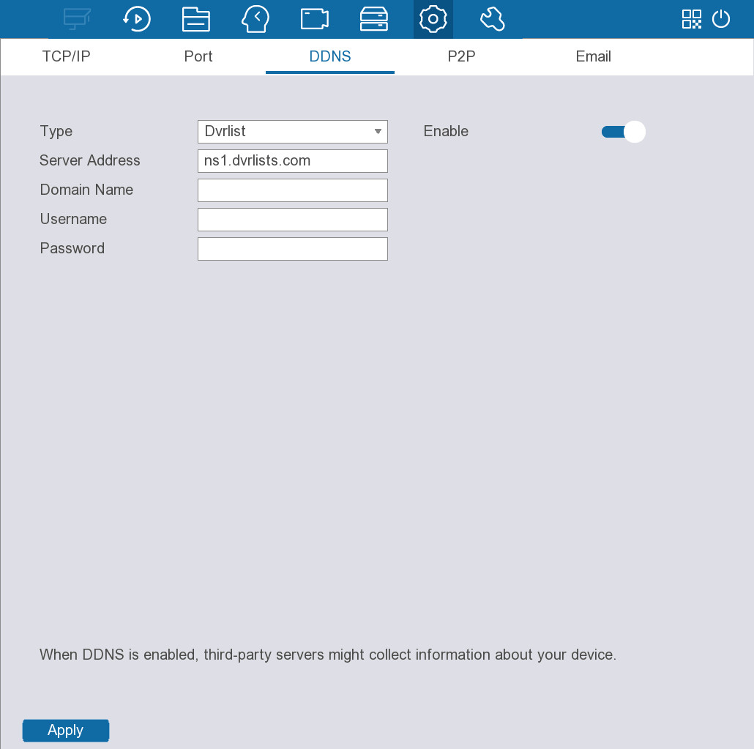
Step 2 Click to enable the function.
Step 3 Configure the parameters.
Table 5-32 DDNS parameters
Parameter | Description
Type | Displays the type and address of the DDNS service provider.  ● For Dvrlist, the default address is nsl.dvrlists.com.  ● For NO-IP DDNS, the default address is dynupdate.no-ip.com.  ● For CN99 DDNS, the default address is members.3322.org.
Server Address
Domain Name | Enter the domain name that you have registered on the DDNS website.
Username | Enter the username and password provided from DDNS service provider.
Password
Step 4 Click Apply.
If the configuration is successful, you can access the web interface of the device by using the domain name.

5.12.3.1.4 Configuring P2P Settings
P2P is a peer to peer technology. After downloading mobile app and registering the Device to the app, you can manage the Device remotely on the phone.
Procedure
Step 1 Select System > Network > Basic > P2P.
Figure 5-88 P2P
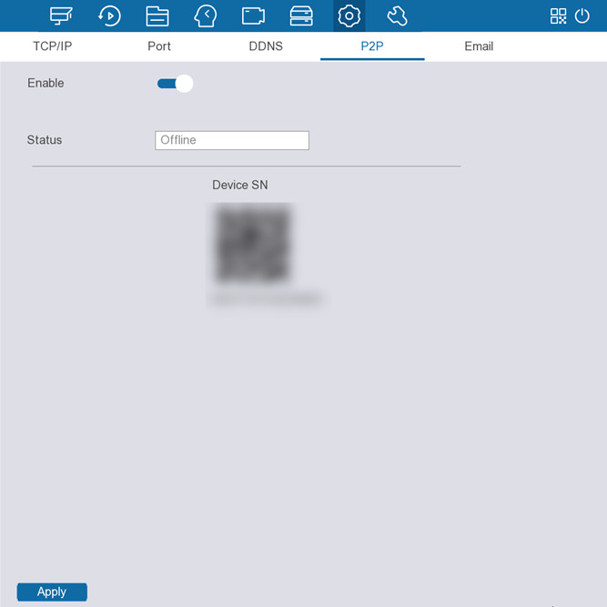
Step 2 Click to enable the function.
Step 3 Click Apply.
The P2P function is enabled. After downloading and installing the mobile client, you can use the mobile client to scan the SN QR code to add the Device for remote management.

5.12.3.1.5 Configuring Email Settings
Configure the email settings to enable the system to send the email as a notification when an alarm event occurs.
Procedure
Step 1 Select System > Network > Basic > Email.
Figure 5-89 Email
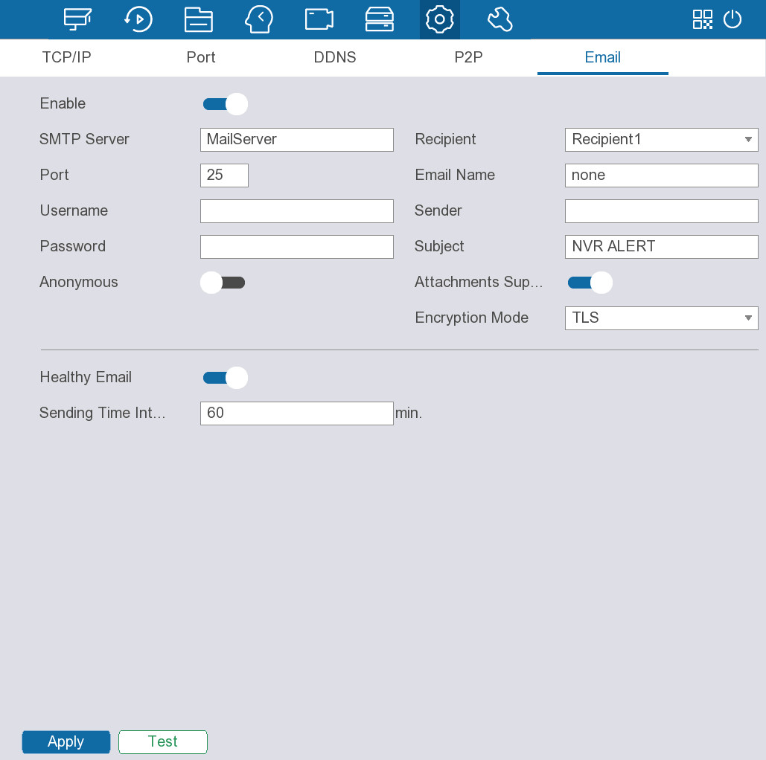
Step 2 Click to enable the function.
Step 3 Configure the parameters.
Table 5-33 Email parameters
Parameter | Description
SMTP Server | Enter the SMTP server address of the sender’s email account.
Port | Enter the port of SMTP server. The default value is 25.
Username | Enter the username and password of sender’s email account.
Password
Anonymous | Enable anonymous login.
Recipient | Select the number of recipient to receive the notification. The Device supports up to three mail recipients.
Email Name | Enter the email address of mail recipient.
Sender | Enter the email address of the sender. You can enter up to three senders separated by comma.
Subject | Enter the email subject.
Attachments supported | After enabling the attachment function, when an alarm event occurs, the system attaches snapshots as an attachment to the email.
Encryption Mode | Select None, SSL, or TLS.  For SMTP server, the default encryption type is TLS.
Healthy Mail | Enable the system to send a test email to check the connection.
Sending Time Interval | Set the interval at which the system send the health test email.
Step 4 Click Apply.
Step 5 (Optional) Click Test to test the email sending function. If the configuration is correct, the recipient will receive the email.

5.12.3.2 Configuring Security Settings
You can configure the basic services, HTTPS function, and firewall for the Device.

5.12.3.2.1 Configuring Basic Services
Enable basic services such as mobile push notification, ONVIF, NTP and SSH. HTTPS helps to protect user information and ensure device security and data security. We recommend enabling this function.
Procedure
Step 1 Configure basic services.
1) Select System > Network > Security > Basic Service.
Figure 5-90 Basic service
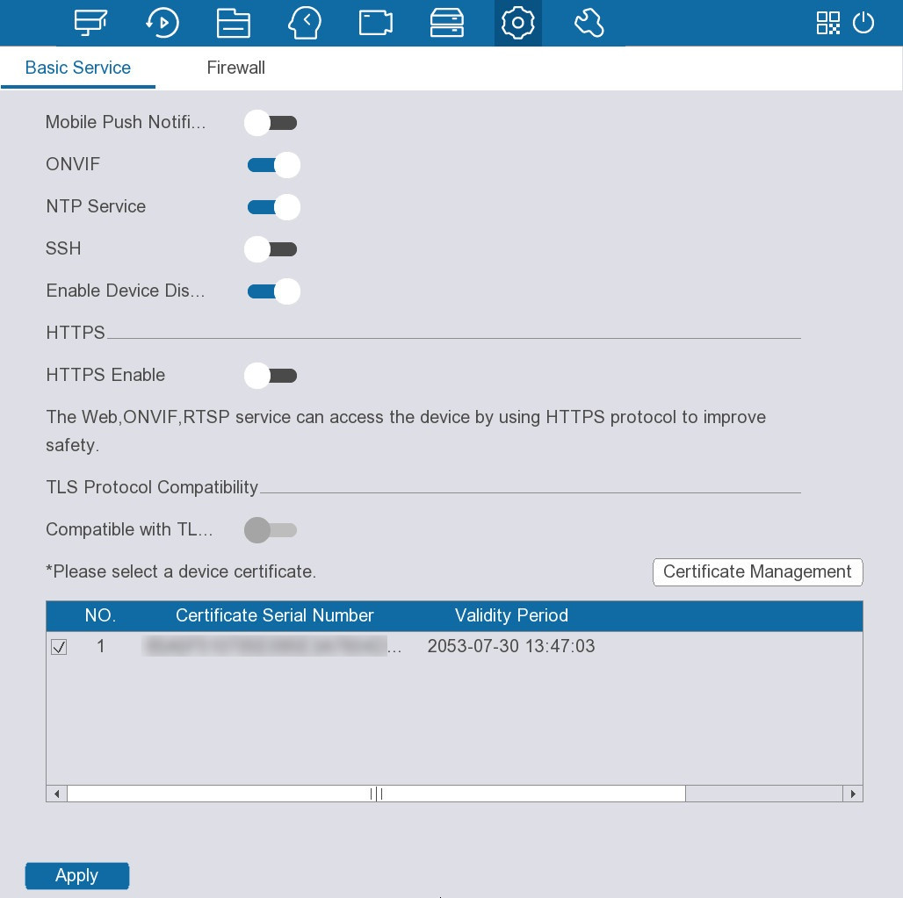
2) Click to enable the system services.
Table 5-34 Basic system services
Parameter | Description
Mobile Push Notification | After enabling this function, you can receive alarm information from the Device on the mobile client.  To reduce security risks, disable this function when it is not needed.
ONVIF | After the function is enabled, remote devices can connect to the device through the ONVIF protocol.  To reduce security risks, disable this function when it is not needed.
NTP Service | After enabling this function, you can use the NTP server for time synchronization.
SSH | After enabling this function, you can access the device through the SSH protocol for system debugging and IP configuration.  To reduce security risks, disable this function when it is not needed.
Enable Device Discovery | Enable the device to be found by other devices through search.
3) Click to enable the HTTPS function.
4) Click to enable compatibility with the TLS protocol.
TLS (Transport Layer Security) provides privacy and data integrity between 2 communications applications.
5) Click Certificate Management to create an HTTPS certificate.
a. Click Install Device Certificate.
b. Configure the parameters.
c. Click Create.
Figure 5-91 Create certificate
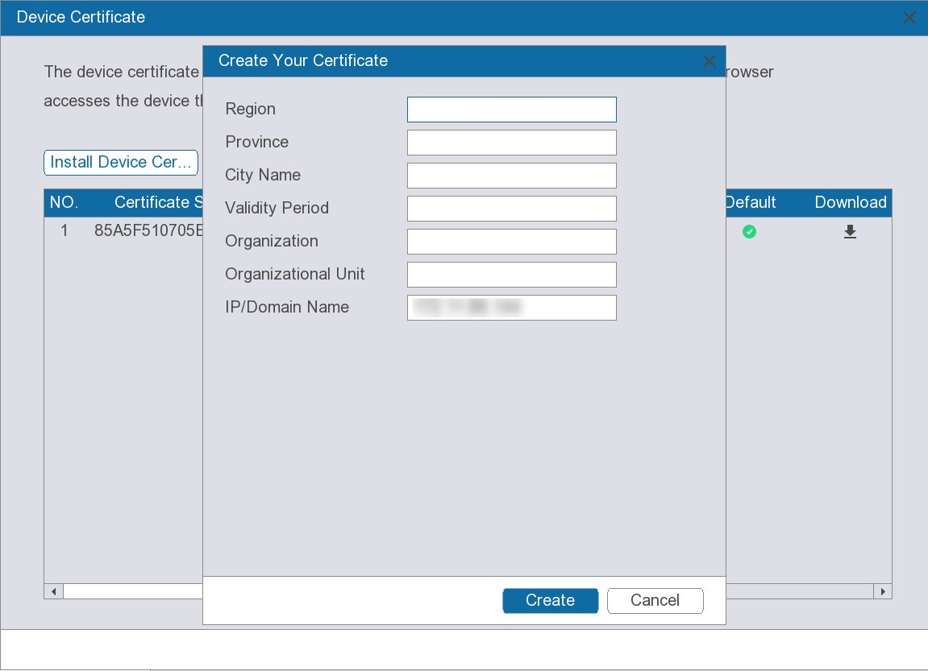
Step 2 Click Apply.

5.12.3.2.2 Configuring Firewall
You can configure the hosts that are allowed or prohibited to access the device.
Procedure
Step 1 Select System > Network > Security > Firewall.
Figure 5-92 Firewall
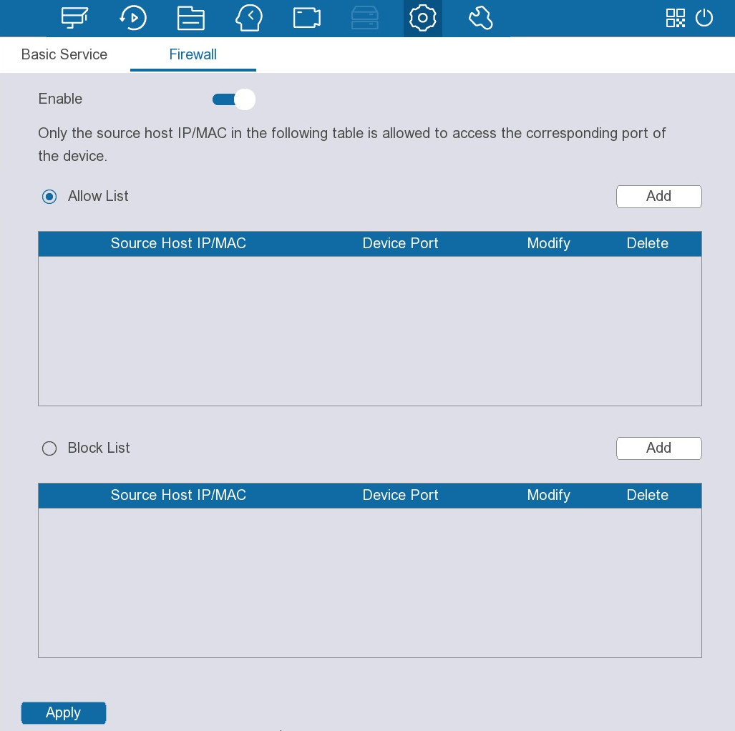
Step 2 Click to enable the firewall.
Step 3 Select a firewall mode.
● Allow list: The hosts on the allowlist can access the device.
● Block list: The hosts on the blocklist are prohibited to access the device.
Step 4 Click Add and then select a type for the allowlist or blocklist.
You can allow or prohibit a specific IP address, IP addresses on a specific network segment, or a specific MAC address to access the Device.
● IP address.
Enter the IP address, starting port and ending port, and then click OK.
● IP segment.
Enter the start address and end address, starting port and ending port, and then click OK.
● MAC address.
Enter the MAC address, and then click OK.
Step 5 Click Apply.

5.12.4 Configuring Events

5.12.4.1 Disarming All
You can disarm all alarm linkage actions with one click.
Procedure
Step 1 Select System > Events > Disarm All.
Figure 5-93 Disarming all
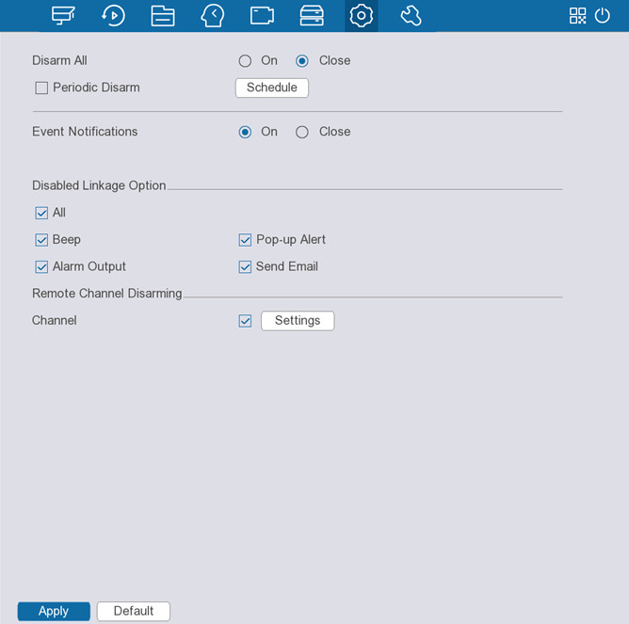
Step 2 Enable disarm all or periodic disarm.
● Disarm all: Select On to enable this function.
The alarm will take effect at all times.
● Periodic disarm: Select Close for Disarm All, and then click Schedule to set the disarm period.
The alarm will take effect at a specific time.
Periodic disarm is available only when disarm all is disabled.
Step 3 Enable Event Notifications as needed.
You can select On or Close.
Step 4 Select the alarm linkage actions that you want to disarm.
Table 5-35 Alarm linkage actions
Parameters | Description
Beep | Enable the Device to make a beep noise when an alarm occurs.
Alarm Output | Click Settings next to Alarm Output, click to enable the local alarm, and then select alarm output port as required.  Make sure that the alarm state of the alarm output port has been configured. For details, see "5.12.4.3.3 Configuring Alarm Output".
Pop-up Alert | Enable on-screen prompt of detected motion.
Send Email | Enable the system to send an email to notify you of an alarm event.  ● This function is available on select models.  ● Make sure that the email function has been configured in System > Network > Basic > Email.
Step 5 To disarm remote channels, select the checkbox at Channel, and then click Settings to select channels.
This function is only effective when the connected camera supports one-click disarming.
Step 6 Click Apply.

5.12.4.2 Configuring Video Detection Alarms
You can configure alarms for events such as motion detection, scene changing, and video tampering.

5.12.4.2.1 Configuring Motion Detection Alarms
When a moving object appears and moves fast enough to reach the defined sensitivity threshold, an alarm is triggered.
Procedure
Step 1 Select System > Events > Video Detection > Motion Detection.
Figure 5-94 Motion detection
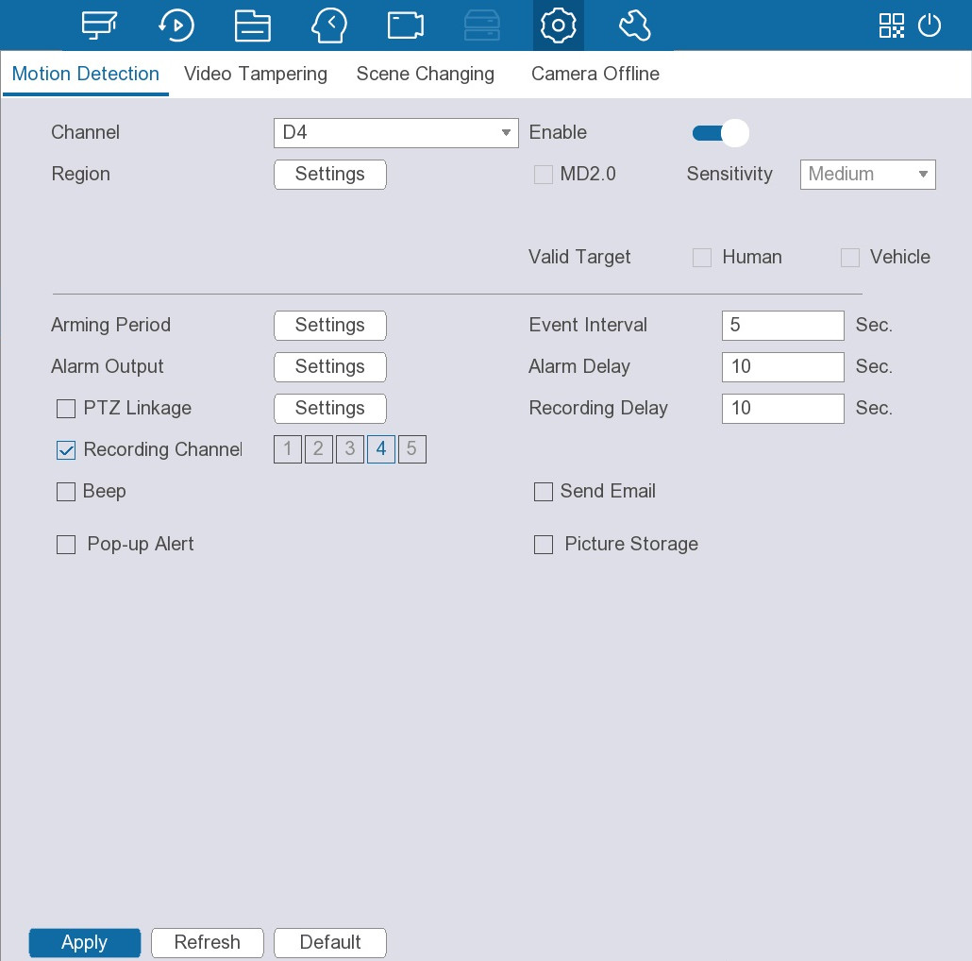
Step 2 Select a channel, and then click next to Enable to enable motion detection.
Step 3 Click Settings next to Region to configure the detection region.
1. Point to the middle top of the page.
Figure 5-95 Detection region
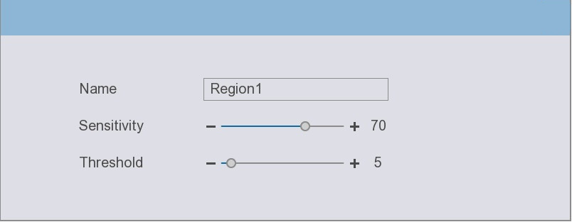
2. Configure the parameters.
● Name: Enter a name to identify the region.
● Sensitivity: Configure the sensitivity for motion detection. The higher the value, the easier to trigger alarm but meanwhile the higher the false alarm rate. We recommend using the default setting.
● Threshold: An alarm is triggered when the percentage of the detected target to the detection region reaches or exceeds the defined threshold.
You can set up to 4 detection regions. When motion is detected in any one of the 4 regions, the corresponding channel will trigger an alarm.
Step 4 Select the checkbox next to MD2.0, select the sensitivity, and then select the valid target from Human or Vehicle.
The higher the sensitivity, the easier to trigger an alarm.
When the MD2.0 function is enabled, only huamn or vehicle can be detected, and then the alarm is trigged.
Step 5 Configure other parameters.
Table 5-36 Alarm settings
Parameter | Description
Arming Period | Click Settings to set the arming period for motion detection.
Alarm Output | Click Settings next to Alarm Output, click to enable the local alarm, and then select alarm output port as required.  Make sure that the alarm state of the alarm output port has been configured. For details, see "5.12.4.3.3 Configuring Alarm Output".
PTZ Linkage | Select the checkbox and then click Settings to configure PTZ linkage.  Make sure that the PTZ control has been configured. For details, see "5.5.4 PTZ".
Recording Channel | Select one or more channels for recording.  Make sure that the recording plan and recording mode has been configured in Storage > Recording Plan.
Beep | Enable the Device to make a beep noise when an alarm occurs.
Pop-up Alert | Enable on-screen prompt of detected motion.
Event Interval | Configure the period from the end of motion detection to the end of alarm linkage action.
Alarm Delay | When alarm delay is configured, alarm continues for an extended period after the alarm ends.
Recording Delay | Configure the length of time for the Device to continue recording after the alarm ends.
Send Email | Enable the system to send an email to notify you of an alarm event.  ● This function is available on select models.  ● Make sure that the email function has been configured in System > Network > Basic > Email.
Picture Storage | When an alarm occurs, the system takes snapshots of the selected channel and stores them on the device.  Make sure that snapshot schedule and snapshot mode have been configured. For details, see "5.11.1 Configuring Recording Plan".
Step 6 Click Apply.

5.12.4.2.2 Configuring Video Tampering Alarms
Video tampering occurs when the camera lens is covered, or the video is displayed in a single color because of sunlight status or other reasons. You can configure alarms for such situations.
Procedure
Step 1 Select System > Events > Video Detection > Video Tampering.
Figure 5-96 Video tampering
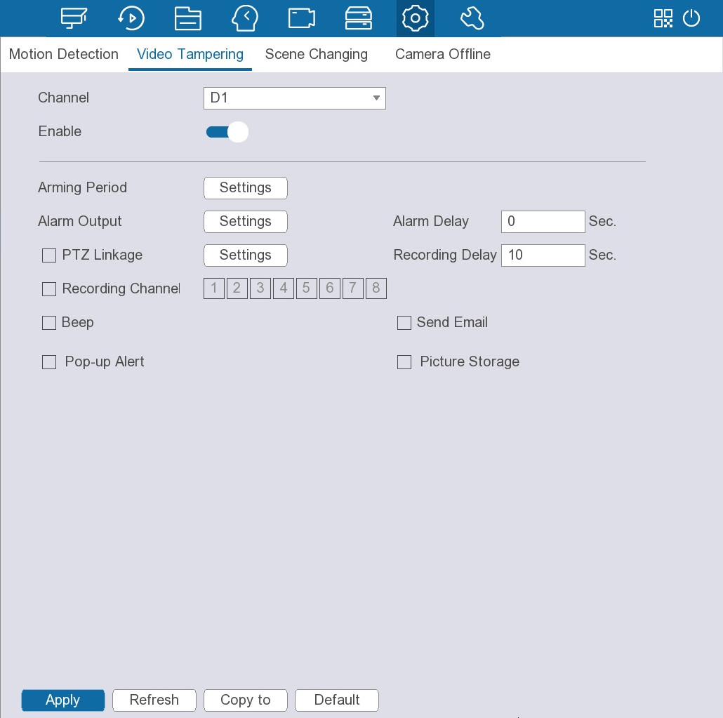
Step 2 Select a channel and then click to enable alarm against video tampering.
Step 3 Configure other parameters. For details, see Table 5-36.
Step 4 Click Apply.

5.12.4.2.3 Configuring Scene Changing Alarms
An alarm is triggered when the system detects scene change.
Procedure
Step 1 Select System > Events > Video Detection > Scene Changing.
Figure 5-97 Scene changing
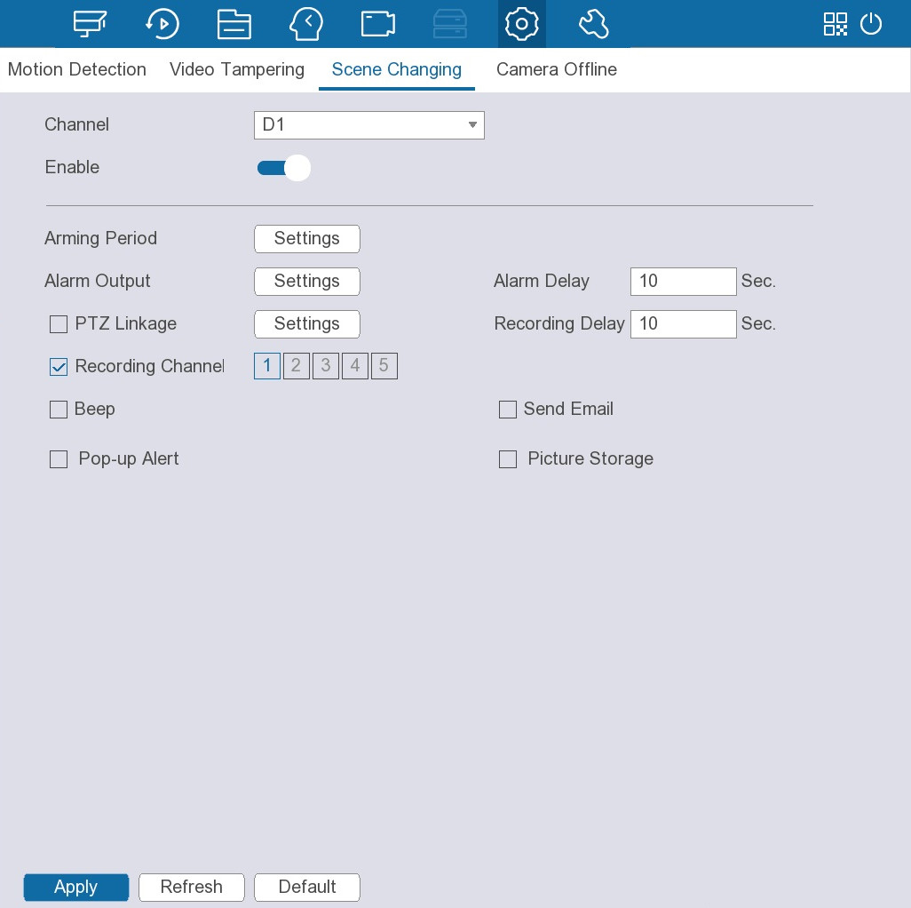
Step 2 Select a channel and then click to enable alarm against scene change.
Step 3 Configure other parameters. For details, see Table 5-36.
Step 4 Click Apply.

5.12.4.2.4 Configuring Camera Offline
An alarm is triggered when the camera is offline.
Procedure
Step 1 Select System > Events > Video Detection > Camera Offline.
Figure 5-98 Camera Offline
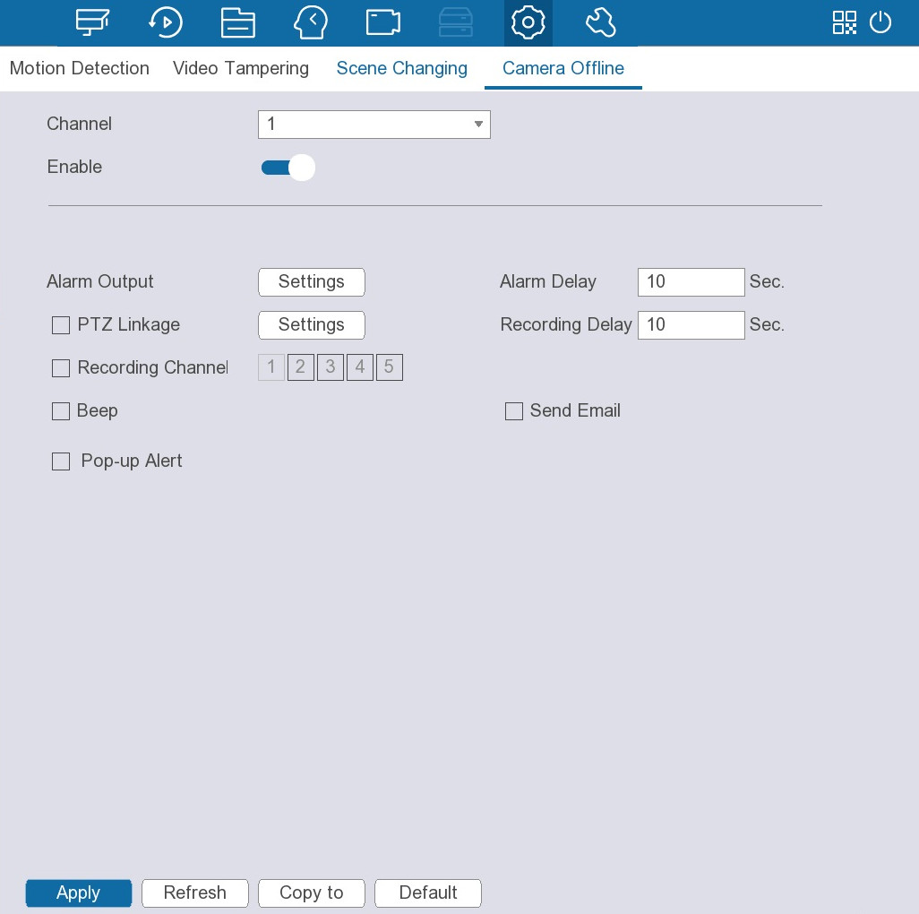
Step 2 Select a channel, and then click to enable alarm against video loss.
Step 3 Configure other parameters. For details, see Table 5-36.
Step 4 Click Apply.

5.12.4.3 Configuring Alarm Settings

5.12.4.3.1 Configuring Local Alarms
After connecting the alarm device to the NVR alarm input port, the system performs alarm linkage actions when there is an alarm signal from the alarm input port to the NVR.
Procedure
Step 1 Select System > Events > Alarm Settings > Local Alarm.
Figure 5-99 Local Alarm
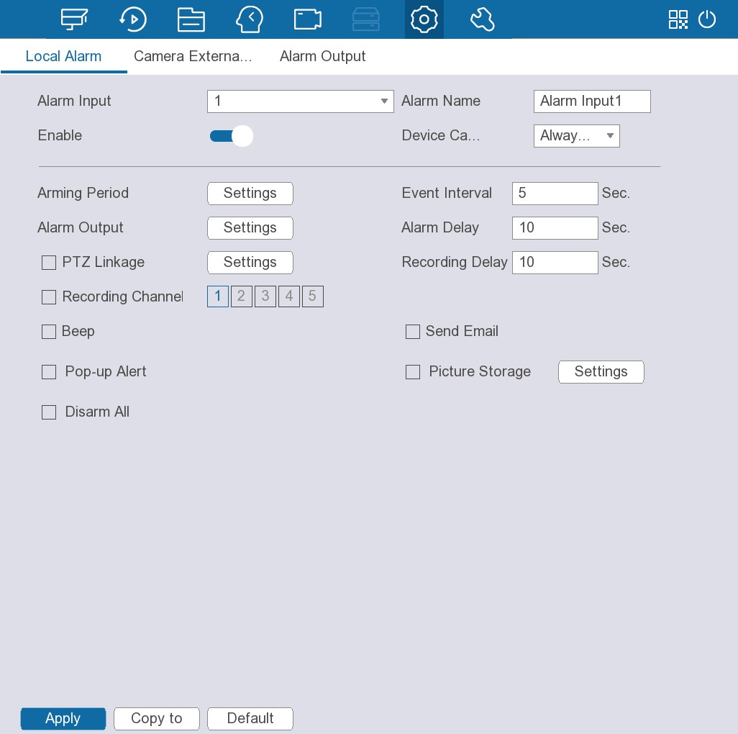
Step 2 Select an alarm input, and then set the alarm name.
Step 3 Click to enable the alarm.
Step 4 Select the device category from Always Closed and Always Open.
Step 5 Configure other parameters. For details, see Table 5-36.
Step 6 Click Apply.

5.12.4.3.2 Configuring Alarms from External Cameras
When the external alarm device of the camera triggers an alarm, the alarm signal is transmitted to the Device and then the system performs alarm linkage actions.
Procedure
Step 1 Select System > Events > Alarm Settings > Camera External Alarm.
Figure 5-100 Camera external alarm
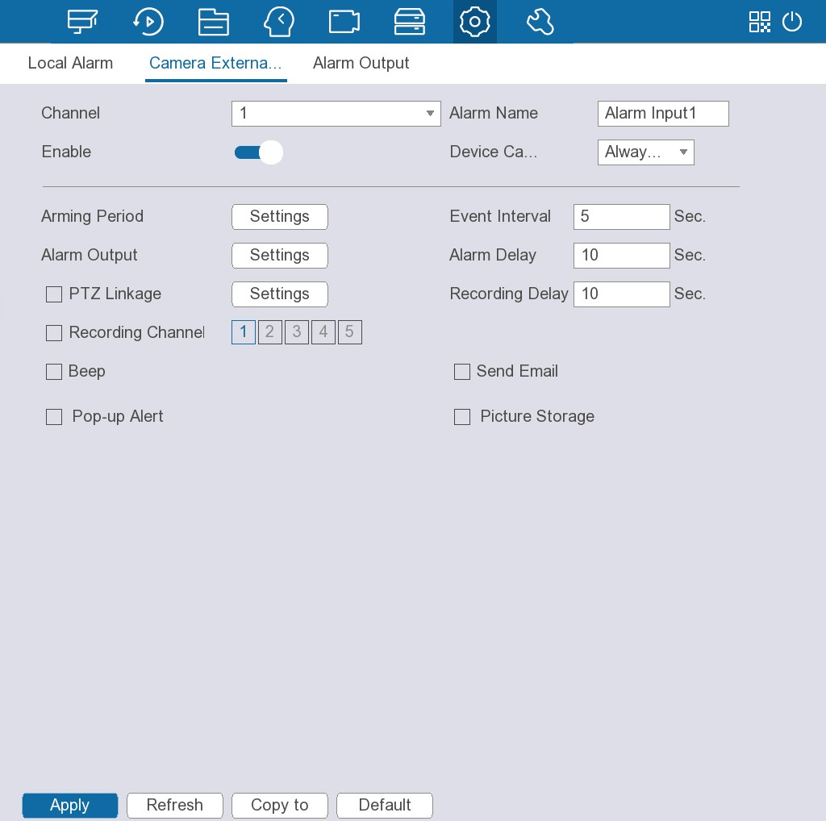
Step 2 Select a channel.
Step 3 Select an alarm input, and then set the alarm name.
Step 4 Click to enable the alarm.
Step 5 Select the device category from Always Closed and Always Open.
Step 6 Configure other parameters. For details, see Table 5-36.
Step 7 Click Apply.

5.12.4.3.3 Configuring Alarm Output
You can set proper alarm output mode to automatic, manual or close. After you connect the alarm device to the alarm output port of NVR, and set the mode to automatic, the system performs alarm linkage actions when an alarm occurs.
Background Information
● Automatic: Once an alarm event occurs, the system generates an alarm.
● Manual: Alarm device is always on the alarming mode.
● Close: Disable the alarm output function.
Procedure
Step 1 Select System > Events > Alarm Settings > Alarm Output.
Step 2 Select the alarm mode of the alarm output channel.
Figure 5-101 Alarm output
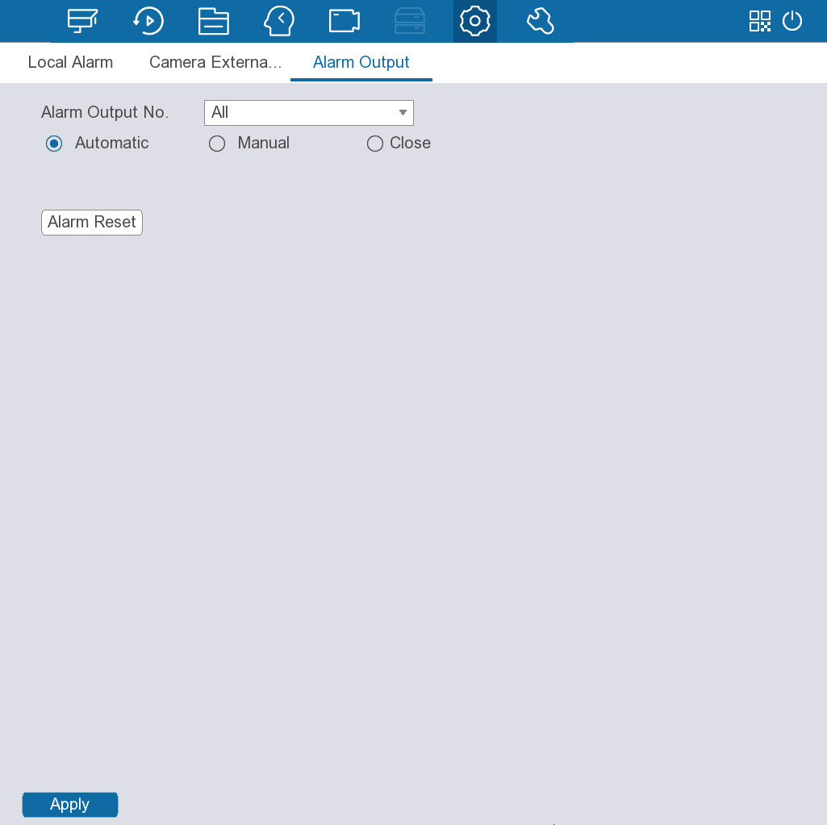
Step 3 Click Apply.
● Click Alarm Reset to clear all alarm output statuses.
● View the alarm output status on the Status column.

5.12.4.4 Configuring Error Alarms
You can configure alarms for system errors.

5.12.4.4.1 Configuring Storage Error Alarms
An alarm is triggered when a storage error occurs.
Procedure
Step 1 Select System > Events > Exception > Hard Disk Drive.
Figure 5-102 HDD alarm
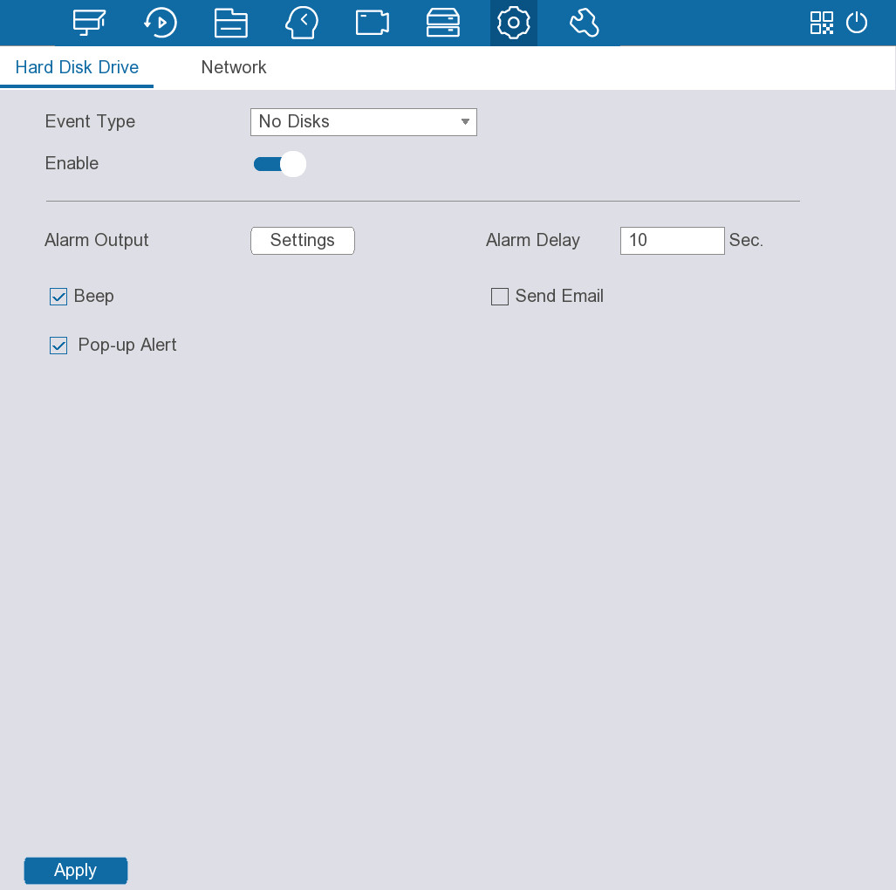
Step 2 Select an event type from No disks, Hard Disk Error and Insufficient storage capacity.
Step 3 Click to enable the alarm.
Step 4 Configure other parameters.
Table 5-37 Alarm settings
Parameter | Description
Alarm Output | Click Settings next to Alarm Output, click to enable the local alarm, and then select alarm output port as required.  Make sure that the alarm state of the alarm output port has been configured. For details, see "5.12.4.3.3 Configuring Alarm Output".
Beep | Select the checkbox to enable the Device to make a beep noise when an alarm occurs.
Pop-up Alert | Enable on-screen prompt of an alarm event.
Alarm Delay | When alarm delay is configured, alarm continues for an extended period after the alarm ends.
Send Email | Enable the system to send an email to notify you of an alarm event.  ● This function is available on select models.  ● Make sure that the email function has been configured in Main Menu > Network Settings > Email.
Step 5 Click Apply.

5.12.4.4.2 Configuring Network Error Alarms
An alarm is triggered when a network error occurs.
Procedure
Step 1 Select System > Events > Exception > Network.
Figure 5-103 Network alarm
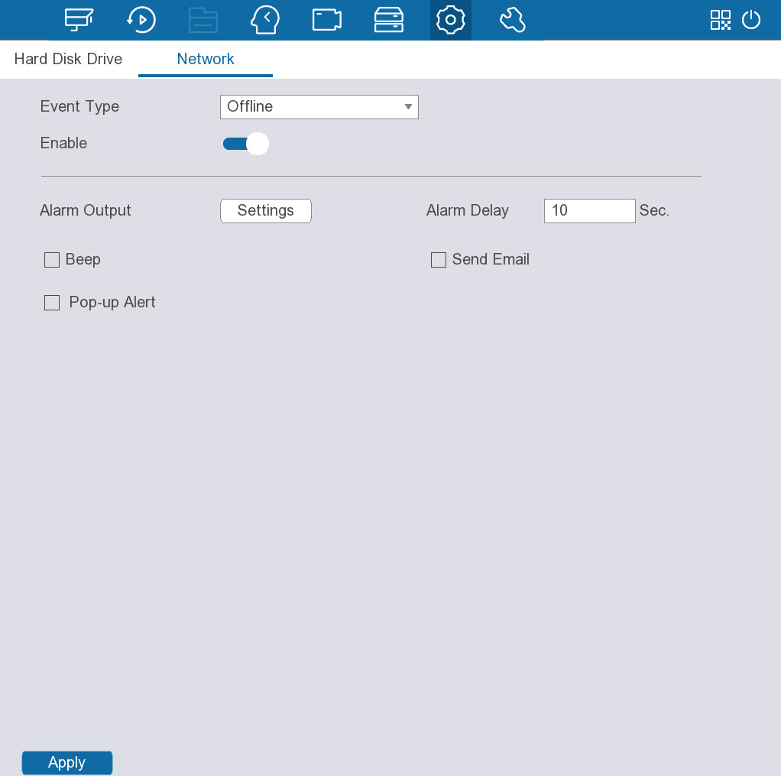
Step 2 Select an event type from Offline, IP Conflict and MAC conflict.
Step 3 Click to enable the alarm.
Step 4 Configure other parameters.
Table 5-38 Alarm settings
Parameter | Description
Alarm Output | Click Settings next to Alarm Output, click to enable the local alarm, and then select alarm output port as required.  Make sure that the alarm state of the alarm output port has been configured. For details, see "5.12.4.3.3 Configuring Alarm Output".
Beep | Select the checkbox to enable the Device to make a beep noise when an alarm occurs.
Pop-up Alert | Enable on-screen prompt of an alarm event.
Alarm Delay | When alarm delay is configured, alarm continues for an extended period after the alarm ends
Send Email | Enable the system to send an email to notify you of an alarm event.  ● This function is available on select models.  ● Make sure that the email function has been configured in Main Menu > Network Settings > Email.
Step 5 Click Apply.

5.12.4.5 Searching for Alarm Information
You can search for, view and back up the alarm information.
Procedure
Step 1 Select System > Events > Event Search.
Step 2 Set the search period, and then select an event type.
Step 3 Click Search.
Figure 5-104 Search results
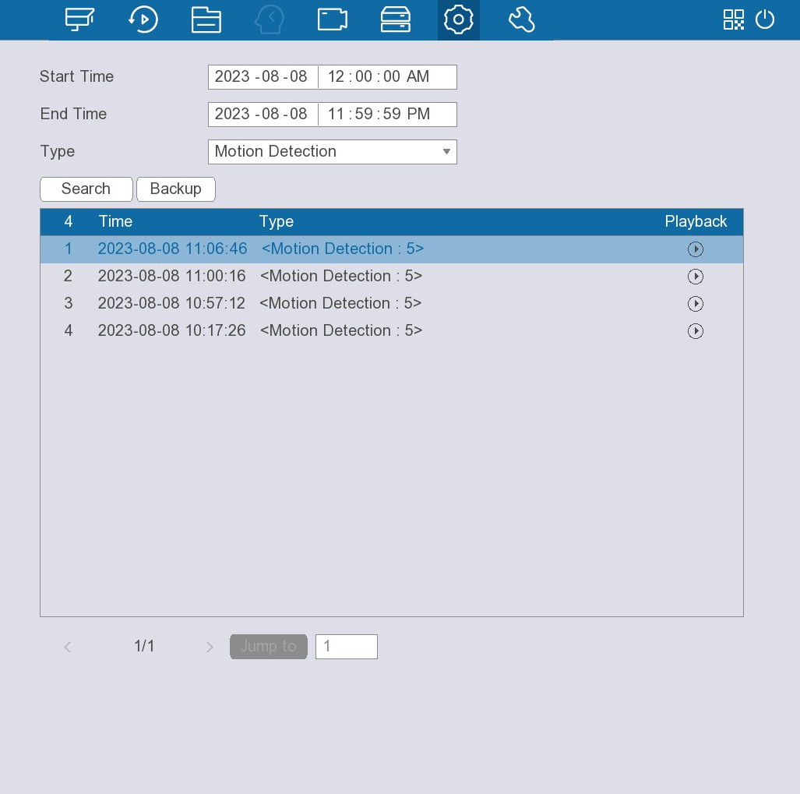
Related Operations
● View details.
Select a record, and then double-click an alarm record to view details.
● Back up.
Click Backup to save the alarm information to a USB storage device.
● Play recorded video.
Click to play the recorded video of the alarm event.

5.12.4.6 Viewing Alarm Status
Select System > Events > Event Search to view alarm status.
Figure 5-105 Alarm status
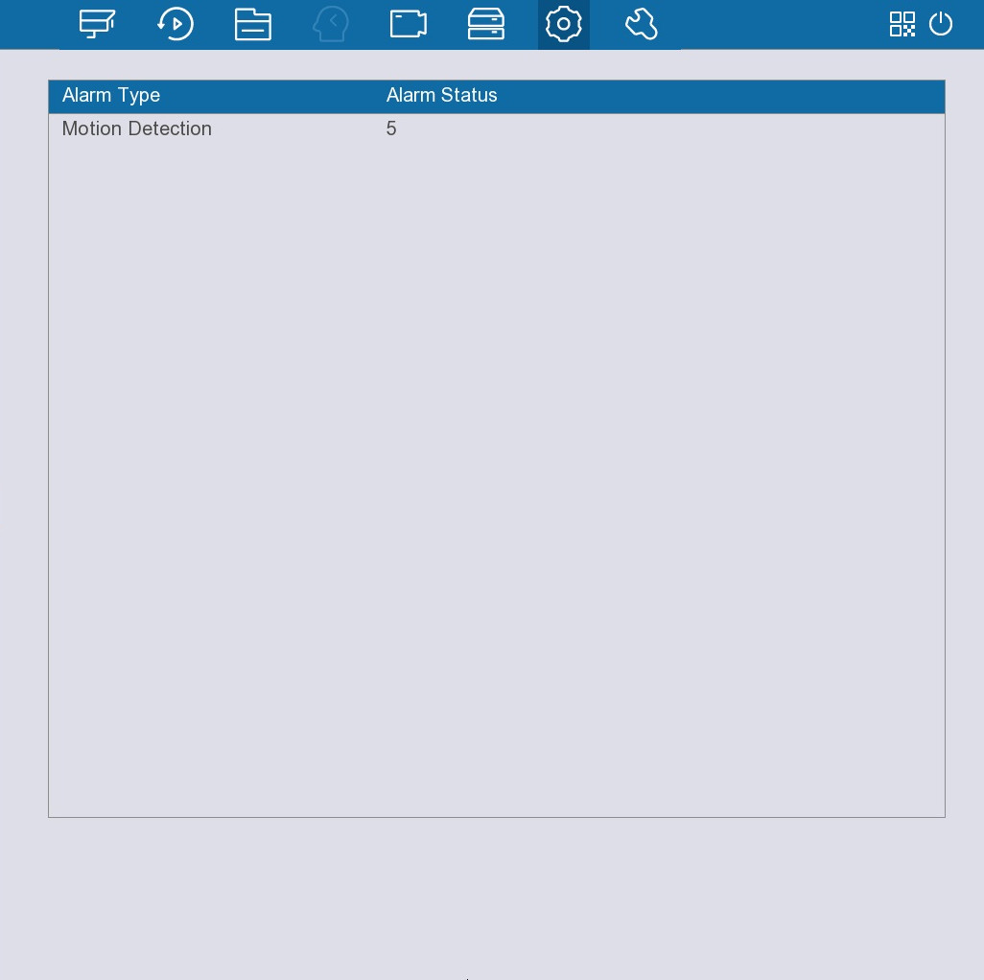

5.12.5 Configuring Display Settings

5.12.5.1 Configuring Display Output
You can configure whether to display time title and channel, adjust image transparency, set the resolution and more.
Procedure
Step 1 Configure the home screen.
1. Select System > Display Output.
Figure 5-106 Display output
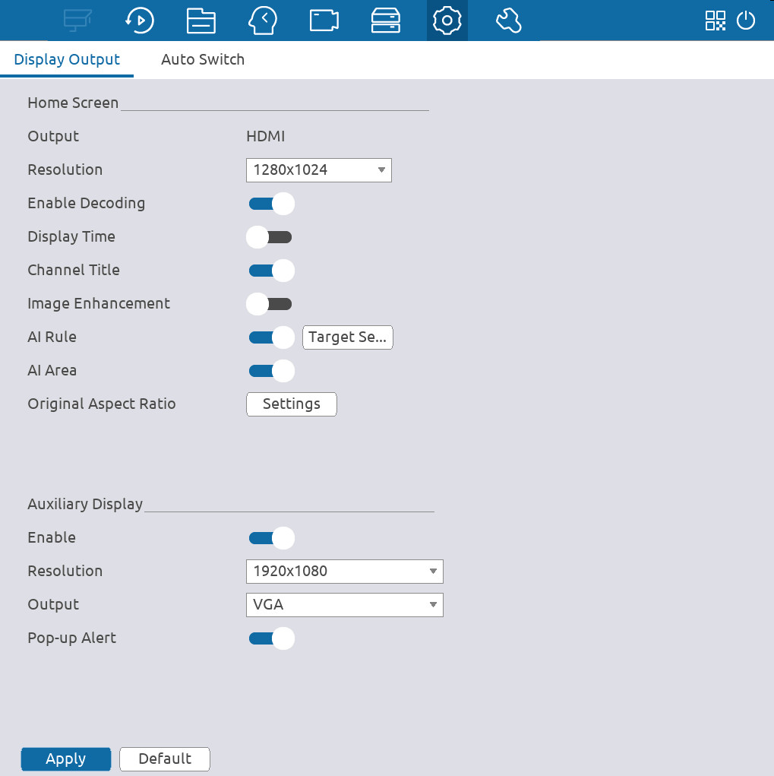
2. Configure the display parameters.
Table 5-39 Display parameters
Parameter | Description
Resolution | Select a resolution for the video image. The default value is 1280 × 1024.
Enable Decoding | Enable the decoding function.
Display Time | Displays time information in each live channel window.
Channel Title | Displays channel name, channel number and recording status in each live channel window.
Image Enhancement | After the function is enabled, the system optimizes the live images.
Smart Rule | Displays smart rule in each live channel window.
AI Area | Enable display of AI area.
Original Aspect Ratio | Click Settings, and then select one or more channels to restore the channel image to the original scale.
Pop-up Alert | Enable on-screen prompt of detected motion.
Step 2 Configure the auxiliary screen.
1. Click to enable this function.
2. Configure the display parameters. For details, please refer to Table 5-39.
Step 3 Click Apply.

5.12.5.2 Configuring Auto Switch
You can configure a tour of selected channels to repeat playing videos. The videos are displayed in turn according to the channel group configured in tour settings. The system displays one channel group for a certain period and then automatically changes to the next channel group.
Procedure
Step 1 Select System > Display > Auto Switch.
Step 2 Select Home Screen or Auxiliary Screen from Screen Number.
Step 3 Click to enable this function.
Figure 5-107 Auto Switch
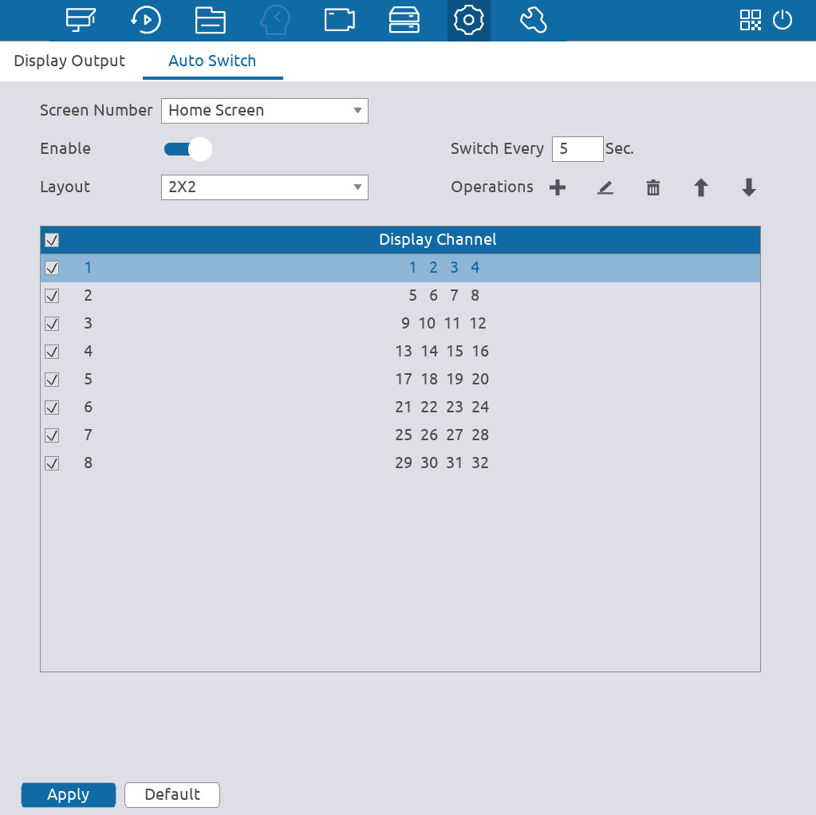
Step 4 Configure the tour parameters.
Table 5-40 Tour parameters
Parameter | Description
Switch Every | The duration for which each channel group is displayed. The default value is 5 seconds.
Layout | Select a layout of the live view.
Operations | You can add, modify, delete, or change the sequence of the channel groups.
Step 5 Click Apply.
Related Operations
On the navigation bar on the live page, click  to enable or disable tour.

5.12.6 Configuring Serial Port
After setting RS-232 parameters, the NVR can use the COM port to connect to other device to debug and operate.
Procedure
Step 1 Select System > Serial Port.
Figure 5-108 Serial port
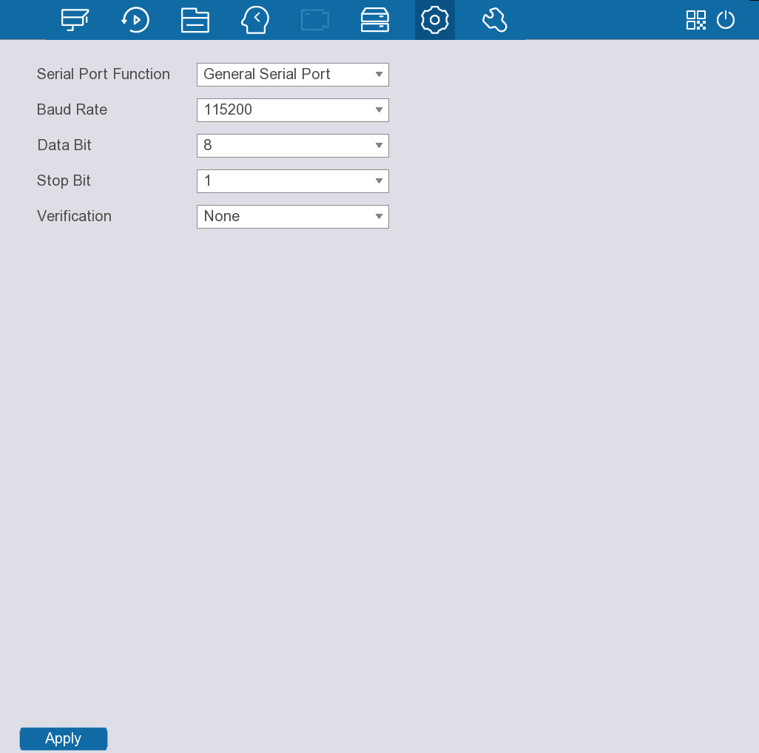
Step 2 Configure parameters.
Table 5-41 Serial port parameters
Parameter | Description
Function | Select serial port control protocol.  ● General Serial Port: Upgrade the program and debug with the console and mini terminal software.  ● Control Keyboard: Control this Device with special keyboard.  ● Transparent Serial Port: Connect with the computer directly for transparent transmission of data.  ● Protocol Serial Port: Configure the function to protocol COM, in order to overlay card number.  ● PTZ Matrix: Connect matrix control  Different series products support different RS-232 functions.
Baud Rate | Select baud rate, which is 115200 by default.
Data Bits | It ranges from 5 to 8, which is 8 by default.
Stop Bits | It includes 1, 1.5 and 2.
Verification | It includes none, odd, even, flag and empty.
Step 3 Click Apply.

5.13 Maintenance
Select Maintain, and then you can view system information and logs, update the system, restore the device to factory defaults, and more.

5.13.1 Viewing System Information
Select Maintain > Device Info to view the version information, disk information, stream information, and more.
● Version information: The device model, alarm input, alarm output, firmware version, system version, ONVIF server version, and more.
● Disk information: The device name, physical position, attributes, total capacity, health status and other information on each HDD.
● Stream information: The resolution and stream rate of each channel.
You can click Waveform to view the stream fluctuation chart.
● Network information: The DHCP, IPv4 address, IPV4 subnet mask, IPv4 default gateway, MAC address, preferred DNS server, and more.

5.13.2 Searching for Logs
Background Information
You can search for and view logs.
● If there is HDD installed, the logs on system operations are saved in the memory of the Device and other types of logs are saved into the HDD. If there is no HDD installed, the other types of logs are also saved in the memory of the Device.
● If you format the HDD, the logs will not be lost. However, if you take out the HDD from the Device, the logs might be lost.
Procedure
Step 1 Select Maintain > Log Info.
Step 2 Set the search period.
Step 3 Select a log type.
Step 4 Click Search.
The search results are displayed.
Figure 5-109 Search results
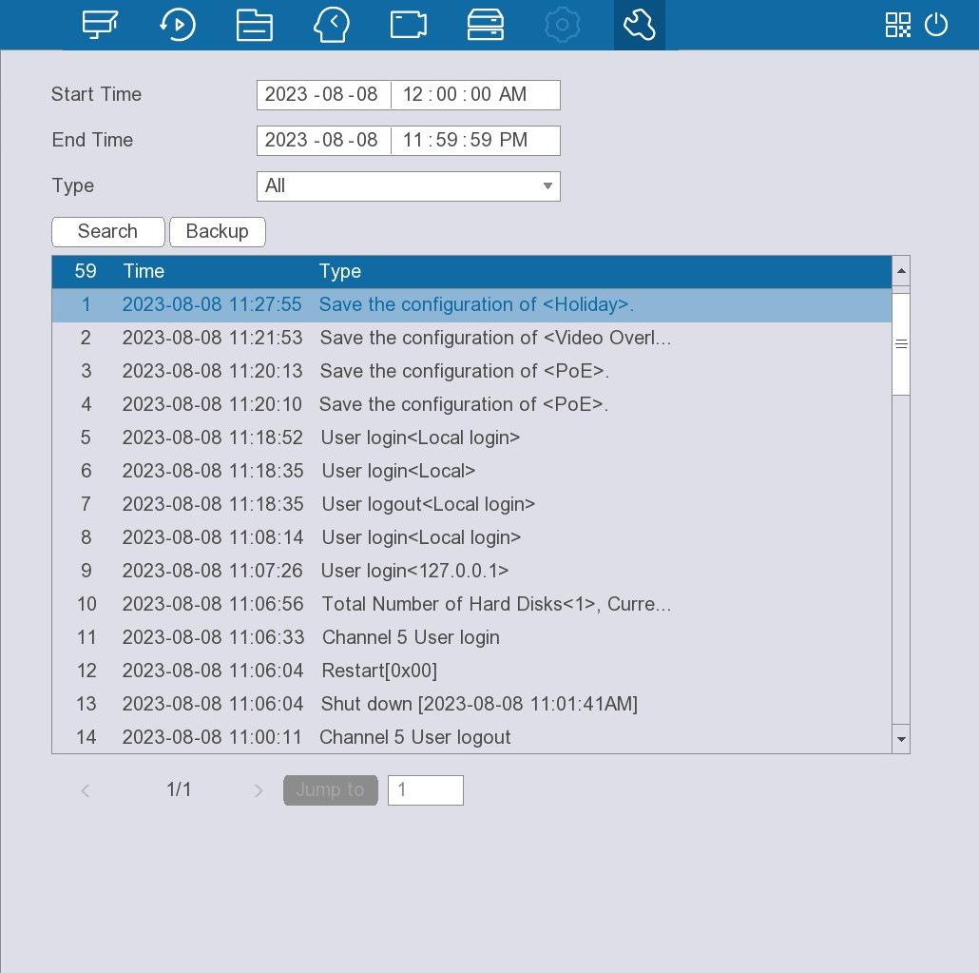
Related Operations
● View details.
Select a log, and then double-click a log to view details. Click Previous or Next to view details of other logs.
● Back up.
Click Backup to save the logs to a USB storage device.

5.13.3 Viewing Network Information
You can view the online users, network load, and test network connection.

5.13.3.1 Viewing Online User
Select Maintain > Network > Online User, and then you can view the information on the online user.
Figure 5-110 Online user
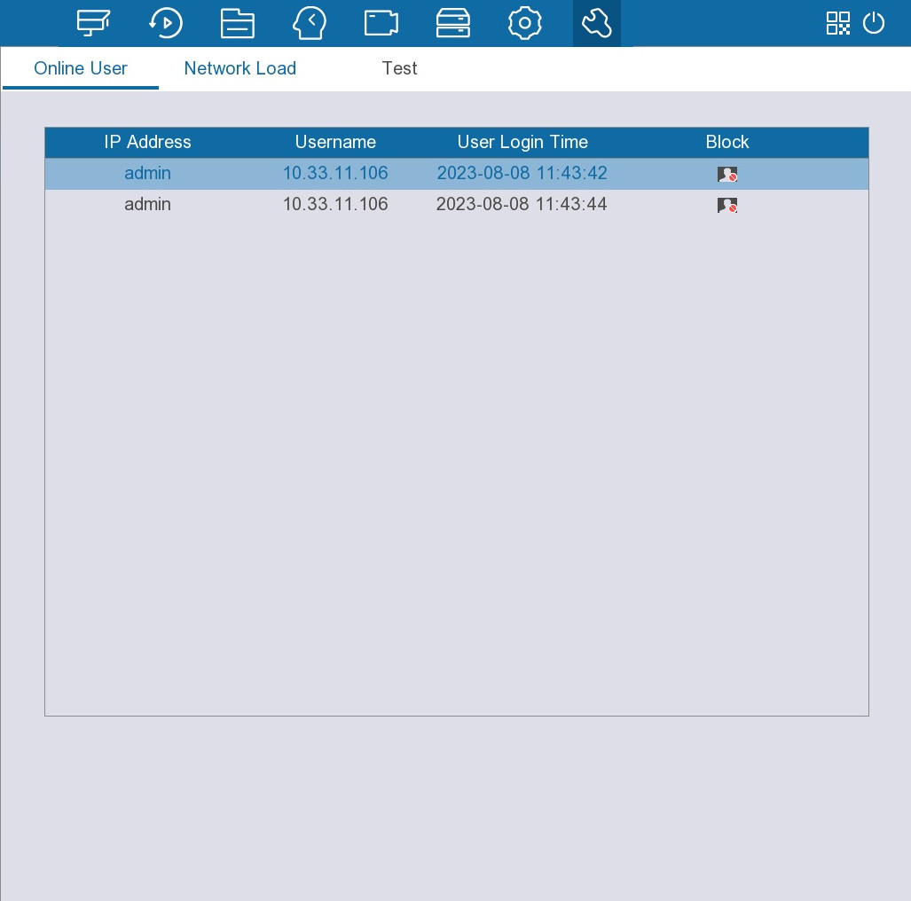
You can click to block a user from logging in to the device.

5.13.3.2 Viewing Network Load
Network load refers to the data flow that measures the transmission capability. You can view the data receiving speed and sending speed.
Procedure
Step 1 Select Maintain > Network > Network Load.
Figure 5-111 Network load
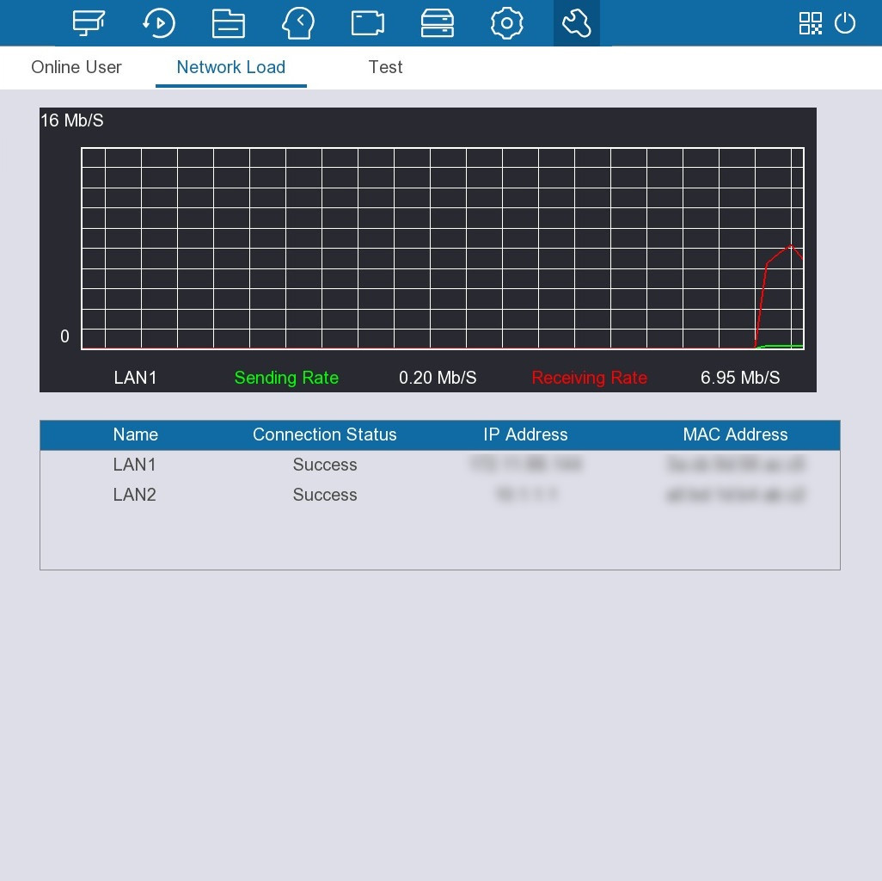
Step 2 Click the LAN name to view the corresponding sending and receiving rate.
You can view the network of one LAN at one time.

5.13.3.3 Testing Network
You can test the network connection between the Device and other devices and capture the packets when the network of the Device is abnormal. The captured packets can help technical support to diagnose and solve network problems.
Procedure
Step 1 Select Maintain > Network > Test.
Figure 5-112 Test
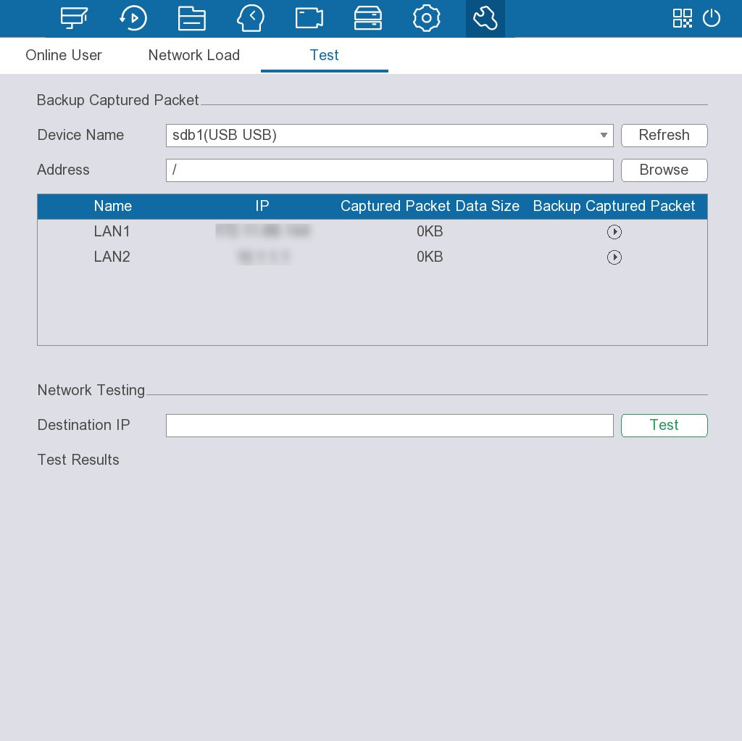
Step 2 Capture packets.
1) Connect a USB storage device to the Device.
2) Click Refresh.
After the Device detects the connected USB device, the name of the USB device appears in the Device Name box.
3) Click Browse to select the storage path.
4) Click to start packet capturing and backup. Click the icon again to stop.
● You cannot capture the data packets of several network adapters at the same time.
● During packet capturing, you can go to other pages for operation and go back to the Test page later to stop packet capturing.
Step 3 Enter the destination IP address, and then click Test.
You can view the load of one network adapter at one time.
After testing is complete, view the test results of the average delay, packet loss rate, and network status.

5.13.4 Exporting and Importing System Configurations
You can export the configuration file of the Device for backup. When the Device malfunctions, you can import the backup configuration file to restore.
You cannot import or export the system configurations when another backup process is ongoing on other pages.

5.13.4.1 Exporting System Configurations
Procedure
Step 1 Select Maintain > Import/Export.
Figure 5-113 Configuration maintenance
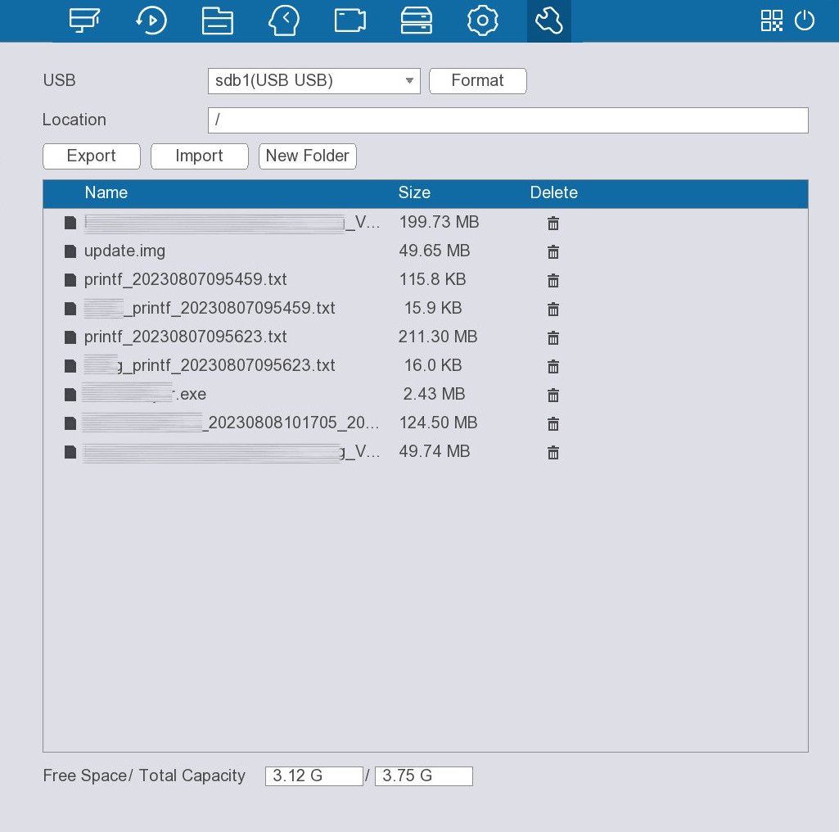
Step 2 Connect a USB storage device to the Device.
Step 3 Click Export.
The configurations are exported to a folder under a name of "Config_[YYYYMMDDhhmmss]".
Double-click this folder to view the backup files.

5.13.4.2 Importing System Configurations
Procedure
Step 1 Connect a USB storage device containing the configuration files to the Device.
Step 2 Select Maintain > Import/Export.
Step 3 Select the configuration folder (under a name of "Config_XX").
Step 4 Click Import.
The Device will restart after the configurations are imported.
The imported configurations will overwrite the original configurations.

5.13.5 Updating the System
You can upgrade the system through file update and online update.

5.13.5.1 File Update
Procedure
Step 1 Connect a USB storage device containing the update file to the Device.
Step 2 Select Maintain > Upgrade.
Figure 5-114 Update
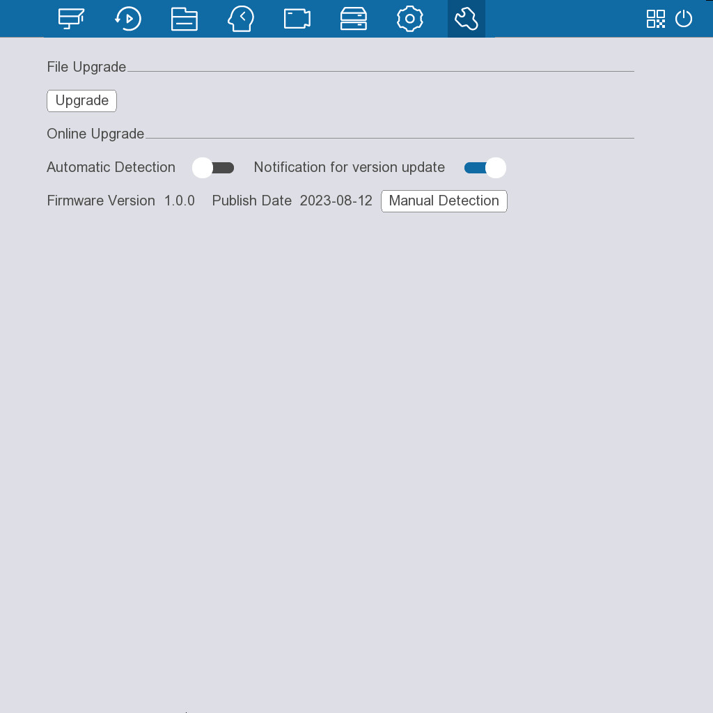
Step 3 Click Upgrade.
Step 4 Select the update file that you want to use.
Step 5 Click OK.

5.13.5.2 Online Update
After the Device is connected to the network, you can update the system online.
Procedure
Step 1 Select Maintain > Upgrade.
Step 2 Check whether there is a new version available.
● Automatic detection: Click to enable automatic detection.
● Manual detection: Click Manual Detection to check the version immediately.
If the system prompts Already the latest version, you do not need an update. If the system prompts a new version is available, go to the next step.
Step 3 Click Upgrade now.

5.13.6 Restoring Defaults
When the system runs slowly and has errors in configuration, you can try to fix such problems by restoring the default settings.

5.13.6.1 Restoring Defaults on the Local Interface
You can restore the Device to default settings on the local interface.
Procedure
Step 1 Select Maintain > Default.
Step 2 Restore the settings.
● Restore: Restore all the configurations except network settings and user management to the default.
● Factory Default: Restore all the configurations to the factory default settings.

5.13.6.2 Resetting Device through the Reset Button
Background Information
You can use the reset button on the mainboard to reset the Device to factory default.
This button is available on select models.
Procedure
Step 1 Power off the Device, and then remove the cover. For details on the removal operation, see "4 Installation".
Step 2 Press and hold the reset button 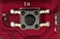 on the mainboard for 5 seconds to 10 seconds.
The position of the reset button might vary depending on the model.
Step 3 Restart the Device.
After restart, the settings are restored to the factory default.

5.13.7 Configuring Automatic Reboot
When the Device has been running for a long time, you can enable the Device to restart automatically at the idle time.
Procedure
Step 1 Select Maintain > Auto Reboot.
Step 2 Select a time for automatic restart.
Step 3 Click Apply.

6 Web Operations

6.1 Logging in to the Web
Prerequisites
Make sure that the IP addresses of your computer and the Device are on the same network segment.
Procedure
Step 1 Enter the IP address of the Device in the address bar of the browser, and then press the Enter key.
Figure 6-1 Login
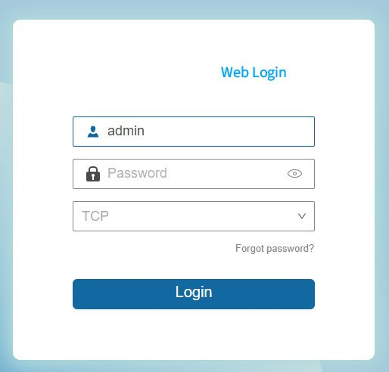
Step 2 Enter username and password.
Step 3 Click Login.

6.2 Web Main Menu
After login, the main menu is displayed.
Figure 6-2 Web main menu
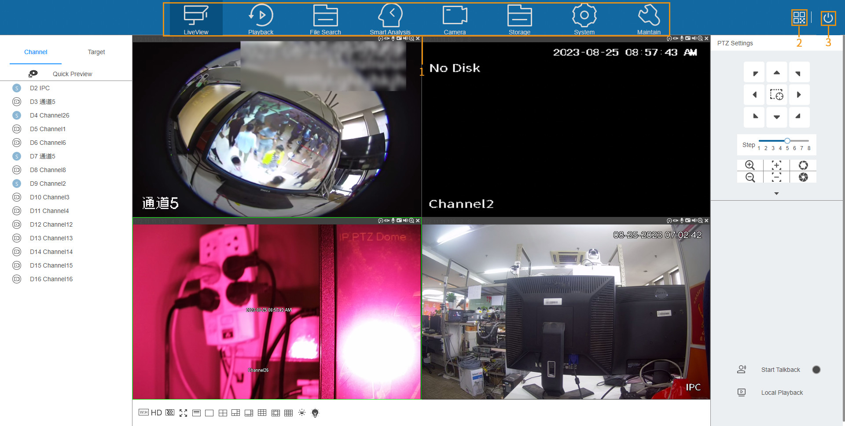
Table 6-1 Main menu description
No. | Name | Description
1 | Function tiles | Click each tile to open the corresponding configuration page.
2 | QR code | Scan the QR code to add the Device for remote management.
3 | Shut down | Log out of the current account, restart or shut down the Device.

Appendix 1 HDD Capacity Calculation
Use the following formula to calculate the HDD capacity:
Total capacity (MB) = Channel number× Demand time length (hour) × HDD capacity occupied per hour (MB/hour)
Based on this formula, the formula to calculate recording time goes as follows:
For example, for single-channel recording, the HDD capacity occupied per hour is 200 MB/hour. If you use 4-channel device to make 24-hour continuous recording in every day of one month (30 days), the required HDD space is: 4 channels× 30 days× 24 hours× 200 MB/hour = 576 G. Therefore, you need five 120 G HDDs or four 160 G HDDs.
According to the formulas, at different stream values, recording file size of 1 channel in 1 hour is shown as follows:
Appendix Table 1-1 HDD capacity
Max. bit stream value | File size | Max. bit stream value | File size
96 Kbps | 42 MB | 128 Kbps | 56 MB
160 Kbps | 70 MB | 192 Kbps | 84 MB
224 Kbps | 98 MB | 256 Kbps | 112 MB
320 Kbps | 140 MB | 384 Kbps | 168 MB
448 Kbps | 196 MB | 512 Kbps | 225 MB
640 Kbps | 281 MB | 768 Kbps | 337 MB
896 Kbps | 393 MB | 1024 Kbps | 450 MB
1280 Kbps | 562 MB | 1536 Kbps | 675 MB
1792 Kbps | 787 MB | 2048 Kbps | 900 MB
The table is for reference only. The data might differ in the actual situation.

Appendix 2 Cybersecurity Recommendations
Compulsory measures to ensure the basic device network security:
● Timely Update Firmware and Client Software
◇ Keep the device (such as video recorder and IP camera) firmware up-to-date based on standard procedure in the tech-industry to ensure the system is equipped with the latest security patches and fixes. When the device is connected to the public network, it is recommended to enable the“auto-check for updates” function to obtain timely information of firmware updates released by the manufacturer.
◇ Download and use the latest version of client software.
● Use Complex Passwords with Combination of Characters, Numbers and Symbols
Please refer to the following suggestions to set passwords:
◇ The length should not be less than 8 characters;
◇ Combine at least two types of characters in a password among upper and lower case letters, numbers and symbols;
◇ Do not contain the account name or the account name in reverse order;
◇ Do not use continuous characters, such as abcdefgh and 12345678;
◇ Do not use overlapped characters, such as aaaaaaaa and 11111111.
Constructive suggestions on improving device network security:
● Change Passwords Regularly
We recommend that you change passwords regularly to reduce the risk of being guessed or cracked.
● Configure and Update Password Reset Information in Time
Password reset function is supported by the device. Please configure related information for password reset in time, including the end user’s email address and password protection questions. Please update the information accordingly in time if it changes. Please do not use simple questions whose answers can be easily obtained when setting password protection questions.
● Enable Account Lock
The account lock is enabled by default. We recommend you keep it on to ensure the account security. A number of failed login attempts will lead the corresponding account and the source IP address to be locked.
● Physical Protection
Physical protection is recommended on the device, especially storage devices. For example, place the device in a special computer room and cabinet, and implement strict access control permission and key management to prevent unauthorized personnel from carrying out physical contacts such as damaging hardware and unauthorized connection of removable device (for example, USB flash drive and serial port).
● Reset Default HTTP and Other Service Ports
Changing the default HTTP and other service ports is recommended. We recommend you change them into any set of numbers between 1024–65535 to reduce the risk of exposing ports in use to outsiders.
● Enable HTTPS
HTTPS is recommended to be enabled so that you can obtain the web service through a secure communication channel.
● Bind IP and MAC Address to Device
To reduce the risk of ARP spoofing, we recommend you bind the IP and MAC address of the gateway to the device.
● Assign Accounts and Privileges Reasonably
Based on business requirements and management requirements, prudently add user accounts and assign a minimum set of permissions to them.
● Disable Unnecessary Services and Apply Secure Modes
If not needed, we recommend you turn off some services such as SNMP, SMTP, and UPnP to reduce risks.
If necessary, we recommend using security modes, including but not limited to the following services:
◇ SNMP: Choose SNMP v3, and set up strong encryption passwords and authentication passwords.
◇ SMTP: Choose TLS to access mailbox server.
◇ FTP: Choose SFTP, and set up strong passwords.
◇ AP hotspot: Choose WPA2-PSK encryption mode, and set up strong passwords.
● Establish a Secure Network Environment
The following actions are highly recommended to ensure device security and to reduce potential cyber risks:
◇ Disable the port mapping function of the router to avoid direct access to the intranet devices from external network.
◇ Partition and isolate the network according to the actual network needs. If there are no communication requirements between two sub networks, we recommend you adopt network isolation through VLAN, network GAP and other technologies.
◇ Establish the 802.1x access authentication system to reduce the risk of unauthorized access to private networks.
◇ Enable IP/MAC address filtering function to limit the range of hosts allowed to access the device.
● Security Auditing
◇ Check online users: Check online users regularly to prevent unauthorized login.
◇ Check device log: Obtain the IP addresses that were used to log in to the device and their key operations with help of the logs.
● Network Log
The stored log is not saved in full due to the limited storage capacity. If you need to save the log for a long time, we recommend you enable the network log function to make sure that the critical logs are synchronized to the network log server for tracing.

